**ARTHIMETIC**

**NUMBER SYSTEM**

1. When 31 is divided by 5, the quotient is 6 and the remainder is 1.

Sol:

5) 31( 6

__30 __

1__

31 – Dividend

5 – divisor

q- quotient

r– remainder

31 = ( 5 X 6) + 1

D = dq + r

2. When a number is divided by 240, the remainder is 51. What will be the remainder, if the same number is divided by 40.

Sol:

d D

q – r

D = dq + r

240 D

q – 51

D = 240 q + 51

The number is of the form 240 q + 51

Let q = 1

Then D = 240 + 51 = 291

When we divide 291 by 40,

40) 291( 7

__ 280 __

11 _

The remainder = 11

Let q = 4

Then D = ( 240 X 40 ) + 51 = 960 + 51 = 1011

40) 1011( 25

__ 80 __

211

200

11

If we divide 1011 by 40, we get the same remainder 11.

This is because when we divided 291 by 40. We divide 240 by 40 and also 51 by 40 . The first part is exactly divisible by 40 and and when we divide 51 by 40 we get the remainder 11.

it is the same case with 1011 also.

We can look at the given sum as follows:

d1 = 240 , r1 = 51

d2 = 40 , r2= ?

Short cut: Check if d2 divides d1 then divide r1 by d2 to get r2.

40 divides 240

So, divide 51 by 40 and we get 11 as the remainder.

∴ Ans is 11

3. Find r, when

Sol:

23 = ( 22 + 1)

24 = ( 22 + 2)

25 = ( 22 + 3)

26 = ( 22 + 4)

∴

Wherever 22 is there, it will be exactly divided by 11.

So the final remainder is obtained from the product of the remainders left out after they are divided by 11

Therefor the remainder = 2

4. Find r, when 11 8 is divided by 7

Sol:

11 = (7+4)

Therefore

Note: If is divided by x, then the remainder is

Let n = 1

Then,

Let n = 2

Then

∴ by Induction

Therefore when

The remainder =

Again 16 = 14 +2

∴

Again

Final r =2

To find the digit in the unit’s place in the expansion of .

The sum can be looked as shown:

Let us learn the behaviour of different digits when they are raised to multiple powers

n>0

41 ends in 4, 42 ends in 6

43 ends in 4, 44 ends in 6

∴ 4n ends in 4 if n is odd

Ends in 6 if n is even

4135 ends in 4

4478 ends in 6

9n

91 ends in 9 , 92 ends in 1

93 ends in 9 , 94 ends in 1

∴ 9n ends in 9 if n is odd

Ends in 1 if n is even

9237 ends in 9

9534 ends in 1

We have so far seen the behaviour of the digits 1,4,5,6 and 9. The digits left are 2,3,7,8

2n

21 – 2

22 – 4 234 => 32 + 2 => r = 2 ends in 4

23 – 8 245  => 44 +1 => r = 1 ends in 2

24 – 6 256 => 52 +4 => r = 4 ends in 6

25 – 2 267 => 64 +3 => r = 3 ends in 8

26- 4

27 – 8

28 – 6

Note 1: Divide the Index by the cycle number : i.e ‘4’

Note 2: Test for 4

The number formed by the last 2 digits 4

Note 3: For even number power ‘n’, if n is exactly divided by 4 then the last digit is 6

Similarly the cycle number for 8,3 and 7 is also 4.

The digit in the unit’s place of

77 =76 + 1 => r = 1

66=64 + 2 => r = 2

3 power 1 ends in 3 and 7 power 2 ends in 9 also 9 power odd number ends in 9.

∴ the product of 3x9x9 will end in ‘3’

Numbers are broadly divided into two categories

Prime Numbers Composite Numbers

2 = { 1,2} 4 = {1,2,4}

3 = {1,3} 8 = {1,2,4,8)

5 = { 1,5} 12= {1,2,3,4,6,12}

Numbers having only 2 factors are prime Numbers having a minimum of 3 factors are

2 is the least prime composite numbers.

2 is the only even prime

Mutually Prime/ Co – prime numbers :

1. (3,5) are Co-prime

2. ( 6,7) are Co-prime HCF = 1

3. ( 8, 15) are C0 -prime

=> Numbers having HCF = 1 are called Co-Prime Numbers

1.) Both 3 and 5 are prime numbers

=> Any two prime numbers are always Co-prime

2.) 6 and 7 are consecutive Positive integers

=> Any two consecutive Positive integers are also Co-prime

3.) 8 and 15 both are composite numbers still they are Co-prime because their HCF = 1

To find the total number of factors to a given number

24 = ( 1,2,3,4,6,8,12,24 )

Total no of factors of 24 are ‘8’

24 = 4 X 6 = 2 X 2 X 2 X 3 = 23 X 31

N f (24) = ( 3+1) ( 1+1) = 4 X 2 = 8

Steps to find total no of factors

Step 1: Break the number into product of its prime factors 24 = 2 X 2 X 2 X3

Step 2: Express them in Index form 24 = 23 X 31

Step 3 : Increase the indices by 1 and multiply to get the total no of factors

Total no of factors = ( 3 +1) ( 1 + 1) = 4 X 2 = 8

Find the total no of factors of

1. 54

Sol:

54 = 6 X 9 = 2 X 3 X 3X 3 = 21 X 33

n(f) = 2 X 4 = 8

2. 225

Sol:

152 = 32 X 52

n(f) = 3 X 3 = 9

3. 361

Sol:

361 = 192

n(f)= 2 + 1 = 3

4. 576

Sol:

576 = 242 = 32 X 82 = 32 X (23)2

= 32 X 26

n(f) = 3 X 7 = 21

5. 729

Sol:

729 = 93 = 36

n(f) = 7

6. 961

Sol:

961 = 312

n(f) = 3

7. 1024

Sol:

1024 = 322

= (25) 2 = 210

n(f) = 11

8. 1764

Sol:

1764 = 4 X 441 = 22 X 212 = 22 X 32 X 72

n(f) = 3 X 3 X 3 = 27

9. 2025

Sol:

2025 = 452 = 52 X 92 = 52 X 34

n(f) = 3 X 5 = 15

10. 3003

Sol:

3003 = 3 X 1001

This number 1001 appears to be a prime number. Let us find the factors of 1001

**Test of Divisibility**

Number tested Test

2 The number should be even or the number should end in ‘0’

3 Sum of the digits should be divisible by 3

Ex : - 123, 234, 345, 456, etc

111, 222, 444, 666, 777 etc

4 1024 = 4 X 256

The number formed by the last two digits should be divisible by 4

5 The number ends in 5 or 0

6 6 = 2 X 3 even number, and test for 3

**Test for 7**

2~~1~~

-2

0

Rule : Double the last digit and subtract it from the preceding digits to get a single remainder of either a ‘0’ or a multiple ‘7’

1001 is by 7

**Test for 8**

The number formed by the last 3 digits should be divisible by 8

1 3 2 5 7 4 5 6 is by 8

**Test for 9**

The sum of the digits should be divisible by 9

2736, 5418

Find the least positive integer that should come in the place of _

3 4 5 ­_ 🡪 6

4 _ 5 6 🡪 3

5 6 7 _ 🡪 0

**Test for 11**

112 = 121

113 = 1331

1 2 1 1 +1 = 2

2 = 2 and 2 – 2 = 0

The sum of the outer two numbers should be equal to the middle number

Ex : - 2 7 5 4 5 1 are all by 11

3 9 6 5 8 3

Also

2 0 9 9 0 2

3 0 8 8 0 3 are also by 11

4 0 7 7 0 4

5 0 6 6 0 5

1 0 0 1

1 + 0 = 1

0 + 1 =- 1

0

113 = 1 3 3 1

1 +3 = 4

3 + 1= 4 – 4 = 0

Rule: The difference between the sum of alternate digits should either be a ‘0’ or a multiple of 11

1001 is by 11

**Test for 12**

12 = 2 X 6 HCF = 2

= 3 X 4 HCF = 1

We should test for 3 and 4 only and not 2 and 6

We should select only Co-Prime Factors

**Test for 13**

Multiply the last digit by 4 and add to the preceding digit to get a single remainder, which is a multiple of 13

1 0 0  ~~1~~  1 x 4 = 4 3 X 4 = 12

+ 4 2 7  ~~3~~

1 0  ~~4~~  + 12

+ 16 39

2 6

143, 273 are by 13

1001 is by 13

**Test for 17**

8 ~~5~~

-25

- 17

5 X 5 = 25

Rule : Multiply the last digit by 5 and Subtract. The result should be a ‘0’ or a multiple of 17.

**Test for 19**

9 ~~5~~

+ 10

19

Rule: Double the last digit and add to the preceding digit to get a single remainder of a multiple of 19.

The number of factors of 3003

10.) 3003 = 3 X 1001 = 31 x 71 X 111 X 131

N f(3003) = 2 X 2 X 2 X 2 = 16

**Least Common Multiple**

1. A number  by 2 And 5 is also by 10

2. A number by 4 and 5 is also by 20

3. A number by 6 and 8 is also by 24

🡪 A number by a series of numbers is by the LCM of the numbers

1. Both 2 and 5 are Prime Numbers

🡪 The LCM of any two prime numbers is their PRODUCT

2. 4 and 5 are consecutive Positive integers

🡪 The LCM of any two consecutive Positive integers is also their PRODUCT

3. Both 6 and 8 are composite and not Co-Prime.

∴ their LCM is NOT their product

Find LCM of Factor Method

2, 3, 4 LCM = 3 X 4 = 12

3, 4, 5, 6 LCM = 2 X 2 X 3 X 5 = 60

4, 5, 6, 7 LCM = 2 X 2 X 3 X 5 X 7 = 420

5, 6, 7,8 LCM = 2 X 3 X 4 X 5 X 7 = 840

The LCM of 6,7,8,9,10 Leave the prime number out.

5 6, 8, 9, 10

3 6, 8, 9, 2

2 2, 8, 1, 2

2 1, 4, 1,1

2 1, 2, 1, 1

1,1,1,1

5 X 2 X 3 X 2 X 2 = 10 X 9 X 4 = 360

LCM = 360 X 7 = 2520

**The above method is called the long Division Method**

1. Divide only by Prime Factors

2. Start with the greatest Prime factor and end with 2

HCF (HIGHEST COMMON FACTOR)

Find HCF of 36 and 48

Factor method Division method

36 = 12 X 3 36) 48 ( 1

48 = 12 X 4 36

HCF = 12 12) 36 ( 3

36

0

HCF = 12

Find HCF of :

**Subtraction Method**

1. 36, 54, 72

36, ( 54- 36), ( 72- 54)

36, 18, 18

HCF = 18

2. 143, 195, 272

143, 52, 78

52, 78, 143

52, 26, 65

26, 52, 65

26, 26, 13

HCF = 13

3. 187, 255, 357

187, 68, 102

68, 102, 187

68, 34, 85

34, 68, 85

34, 34, 17

HCF = 17

4. 209, 285, 399

209, 76, 114

76, 114, 209

76, 38, 95

38, 76, 95

38, 38, 19

HCF = 19

**LCM of fractions =**

**HCF of fractions =**

Ex:- Find LCM and HCF of

LCM =

HCF =

Note : The HCF of Consecutive Positive integers = 1

**2. Percentages**

Per – for every

Cent – hundred

Calculating for every 100 is a percentage

If ratio of total = 5

% b =

%g =

Note: To convert a fraction into a % multiple by 100

Unit Fractions

**To by 9 multiply the numerator by 11**

🡪X % of y = y% of x

40% of 60 = 60% of 40

🡪If x% and y% are the increase then % net increase =

🡪If x% and y% are the decrease then % net decrease =

🡪The single discount % equivalent to two successive discounts of x% and y% =

🡪The single discount % equivalent to three successive discounts of x%, y% and z%

=

Find 83.33% of 2400

Sol:

Find 87.5% of 88888

Sol:

It is easy to deal with fraction than with decimals

Exercise

1. 5 is what % of 8?

Sol:

2. 8 is what % of 5?

Sol:

3. 30% of 80 = 40% of x

Sol;

X = 60

4. 10% 20= 20 % of x?

Sol:

X = 10

X% of y = y% of x

5. Find 4236.24% of 5000

Sol:

4236.24% of 5000

= 50005 of 4236.24

= 50% of 423624 = 211812

1. The population of village is 20000. In the 1st year the population is increased by 20% and in the next year it is decreased by 10%. Find

a) The population at the end of 2 year

b) The % change in population

a) The population at the end of 2 year

=

Note: To increase a number by 20% . Find 120% of the number (100+20)

Note: To decrease a number by 30% . Find 70% of the number (100-30)

∴ The population is increases by = 1600

2. The % change in population =

If only % change is asked:

If x% and y% are the increase then % net increase = ( x + y + )%

If x% and y% are the decrease then % net decrease = ( x + y -

Here x = 20 y= -10

% net change = 20 – 10 +

2. If the length of a rectangle is increase by 12% and its width is increase by 8% then find the % increase in its area?

Sol:

here x = 12% , y = 8%

% increase in area = 12 + 8 +

3. If each side of a square is decreased by 10% then find the % decrease in its area

Sol:

Here x = y = 10% decrease

% net decrease in area = x + y –

4. If the area of circle is decreased by 36% then find the % decrease in its radius

Sol;

Here x = y =?

% net decrease = 36

X + y –

But x = y

x + x –

2x -

Note: You can frame a quadratic equation but never try to solve it in the exam

A) 10% B) 15% C) 20% D) 25% E) 30%

Sol:

2x –

A) 10%

B) 15%

C) 20%

Let x = 20

Then 2 X 20 –

4. When the price of cars is reduced by 40%, the consumption is increased by 60%. Find the % change in the revenue

Sol: here x = -40 y = 60

% net change = -40 + 60 +

Revenue decrease by 4%

5. If A’s income is 25% more than B’s income, then by how much % is B’s income less than A’s income

Sol:

A B

125 100

100 x

X =

B’s income is less than A’s income by = 100 – 80 = 20%

Note: If A’s is income r % more than B’s income then B’s income is less than A’s income by =

Note: If A’s is income is r% less than B’s income, then B’s income is less than A’s income by =

6. If one side of a square is 40% more than the adjacent side, then the other side must be decreased by how much % to maintain the area

Sol:

r = 40%

The other side must be decreased by =

7. When the price of fuel is increased by 20% find by how much % should the consumption be decreased so as to maintain the expenses

Sol:

r = 20%

The consumption should be decreased by =

8. In an election between A and B, A got 57% of the total cotes and won the election by 2100 votes. Find the total number of votes

Sol:

A = 57%

B = 43%

Margin = A – B = 57 – 43 = 14%

Also margin = 2100 votes

Therefore 14% of total votes = 2100 votes

Total number of votes =

9. In an examination 50% passed in maths, 60% passed in English. If 20% failed in both, find the % passed in both the subjects

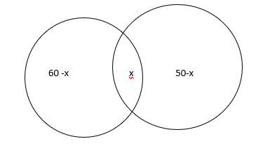

M(60%) E (50%)

Sol;

Let percentage passed in both subjects = x

Since 20% failed in both

Overall % passed = 100 – 20 = 80%

∴ 60 -x + x + 50 -x = 80

110 – x = 80

Or x = 30%

10. In an examination a student who secured 25% of max marks failed by 120 marks. Another student who secured 40% of the max marks got 60 marks more than necessary for passing. Find

a) The max marks

b) The pass marks

c) The pass %

sol:

let x be the maximum marks then

= 120 + 60

X = 1200

a) maximum marks = 120

b) pass marks =

c) pass % =%

11. In an examination 65% of the boys and 85% of girls secured 1st class. If 80% of the whole secured 1st class find how many the boys in a total of 400 students?

Sol:

Let the number of boys = x

Then the number of girls = 400 – x

Then

X = 100 boys

12. The single discount % equivalent to two successive discount of x % and y% =

The single discount % of x%, y% to three successive discounts of x%, y% and z% =

**Double Matrix Sum**

In a toy manufacturing unit half of the toys are small and half large. 40% of the toys are red and the rest green. If 10% of the toys are red and small and 40 number of toys are green and large, find how many toys are red and large

Small large Total

Red 10% 30% 40%

Green 40% 20% 60%

Total 50% 50% 100%

You have to complete the total column first colour wise and size wise. Then filling in for red and small as 10% we can complete the remaining grids across and down .

It is given that 40 number of toys are green and large

Green and large = 20% = 40

∴ red and large = 30% = ?

=

ex. In a toy manufacturing unit half of the toys are small and half large. 40% of the toys are red and the rest are green. If 10% of the toys are red and small and 40 number of toys are green and large, find how many are red and large

|  |  |  |  |
| --- | --- | --- | --- |
|  | Small | Large | Total |
| Red | 10% | 30% | 40% |
| Green | 40% | 20% | 60% |
| Total | 50% | 50% | 100% |

20% of toys are green and large and number of green and large toys = 40

30% of toys are red and large

∴ The number of red and large toys =

**Profit and Loss**

The simplest of business is trading i.e. buying and selling

Selling Price = SP

Cost Price = CP

∴ If SP > CP there is a profit

If CP > SP then there is a loss

SP – Cp = P

CP- SP = L

P or L is calculated as a % on Cp

P% =

L% =

When there is a profit when there is a loss

SP = ? SP = ?

P = 30% l = 20%

SP = 130 % of Cp SP = 80% of CP

SP = Sp =

Cp = Cp =

Cp = 1800 Cp = 2400

P = 18% l = 17%

SP = Sp =

SP = 2541 SP= 1909

P= 21% l = 17%

SP = Cp=

If CP of ‘x’ article = SP of ‘y’ article

and If x > y then P% =

If x < y then L% =

If the selling price of two articles are the same and if the P% on 1 equals the L% on the other , then there is always a loss

L% = x% of x

X is the common P or L%

Marked Price = MP

‘d’ is the discount

d = MP – SP

Mark up = MP – CP

∴ SP =

MP =

Also MP =

1. By selling an article at ₹ 1380 if 15% is gained. Find SP to gain 25% and to incur a loss of 20%

115% - 1380

125% = ?

Sol:

To incur a loss of 20%

SP=

2. If CP of 20 apples = SP of 15 apples. Find P%

Sol:

If CP of x articles = SP of y articles

And if x>y

P% =

3. If CP of 50 articles = SP of 65 articles Find Loss%?

Sol:

If CP of x articles = SP of y articles

And if x<y then

Loss% =

4. By selling 20 cycles a trader gained the SP of 5 of them. find his P%?

Sol: SP = CP + P

SP of 20 cycles = CP of 20 cycles + SP of % cycles

CP of 20 = SP of 20 – SP of 5

CP of 20 = SP of 15

P% =

5. A trader claims to sell his goods at Cost price, but he gains 25% Find the weight Substituted for a kg wt?

So:

1 Kg weight = 1000gms

Therefore CP of 1000gms = SP of y gms

1000 > y

P%

4000 – 4y = y

5y = 4000

Y = 800gms

The weight substituted = 800 gms

6. A man bought two articles together for ₹ 1800. He sold one at a profit of 5% and the other at a loss of 4%. If he neither gained nor lost in the transaction, find the cost price of each articles?

Sol: Let Cp of I = x

Then CP of II = (1800 – x)

He neither gained nor lost

5 % of I = 4% on II

X = 800

CP of I = 800

CP of II = 1000

7. A man sold two articles for ₹ 6000 each. He sold one at a gain of 20% and the other at a loss of 20%. Find his overall P or L % ?

Sol:

% net change = x + y +

X = 20, y = -20

% net change = 20 – 20 +

There is a loss of 4%

8. The profit % obtained by selling an article for ₹ 1920 is the same as the loss % incurred by selling the same article at ₹ 1280. Find the SP to gain 25%

Sol:

Profit Loss

Let CP = x Let CP = x

P = (1920 – x) l = ( x – 1280)

∴ =

2x = 3200

x = CP = 1600

The SP required to gain 25% =1600 2000.

9. A man bought article worth ₹. 4500. He sold of them at a loss of 10%. Find for how much profit % should he sell the remaining articles so as to gain 30% on the whole?

Sol:

SP required to gain 30% on the whole =

SP of at 10% loss =

SP of articles = 5850 – 1350 = 4500

Cp of articles = = 3000

The required Profit = 4500 – 3000 = 1500

% Profit required =

**% method:**

2x – 10 = 90

2x = 100

X = 50%

10. A reduction of 20% in the price per kg of rice enables a customer to get 8 kgs more for ₹ 160. Find

a) The original price per kg

b) The reduced price 1 kg

sol:

The number of kg bought =

Let the original price 1 kg = x

Then the reduced price 1 kg =

Then

X = ₹ 5

The original price per kg = ₹ 5

The reduced price per kg =

11. An article is marked 50% above the cost price. If a discount of 20% is offered find the P%

Sol: let CP = 100

The mark CP = 50%

Then MP = 150

D= 20%

SP =

SP = 120

CP = 100

P = 20%

The profit = 20%

12. The CP of a book is ₹ 75. A discount of is offered and the profit is 20% find the Mp

Sol:

CP = 75

P = 20%

SP =

SP = 90

d =

MP =

MP= ₹ 96

Or .

13. The SP of an article after a discount of 10% is ₹ 45, and the profit is 50%. Find the P% if no discount is offered

Sol:

SP = 45

d = 10%

MP =

SP = 45

Profit = 50%

CP = =

If d = 0%

SP = MP

SP = 50

Cp = 30

P = 20

% P =

14. An article is sold at a profit of 20% if each Cp and SP is less by ₹ 100, then the profit would be 4% more. Find the CP

Sol: Let original CP = x

Then original CP = 1.2x

Profit = 0.2x

New CP = (x – 100)

New SP = ( 1.2x – 100)

Profit = 0.2x

Given, 0.2x =

20x = 24x – 2400

24x -20x = 2400

4x = 2400

X = CP = ₹ 600

**Ratio and Proportion**

**Ratio:** Comparison of two similar quantities by division

Ratio is a Quantifier

It is used to express the unknown quantity in terms of known quantity

I: II

a: b

a🡪 antecedent

b 🡪 Consequent

**Properties of ratio:**

Ratio is a ‘mere’ number

The order of the terms must be maintained a:b b : a

The units of the terms must be the same 1m: 1 cm = 100 cm: 1 cm = 100: 1

3x: 4x = 6x: 8x = 30x: 40x = 45x: 60x

By multiplying each terms of a ratio by a non-zero constants the value of ratio remains unchanged

b

**Types of ratio:**

**Equal ratio:**

3x: 2x is the equal ratio of 3: 2

**Inverse ratio**

b: a is the inverse ratio of a : b

speed ratio = 8 : 11

time ratio = 11 : 8

**Combined ratio:**

a : b : c is called the combined ratio of a : b and b : c

find a : b : c if a : b = 2 : 3 and b : c = 4 : 5

sol:

a : b : c

2 : 3

+

4 : 5

8 : 12 : 15

Note : If a number is divisible in the ratio of x : y then the number is divisible by x + y

**Proportion**

if then a, b , c, d in order are in proportion

if a, b, c are in proportion then then b2 = ac => => b =

‘b’ is called the ‘mean proportional to a and c

‘c’ is called the ‘third proportional to a and b

Find mean proportional b =

1. 18 & 8

b =

2. 25 & 30

b =

3. 36 & 64

b =

find third proportional to

1. 25 & 30

C =

2. 36 & 42

C =

3. 64 & 72

If then

1.

2.

3.

4.

5.

How to combine two ratios:

a and c are related to ‘b’ but differently. We have to make ‘b’ common to both a and c by taking the LCM then we raise a and c to the level of ‘b’

1. Divide ₹ 25,000 among A, B & C such that A : B = 5 : 6 & B : C = 7 : 8

Sol:

A : B : C

5 : 6

7 : 8

35 : 42 : 48

Total 125

A =

B =

C =

2. Find a : b : c : d if a : b = 2 : 3 , b : c = 4 : 5 , c : d = 6 : 7

Sol:

a : b : c : d

2 : 3

4 : 5

8 : 12 : 15

6 : 7

48 : 72 : 90 : 105

a : b : c : d = 16 : 24 : 30 : 35

a =

b =

c =

d =

3. Instead of dividing a sum of money between A and B in the ratio of 4 : 5, if was divided in the ratio of 3 : 4. If A received ₹ 200 less than before, find the sum of money

Sol:

A : B Total A’s

Original ratio = 4 : 5 9

Ratio divided = 3 : 4 7

Let the sum of money = x

Then

X = ₹ 12600

**Note :**  If a number is divisible in the ratio of x : y, then the number is divisible by the sum of parts

4. The income ratio of A : B = 3 : 2 if each of them saves ₹ 4000, find the income of each, if their expenditure ratio = 2 : 1

Sol:

Income – Savings = Expenditure

A : B

Income ratio = 3x : 2x

Then

A’s income = ₹ 12,000

B’s income = ₹ 8000

5. Divide 1110 into three parts such that 4 times the 1st part, 5 times the 2nd part and 6 times the 3rd part may all be equal

Sol:

The given number = 1110

Let the three parts be a, b, c

Then ……………………….. 1

And 4a = 5b = 6c …………………………………….. 2

4a = 5b 5b = 6c

a : b : c

5 : 4

6 : 5

30 : 24 : 20 = 15 : 12 : 10

Total = 37

a =

6. The ratio of P : F in an examination is 3 : 1. Had 8 more appeared and 6 less passed then the ratio of P : F = 2 : 1. Find how many appeared

Sol:

Passed = P

Failed = F

P : F Total

Original ratio = 3x : x 4x

Had 8 more appeared, the new total = 4x + 8

Had 6 less passed, the new no of = 3x – 6

passed candidates (-) (+)

The new no failure = x + 14

The new ratio of P: F = 2 : 1

∴

3x – 6 = 2x + 28

X = 34

∴ 4x = 136

Total no of students appeared = 136

7. The ratio of ages of A : B = 4 : 5 and the ratio of ages of B : C = 4 : 5. If the sum of there ages is 183, find the age of B?

Sol:

A : B : C

4 : 5

4 : 5

16 : 20 : 25

Total = 61

B’s age =

B’s age = 60 years

8. The Uranium extraction in a certain year in California was parts of all the Uranium extraction in the U.S and it was parts in case of Texas. If the Uranium extraction by all the remaining states was 42 mn tonnes, find the extraction from California?

Sol:

Uranium extractions

By California =

By Texas =

Together =

∴ Extraction by all the remaining states =

Given parts = 42 mn tonnes

∴ by California = parts

=

**Proportions**

if then a, b, c , d taken in order is called the proportion

**Equalities of ratio constitutes proportion**

if a, b, c are in proportion then

b2 = ac

b =

‘b’ is called the ‘Mean proportional’ to a and c

ç’ is called the ‘Third proportional’ to a and b

**Find mean proportional to**

b =

1. 18 and 8 =>

2. 25 and 36 =>

3. 64 and 81 =>

**Find “Third Proportional’ to**

1. 25 and 30 =>

2. 36 and 42 =>

3. 64 and 72 =>

If then

1.

2.

3.

4.

5.

=> If then ad = bc

If a : b : : c : d

a and d are Extreme ratio

b and c are mean ratio

ad = bc

product of means = product of extreme

proportion is also called ‘variation’

**types of variations**

1. Direct variation

2. Inverse variation

**1. Direct variation**

X = ky

If the ratio of two quantities is a constant, then they will vary directly

Ex : work 🡪 time

Work 🡪 men

Distance 🡪 time

Distance 🡪 fuel

Work days

Less 1 --🡪 40 less

More 1 🡪 x more

**2. Inverse variation**

XY is a constant

If the product of two quantities is a constant, then they will vary inversely

Ex: Speed 🡪 time

Men 🡪 time

Time in hr 🡪 time in days

Men days

Less 20 30 more

More 30 x less

**Mixed Ratio**

Work Men Hrs day

1 40 8 60

1 60 10 x

Or

1. In 60 litres of mix of milk and water the ratio of m : w = 2 :1. How much water must be added to make the ratio of m ; w = 1 : 2

Sol:

In 60 litres

Ratio of mix = m : w = 2 : 1 => total = 3

Quantity of milk =

Quantity of water

Let the quantity of water added = x litres

Then,

20 + x = 80 or

x = 60 litres

2. How much quantity of paint costing ₹ 40/ltr be mixed with 20 ltr of paint costing ₹ 80litre so that the mix may cost at ₹ 50/ltr?

Sol:

I II

40 80

50

( 80 – 50) ( 50 – 40)

30 : 10 = 3 : 1

= 60 : 20 lts

60 litres of 1st variety paint must be mixed

3. How much water must be added to 100 lts of 30% wine content to make wine content 10%

Sol:

In 100lts

Wine content =

Let the quantity of water added = x ltr

Then

100 + x = 300

X = 200 ltr of water

4. In a 50 ml after share lotion the alcohol content is 30%. If 30ml water is added to the solution then find the alcohol content now

Sol;

In 50ml

Alcohol content =

The total quantity after 30ml

Water is added = 50 + 30 = 80ml

∴ alcohol content now =

5. A vessel contains 5 parts syrup and 3 parts water. How much quantity of the mix must be taken away and replaced with water so that the resulting mix may be half syrup half water.

Sol:

Let the quantity of mix taken away and replaced with water = x

Then Syrup : Water Total

5 : 3 8

: 1

**Time and work**

Efficiency or rate of doing a work is the amount of work done by a person in unit time.

Efficiency ratio = work ratio but work ratio and time ratio vary inversely.

If a person ‘A’ can do a work in 15 days then work done by A in 1 day =

Assumption 1: If is assumed that each person is capable of doing the same amount of work each day

Assumption 2: If ‘n’ persons are employed in a job, it is assumed that each person is capable of doing the same amount of work each day

If another person ‘B’ can do the same work as ‘A’ in 10 days, then work done by B in 1 day =

Q. How long will A and B working together take?

Sol;

Work done by A and B in 1 day =

Together A and B will take ‘6’ days

**Individual to combined**

If ‘A’ takes ‘x’ days and ‘B’ takes ‘y’ days then time taken together = days

Here x = 10, y = 15

Time taken together =

1. If A can do a work in 30 days and A and B together can do it in 10 day then how long will B alone take ?

Sol:

……………………. 1

…………………….. 2

B alone will take 15 days

**Combined to Individual**

If A alone takes x days and A and B together take ‘y’ days then time taken by B =

Here x = 30 y = 10

Time taken by B =

2. A, B, and C can do a work in 10 days they started the work together and A left 4days . If B and C took 10 more days to complete the remaining work, find how long A alone with take to do?

Sol:

……………………. 1

……………………. 2

From 1

A alone can do it in 25 days

3. A can do a work in 12 days and B in 18 days. A started the work and B joined him later. Find when did B join A, if the entire work was completed in 8 days

Sol:

Let B join A after ‘x’ days then A worked for ‘8’ days and B worked for (8-x) days

∴ 8 days of A + ( 8- x) days of B = 1

8 – x = 6

X = 2 days

B joined A after 2 days

4. A can do a work in 15 days B in 30 days and C in 45 days. They completed a work together and were paid $3410. Find the share of B

Sol:

Ratio of work done in 11 day by A,B ,C

A : B : C

The can pf 15, 30, 45 is 90

Ratio of work done A : B : C in 1 day = = 6: 3 : 2

Total = 11 part

Share of B = $930

5. A can do a work in 36 days, B in 54 days and C in 72 days. They started the work together but A left 8 days before and C left 12 days before the completion of work. Find how long did ‘C’ take to complete?

Sol:

Let ‘C’ take ‘x’ day in all then ‘A’ worked for ( x- 8) days and ‘B’ worked for ( x – 12) day

∴ (x – 8) days of A + ( x – 12) days of B + x days of C = 1

6x – 48 + 4x – 48 + 3x = 216

13x – 96 = 216

13x = 312

= 24 days

C worked for 24 days

6. A is thrice as efficient as B and so he takes 40 days less than B to do a work. How long will A and B together take to do

Sol:

Efficiency ratio = work ratio

Work ratio = A : B = 3 : 1

Let B take x day then A will take ( x – 40) days

Time ratio = ( x – 40) : x = 1 : 3

3( x – 40) = x

3x – 120 = x

2x = 120

X = 60 days

B takes 60 days then A will take ( 60 – 40) = 20 days

Time taken together =

7. A and B together can do a work in 12 days , B and C together can do in 15 days, and A and C together can do in 20 days . Find how long will they take working 1 together 2 alone

Sol:

………………. Equation 1

………………. Equation 2

………………. Equation 3

Adding vertically we get

……………… Equation 4

together they will take 1o days

‘A’ alone takes:

From 2 and 4

‘B’ alone takes:

From 3 and 4

‘C’ alone takes:

From 1 and 4

∴ A takes = 30 days

B takes = 20 days

And C takes = 60 days

All three together can do the work in 10 days

8. A can do a work in 3hrs and B the same work in 6 hrs. If they work in stretchers of 1hr alternately beginning with A at 7 am, when will the work be completed?

Sol:

A and B do not work together

7 8 9 10 11 12

A B A B A B

The work done in the 1st 2 hrs =

Half the work is done in 2 hrs

Total work will take =

∴ The work will be completed 4 hrs from the start of 7 am i.e. at 11: 00 am

**Pipes and Cisterns**

**Inlet pipe**

It collects water +

**Outlet pipe**

It empties water -

Collecting water is considered a positive work and emptying water is considered a negative work

1. If pipe A can fill a tank in 4 hrs and pipe B can empty the tank in 5 hrs. how long will it take to fill the tank if both the pipes are opened at the same time

Sol:

The amount of water collected in 1 hr =

It will take now 20 hrs

2. Pipe A can fill a tank in min and pipe B in 45 mins. Both the pipes are opened together find when should pipe B be closed so that the tank is filled in half an hour

Sol:

Let pipe B be opened for x min then

30 min of A + x min of B = 1

Pipe B should be closed after 9 min

3. Pipe A can fill 45 gal/min, pipe B can fill the tank in 6 min and pipe C can empty the tank in 12 days. If all three pipes are opened then the tank is filled in 4 min. find the capacity of the tank

Sol:

4 min of A, B, C = 1

1 min of A, B, C =

Pipe A can fill the tank in 6 min

∴ Capacity of the tank =

4. A tank is connected to 12 pipes some are fill pipes and the rest are drain pipes. Each fill pipe can fill the tank in 8 hrs and each drain pipe can empty the tank in 6 hrs. If all the pipes are opened, then the tank is filled in 24 hrs. Find how many are drain pipes

Sol:

Since the capacity of each fill pipe is less than the capacity of each drain pipe, the number of fill pipes must be more than the number of drain pipe

F D

~~6 6~~

7 5

Check :

Which is true

∴ There are 7 fill pipes

or let the number of fill pipes = x then the number drain pipes = (12 – x)

Then

3x – 48 + 4x = 1

7x = 49

X = 7

Number of fill pipes = 7

|  |  |
| --- | --- |
| **Time and Distance**  Average Speed:   1. 1. A taxi covers 60% of the distance at 30mph, 20% of the distance at 20mph and the rest at 10mph . find the average speed of taxi   Sol:  Let distance d = 100 miles  The total time =  Average speed =   1. A man covers the first 300 miles in 5 hrs, the next 200 miles at 40 mph and he travels for the last 3 hr at 50mph. Find his average speed   Sol:  Total distance = 300 + 200 +(3 x 50) = 500 + 150 = 650 miles  Total time =  Average speed =   1. A man travels from A to B at 60 mph and returns by the same may at 40mph. Find his average speed   Sol:  Note: Average |  |
|

A (60mph) d B( 40 mph)

Let d = 120 miles

Then total distance = 120 + 120 = 240 miles

Total time =

Average Speed =

Note : If the distance travelled is the same on either direction then the average speed

Where x and y are the speeds on either direction

Here x = 60 y = 40

Average speed

1. If C is the midpoint of AB and a man travels from A to C at 20mph and from B to C at 30 mph, find his average speed

Sol:

The distance covered is the same

Average speed =

1. A man divides the distance to be travelled into three equal parts. If his average speed is and the sum of the speeds is 14, find the least of the three speeds given the speeds are integers in meters/min

Note: The average speed when the distance is divided into three equal parts =

Sol:

Since 70 and 59 are co-prime we can take xyz = 70

And xy + yz + zx = 59

Also, x + y + z = 14

6+5 +2 = 14

The least of the three speeds = 2meters/min

6. A man divides the distance to be travelled into four equal parts. He doubles his speed at the end of each part. If his initial speed in the first part is 30 mph, find his average speed

Sol:

30mph 60 mph 120 mph 240 mph

Let

Distance d = 4 x 240 = 960 miles

Total time =

Average speed =

Sums on Time Difference

7. A boy travelling at 5mph reaches his school 5 min late. If he travels at 6 mph, he is early by 5 min find the distance he travels from his house to the school

Sol:

H distance S

At 5 mph late by 5 min

At 6 mph early by 5 min

Time difference = 10 min

D = 5 miles

8. A train running at 40 mph, reaches its destination punctually. If it runs at 35 mph instead it is late by 15 mins, find the distance travelled by the train

Sol:

The time difference = 15 min

9. A train covers a distance of 840 miles at a certain speed. If the speed of train is 10mph faster it would take 2 hrs less to reach. Find the original speed of the train

Sol:

Let the original speed = x mph

Then the increased speed = ( x + 10) mph

The time difference = 2hrs

Therefore

Solving x = 60 mph

Find x:

Solve:

X = 50 mph

X = 60 mph

Solve:

X = 100 mph

10. A train 1 starts from station P at 10 am and runs at x mph towards Q at a distance of 1080 miles. Another train 2 starts from Q at 1 pm and travels towards P at ( x + 15) mph when will the trains meet midway?

Sol:

Mid way of 1080 miles = 540 miles

T1 P Q T2

540 540

Time difference = 3hrs

Solving x = 45 mph

The time taken by T1 =

i.e. at 10 pm the trains will meet midway

**Relative speed**

11. Cyclist 1 starts from A at 7 am and travels at 30 mph towards B.

cyclist 2 starts from A at 9 am and travels at 45 mph. When will cyclist 2 over take C1

Sol:

Step 1: find the time difference = 9 -7 = 2 hrs

Step 2: find the distance travelled by C1 in the time difference = 2 x 30 = 60 miles

Step 3: find relative speed

Relative speed

30 in the C1 will cover = 30 miles

30 15 in the C2 will cover = 45 miles

Difference of speed = 45 – 30 = 15 mph

Step 4 : find the time taken

9 am ie at 1 pm

12. Train 1 starts from X at 8 am and travels towards Y at 55 mph. At the same time Train 2 starts from Y and travels towards X at 65 mph. When will the trains meet, if XY = 600 miles

Sol:

600 miles

T1 55 mph 65 mph T2

In 1 hr Train1 will cover 55 miles from x to y

And In 1 hr Train 2 will cover 65 miles from y to x

Relative speed = sum of speed = 55 + 65 = 120 mph

Therefore t = d/s = i.e at 1 p.m

13. Train A stars from P at 10am and travels towards Q at 30 mph. Train B starts from Q at 1:20pm and travels towards P at 24 mph. when will the trains meet? Given distance

AB = 208 miles

Sol:

P 208 miles Q

TA 10am 30 mph 24 mph TB 1:20pm

Time difference = 13:20 – 10 =

The distance covered by Train A =

Distance left = 208 – 100 = 108 miles

Relative speed = 30 + 24 = 54 mph

i.e. 2 hrs after 1:20pm exactly at 3:20 pm the trains will meet

**Boats and Streams**

Let the speed of boat/ man = x mph

And the speed of stream = y mph

Then

a = downstream rate = x + y

b = up stream rate = x – y

x = , y =

🡪If x + y = 13

x – y = 7

🡪If x + y = 15

X – y = 5

2x = 20, x = 10 mph

2y = 10, y = 5mph

1. A man rows 1 mile in 1 hr and returns by the same way in Find the speed of man

Sol:

x – y = 1

x + y = 2

x =

2. A man rows 30miles downstream and 10 miles upstream each in 2 hrs. Find the speed of stream

Sol:

X + y =

X – y =

Y =

3. A man finds that in a river the time taken by him to row a certain distance up stream is thrice the time taken to row down the stream. Find the speed of stream.

Time ratio = upstream: downstream = 3 : 1

Speed ratio = 1 : 3

∴ x + y = 3

X – y = 1

X =

Y = 1 mph The speed of stream = 1 mph

4. A man rows a certain distance and returns back in a total of If the speed of boat is 9 mph and the speed of stream is 1 mph, find the distance travelled

Sol:

**Laws of Indices**

1. find a

Sol:

a= 1.2

2. find x

Sol:

X = 6

3. find p

Sol:

P = 35

4. find q

Sol:

2q – q + 5 = 10

q + 5 = 10

q= 5

5. find p

Sol:

∴

4.5 – 1.5 + p = -1

3 + p = -1

P = -4

6. find p

Sol;

P – 2 = -4 p = -2

7. find p

Sol:

8 . find q

Sol:

− q + 2

q = 1

9.

z = ?

z

X = y =

3z

∴

Z = 0.14

10.

Sol:

0.33x = 0.66

33x = 66

X = 2

11. then find

Sol:

a= 4

∴

= 9

12.

find a

Sol:

=

a – b = 4

a + b = 8

a + b = 8

a – b = 4

2a = 12

a = 6

13. simplify

Sol:

14. a and b are > 1 find that ab = 216 then find the value of (a + 1)b – 1

Sol:

216 = b3  = ab

A = 6 and b = 3

∴ (a + 1)b – 1  = ( b+ 1)3 -1

= 72 = 49

15. If 32x – 2  = then find the value of x

a) -2

b) 4

c) 2

d) 3

e) -3

Sol:

32x – 2  =

∴ 5x – 10 + 3x = 6

8x = 16

x = 2

16. If then find a

a) 16

b) 81

c) 625

d) 1

e) 0

sol:

Let a = 16 then

=

=

=

a= 16

17. If m and n are two positive integers and then which of the following cannot be the value of (m + n)?

a) 29

b) 25

c) 20

d) 50

sol:

given

∴ mn = 100

m + n =

25 + 4 = 29

20 + 5 = 25

10 + 10 = 20

50 + 2 = 52

(m + n) cannot be 50

18. There are two statements. Find out which one is true?

Statement 1 : a = b if ax = bx

Statements 2 : x = y if ay = ax

a, b, x, y are all real numbers

sol:

statement 1: a = b if ax = bx is not true because 70 = 90 but

statement 2: x = y if ay = ax is true because if the bases are equal, then the power can be equated

19. If find x

a) 5

b) 6

c) 4

d) 7

e) none

sol:

34 = 81, 35 = 243, 36 = 729

729 – 243 = 486

36 – 35 = 486

∴ x = 6

20. If then find N

a) 0

b) 1

c) 2

d) -1

e) none

sol:

We know that 8 – 4 = 4

N = 2

21. Find the value of

Sol:

=

=

= 370

22. If a4 is the HCF of positive integers a and b and a6 is the LCM of a and b then ab =

a) a4

b) a6

c) a10

d) a12

e) a24

sol:

The HCF of 6 and 8 = 2

The LCM of 6 and 8 = 24

Product of two numbers = their LCM X HCF

Here HCF = a4 and LCM = a6

∴ ab = a6 x a4 = a10

23. If 3x = 5 then find the value of 33x + 3

Sol:

33x + 3 = 33x X 33

=

= 3375

24. If 3 x + y = 81 and 5x – 2y = find x

Sol:

3 x + y = 81 = 34 => x + y = 4

5x – 2y = => x – 2y = -3

X – 2y = -3

2x + 2y = 8

3x = 5

25.

a)

b)

c)

d)

e) 2

sol:

To rationalize the denominator, we have to multiply and divide by the conjugate of the denominator and is the conjugate of

∴

=

=

26. What is

a) 0.005

b) 0.02

c) 0.05

d) 0.2

e) 0.5

sol:

=

=

27. The speed of a space ship is kilometre per year. How many years will it take the space ship to travel kilometres?

Sol:

d= s X t

=

=

Time taken =

28. K is a positive number, if K is twice its reciprocal and j is twice K then find jk

a)

b) 4

c)

d) 6

e) 8

sol:

Given K =

And j = 2k

∴ jk =

29. Which of the following equation is true for x and y?

a)

b)

c)

d)

e)

sol:

a)

b) and not

c) are not

d) is true

e) and not

30. If then find the value of (1-a)2

Sol:

=

A ==3/4

∴ (1 -a) 2 =

31. If then b =?

Sol:

32. If 5a = 7b = b then 490ab2 =?

Sol:

490 ab2 =

=

33. If and a, b, c are different positive integers then

a) 1011

b) 1100

c) 1101

d) 1110

e) 1111

sol:

a + b+ c = 6 then a, b, c are different positive integers 1 + 2 + 3 = 6

a = 1, b = 2, c = 3

10 + 100 + 1000 = 1110

**Functions**

1. If (x, y) = 2x + y and g(x, y) = x + 2y then find f(3, 4)

a) f(3,7)

b) f(3, 10)

c) f(4,3)

d) g(3, 4)

e) g 4, 3)

sol:

f(x, y) = 2x + y , g( x, y) = x + 2y

f(3, 4) = 2( 3) + 4 = 10

g(4, 3) = 4 + 2( 3)= 10

f(3, 4) = g( 4,3)

2. If f(x) = (x – 1.5) (x – 2.5) (x – 3.5) (x – 4.5) then for what value of x is f(x) < 0

Sol:

A : f( 1) = ( 1- 1.5) ( 1 – 2.5) ( 1- 3.5)( 1- 4.5 )

= < 0 < 0 < 0 < 0 => > 0

B: f( 2) = ( 2- 1.5) ( 2 – 2.5) ( 2 – 3.5) ( 2- 4.5)

= > 0 < 0 < 0 < 0 => < 0

∴ for x = 2 f( 2) < 0

f(3) > 0 , f( 4.5) = 0 , f( 5.5) > 0

3. If f(x) = (x – 1) (x – 2) (x – 3) (x – 4)

Sol:

f(2.5) = ( 2.5 – 1) ( 2.5 – 2) ( 2.5 – 3) ( 2.5 – 4)

0 > 0 > 0 < 0 <0 🡺 > 0

f( 3.5) = ( 3.5 – 1) ( 3.5 – 2) ( 3.5 – 3) ( 3.5 – 4)

>0 > 0 > 0 < 0 🡪 < 0

4. If f( n) = for all positive integers then

In column comparison questions the equal values on both the columns must be cancelled first

Cancelling f(2) on both sides

f ( 1) = , f( 3) =

f( 1) = , f( 3) =

Answer : B

5. If h( x) = and if 3 h(v) = 18 find

a) 1

b) 2

c) 3

d) 4

e) 5

sol:

h( x) =

3h(v) = 18 🡺 h( v) = 6

= 6

V = 16

∴

h( 4) = = 2 + 2 = 4

6.

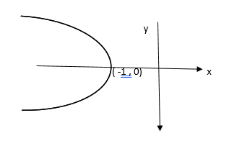

The graph is a parabola that is symmetric about the x – axis. which of the following could be the equation of the parabola?

a) x = -y2 – 1

b) x = - y2 + 1

c) x = - y2

d) x = y2  - 1

e) x = ( y + 1)2

sol:

The parabola is symmetric about the x – axis and it has turned to the left, which means the coefficient of y2 must be negative

so options d and e are out

also the vertex is ( -1 , 0)

if y = 0 then x = -1

This is applicable for choice A

Answer : A

7. g(x) =

In the function above, for what values of x is g(x) a real number?

a)

b)

c)

d)

e)

sol:

for a function to be a real number there cannot be a negative value under root

Or

8.

|  |  |  |  |  |
| --- | --- | --- | --- | --- |
| X | -1 | 0 | 1 | 2 |
| F(x) | 1 | 3 | 1 | -5 |

The table above shows the values of the quadratic function f for several values of x. Which one of the following best represents f?

A) f(x) = - 2x2

B) f(x) = x2 + 3

C) f(x) = - x2 + 3

D) f(x) = - 2x2 – 3

E) f(x) = -2x2 + 3

sol:

when x = 0 for y = 3

this eliminates choice a and d out of b, c, and e

if x = 1 then f(x) = 1

This eliminates choice b and c, ∴ choice E is correct

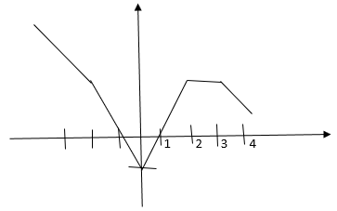

In the function above, if f(k) = 2 then what could be the value of k

a) -1

b) 0

c) 0.5

d) 2.5

e) 4

sol:

f(k) = 2 is called a constant function and a constant function is represented by an horizontal line

The graph is horizontal between the values of x for ∴ For values of K between 2 and 3 inclusive f(k) = 2

ans: d

9. If f(x) = and f(4)- f(1) = 2 and f(4) + f( 1) = 10 find f(3)

a) 1

b) 2

c)

d)

e)

sol:

f(4) =

f(1) =

f(4) – f( 1) = 2a + b – a – b = 2

a = 2

f( 4) + f( 1) = 2a + b + a + b = 10

3a + 2b = 10

3( 2) + 2b = 10

2b = 4

b = 2

f( 3) =

10. At time t = 0, a Projectile was fired upward from an initial height of 10 feet. If the height reached after t secs is given by the function h(t) = p – 10 ( q – t)2 where p and q are positive constants. If the projectile reached a maximum height of 100 feet when t = 3, then what is the height reached in feet of the projectile when t = 4?

a) 62

b) 70

c) 85

d) 90

e) 92

Sol:

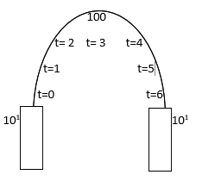

At t = 0 h = 10

h(0) = p -10(q – 0)2 = 10

∴ p – 10q2 = 10 ……………… 1

At t = 3, h = 100

h(3) = p – 10(q-3)2 = 100

(p2 – 10q2) + 60q – 90 = 100

10 + 60 q = 190

60 q = 180

q = 3

substituting in 1

p – 10(3)2 = 10

p – 90 = 10

p = 100

if t = 4 h = ?

h(4) = p – 10 (q – 4)2 = 100 – 10 ( 3 – 4)2 = 100 – 10 = 90 feet

ans: 90 feet

11.

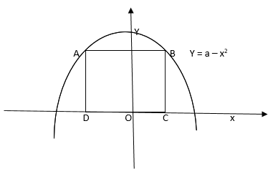

The figure above shows the graphs of y = a – x2 for some positive constant ‘a’. if the square ABCD intersects the graph at points A and B and if the area of square is 16. What is the value of ‘a’?

a) 2

b) 4

c) 6

d) 8

e) 10

sol:

Area of square = 16

∴ side of square =

AD = BC = 4

OC = OD = 2

The co-ordinates of A,B, C, D and A(-2,4) B( 2, 4) C( 2, 0) D( -2 , 0)

A and B are points on the parabola y = a – x2

4 = a – ( = a – 4

a = 8

12. If the function f(x) is defined for all real numbers x as the maximum possible value of (2x +4) on ( 12 + 3x), then for which one of the following values of x will f(x) actually equal(2x + 4) ?

a) -4

b) -5

c) -6

d) -7

e) -9

sol:

Given ( 2x + 4) > ( 12 + 3x)

2x – 3x > 12 – 4

-x > 8

X < - 8 x = -9

13. If f(x) = 2x and g(x) = x3 what is the value of f(g(-3))

a) – 12

b) -24

c) -34

d) -44

e) -54

sol:

f[g( -3)] = f[( -3)3] = f( -27)

= 2( -27) = - 54

14. If f(x) = x – 3 and 2[f(g)] = 14 what is the value of f[4g)?

a) 27

b) 37

c) 41

d) 43

e) 47

sol:

2[f(g)] = 14

F(g) = 7

G – 3 = 7

G = 10

∴ f(4g) = f( 4( 10)) = f(40) = 40 – 3 = 37

15. If f(a, b) = a2b4 and f(m,n) = 5 then what is f(3m, 2n)

a) 120

b) 240

c) 480

d) 720

d) 960

sol:

f(m,n) = m2n4 = 5

f(3m, 2n) = (3m)2 (2n)4= 9m2 x 16n4

( 9 X 6)( m2n4) = 144 x 5 = 720

16. If h( x) = 5x2 + x then h( a +b) = ?

a) 5a2+ 5b2

b) 5a3 + 5b3

c) 5a2+ 5b2 + a + b

d) 5a2+10ab + 5b2

e) 5a2+10ab + 5b2 + a + b

sol:

h(x) = 5a2+ x

h(a + b) = 5( a +b)2 + ( a + )

=5a2+10ab + 5b2 + a + b

17. h( x) = 2x – 1 and g(x) = x2 – 3 if g(m) = 61, what is h(m) if m > 0 ?

a) 5

b) 10

c) 15

d) 20

e) 25

sol:

h(x) = 2x – 1

g(m) = m3 – 3 = 61

m2 = 64

m = 8 , m > 0

h(m) = 2m – 1 = (2 X 8) – 1 = 15

18. If , which of the following must be true? Indicates all such answers

a)

b)

c) The minimum possible value of

sol:

a)

∴ A is true

b)

∴

B is true

c) The minimum values of mod function is ‘zero’

∴ C is also true

19. # x = the square of the number that is 2 less than x. What is the value of #5 - # ( -1)?

a) 0

b) 1

c) -1

d) 2

e) -2

sol:

#x = ( x – 2)2

∴ #5 - # ( -1 ) = ( 5 -2)2 – ( -1 -2) 2 = 32 – (3)2 = 9 – 9 = 0

20. If f(x) = for all integers values of x, then for how many values of x is f(x) undefined?

a) 0

b) 1

c) 2

d) 3

e) > 3

sol:

f(x) =

if x = 0 or x = 1 then f(x) is undefined,

because

1. Under Root we cannot have negative values

2. Division by ‘0’ is not allowed

∴ For 2 values of x, the function f(x) is undefined

21. If f(2a) = 2f(a) and f(6) = 11. Find the value of f(24)

a) 14

b) 24

c) 34

d) 44

e) 54

sol: F(2a) = 2f(a)

∴ f(24) = 2f( 12) and f( 12) = 2f(6)

∴ f(24) = 2 x f( 6) = 4 f( 6) = 4 X 11 = 44

22. The maximum height reached by a ball thrown straight up into the air can be determined by the formula h = - 16t2 + vt + d, where t is the time in secs since it was thrown, V is the initial speed of throw in m feet per sec, d is the height from which the ball is released , and ‘h’ is the height of the ball, t secs after the throw. Two secs after the ball is thrown, how high is the ball reached if it was released at a height of 6 feet and a speed of 80 feet per second

a) 96 feet

b) 100 feet

c) 102 feet

d) 134 feet

e) 230 feet

sol:

h = -16t2 + vt + d

t = 2 , v = 80 , d = 6

h = -16(2)2 + ( 80 X 2) + 6 = - 64 + 166 = 102 feet

23. If then what is the value of f(x + 1)

a)

b) 1

c)

d) 2

e) none

sol:

The given function f(x) is a constant function, which means it is independent of x

∴

24. , what is the value of f( -4)

a) 0

b) -1

c) 1.5

d) 2

e) 3

sol:

=

25. If f(x) = 2x + 2, g(x) = 3x + 3; h(x) = 4x + 4 find f[g(h(x))]

a) 24x + 30

b) 24x + 31

c) 24x + 32

d) 25x + 31

e0 25x + 32

sol:

f[g(h(x))]

= f[g(4x + 4)] = f(3( 4x + 4)]

= f( 12x + 12 + 3) = f( 12x + 15)

f( 12x + 15) = 2( 12x + 15) + 2 = 24x + 30 + 2 = 24x + 32

**Inequalities**

1. If then z ?

Sol:

2.

Column A Column B

X y

Sol:

X = { 10, 11, 12, 13, 14, 15, 16, 17 ,…..} y = { 16, 15, 14, 13, 12, 11, 10, 9…….}

Column A Column B

X y

Ans : D

3. If then x = ?

Sol:

4. If and then what could be the value of x?

Sol:

and x < 0

∴ x + 4 < - 10

X < - 14 Ans: -18

5. If then x could be which of the following values? Indicate all such values?

a 10

b) 20

c) 30

d) 40

e) 50

f) 60

sol:

If x > 0 then x – 30 10

X 40 🡺 40, 50, 60

If x < 0

Then

🡺 10 and 20

Sol:

A, B, D, E, F

6. If and then what is the value of x?

a) -3

b)

c)

d)

e) 3

sol:

Given

Which means x < 0

and x < 0

∴ 3x – 4 = -2x – 6

5x = -2

7. If x + y + z = 0 and z = 8 then which of the following must be true?

a) x <0

b) y < 0

c) x – y < 0

d) z – y < 0

e) x + y < 0

sol:

Given x + y + z = 0

And z = 8

( x + y) should be negative

∴ x + y < o is a must

8.

Column A Column B

P k

Sol:

If both p and k both cannot be positive simultaneously

P > 0 and k < 0

Then p – k > p + k

Cancelling p we get

0 > 2k or k < 0 is true

Column A Column B

p k

Let both p and k be to negative

The p – k > - p + k

2p > 2k or p > k

9. If then which of the following must be true? Indicate all such statements

a)

b) ad < bc

c) ad > bc

sol:

a

∴ is true

b) ad < bc is not true

c) ad > bc is true

10.

Sol:

Both x and y cannot be both positive or negative simultaneously if x > 0 and y < 0

Then xy > x ( -y)

Cancelling x we get

2y > 0 or y > 0

A contradiction

Let x < 0 and y > 0 then -xy > xy

Cancelling y we get

0 > 2x or x < 0 is true

Column A Column B

X < 0 and y > 0 let x = -1 and y = 2

Column A Column B

1 9

Ans : B

11.

! !

-5 -4 -3 -2 -1 0 1 2

The number line above represents which of the following inequalities

a) x < 1

b) – 9 < 3x < 6

c) – 6 < 2x < 2

d) 1 < 2x < 3

sol;

the number lines shows the inequality - 3 to 1 exclusive

-3 < x < 1

Or -6 < 2x < 2

12.

Column A Column B

Z 10

Sol:

Given n > 0 let y > 0

Then min different between y and x is when both x and y are 5

z < y – x

Z < 0

The max different between y and x

Let y = 9 and x = 1

Then z < 9 – 1 z < 8

Column A Column B

Z 10

Ans : B

13. For all integer values of p such that , the function f(p) = p2

Column A Column B

f(p) for the greatest value of p f(p) for the least value of p

sol:

, p is an integer

P = { 2, 3, 4, 5, or -2, -3, -4, -5 }

Column A Column B

F(p) for greatest p f(p) for least p

When p = 5 When p = -5

F(p) = 52 = 25 f(p) = (-5)2 = 25

Ans : C

14. Which of the following inequalities is equivalent to

a) m < 5

b) m < 1

c) -5 < m < 5

d) m > -1

e) – 5 < m < 1

sol:

If m > 0 then m + 2 < 3, m < 1

If m < 0 then m + 2 > -3 , m > -5

Ans : -5 < m < 1

15. In the figure, an equilateral triangle is inscribed in a circle. If the arc bounded by adjacent corners of the triangle is between and long, which of the following could be the diameter of the circle

a) 6.5

b) 9

c) 12.9

d) 15

e) 22

sol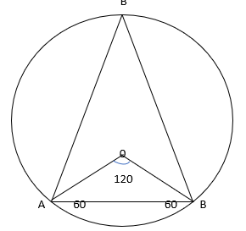

ABC is an equilateral triangle

∴

Let

2r = 12

Let

2r = 18

∴ 12< d < 18

d= 15

16. Solve

Column A Column B

X 9

Sol:

If x > 0

5x – 30 = 15

5x = 45

X = 9

If x< 0

5x – 30 = -15

5x = 15

X = 3

Column A Column B

X = 3 or 9 9

Ans : D

17. Solve

Sol:

18.

Column A Column B

Greatest value greatest value of

If x > 0 if y > 0

Then x + 7 = 13

X = 6 y = 4SS

If x < 0 if y < 0

Then x + 7 = -13

X = -20 y = -4

Column A Column B

Greatest value f(x) = 20 greatest value f(y) = 4

19. both x and y are integers

Column A Column A

Greatest value of x greatest value of y

For x to be maximum, y should be minimum

X = 20 y = 1

For y to be maximum, x should be minimum

Y = 400 , x = 1 Ans : B

20. If

Column A Column B

-x

Sol:

If x > 0 then x3 < 343

∴ x < 34 let x = 33

If x < 0 then x3 < -343

∴ x < -34 let x = -33

Column A Column B

If x > 0 -33 -

-33 - 33 equal

Column A Column B

If x < 0 -(-33)

= 33 A > B

21. and xy2 < 0

Column A Column B

X y

Sol:

Given xy2 < 0

X < 0

But y can be positive or negative

Ans: D

22. 3y – 4.5 > -11

Sol:

3y > -11 + 4.5

3y > - 6.5

Ans: d

23. what is the least integer ‘n’

Sol;

The least integer value of n is 13

24. If x, y, z are positive integers and x < y < z which of the following must be true

a) x + y > z

b) z – y > z

c) z >

d) x + y < z

e) xy > z

sol:

x, y, z are positive integers and x < y < z

let x = 1 y = 2 and z = 3

then is always true

ans: c

25. If and 5 < y < 6 then which of the following best describe ( x – y)

a) 0 < x – y < 8

b) 5 < x – y < - 8

c) -2 < x – y < 5

d) 4 < x – y < 5

e) – 10 < x – yy < -5

sol:

4 < x < 10 …………………. 1

5 < y < 6 ………………….. 2

Step 1 : reverse equation 2

Step 2 : Multiply the result in step 1 by -1

Step 3 : Add this result with equation 1

6> y > 5

-6 < -y < - 5

4 < x < 10

-2 < x – y < 5

26. if ab2c < 0 then which of the following is true?

a) ac < 0

b) c < 0

c) abc < 0

sol:

Given ab2c < 0

Since b2 is always positive

ac < 0 must be true

27.

2x > 3y

Column A Column B

4x + 12y 8x + 6y

Sol:

Column A Column B

4x + 6y + 6y 4x + 4x + 6y

6y 4x

3y 2x

Ans : A

28. 1 < a < 3

Column A Column B

a2  2a

sol:

let a = 1.5

then a2 = 2.25 and 2a = 2(1.5) = 3 A < B

let a = 2

then a2 = 4 and 2a = 2 x 2 = 4 , A = B

let a = 2.5

then a2 = 6.25 and 2 x 2.5 = 5 , A > B

ans : D

29. a > b > 0

Column A Column B

Let a = 2 and b = 1

Column A Column B

=

Ans : B

30. and b2 = 25

d2b = -17

Column A Column B

C a

Sol:

d2b = -17

b < 0 and b2 = 25 => b = -5

∴ a < - 30

b = -5

C > 45

Column A Column B

c a

Ans: A

31. If then the sum of all possible solutions of the equation

Sol:

Let

Then a2 – 10a – 24 = 0

( a – 12) ( a + 2) = 0

a = 12 or a = -2

is not possible

∴

If x > 0 then x + 4 = 12

X = 8

If x < 0 then x + 4 = -12

X = -16

Sum of solutions = 8 – 16 = -8

32. Column A Column B

( a + 5)( 4a + 2) ( 4a + 5) (a + 2)

a > 0

Sol:

Let a = 1

Column A Column B

( 1 + 5) ( 4 +2 ) ( 4 + 5) ( 1 + 2)

6 x 6 = 36 9 x 3 = 27

Ans: A

33. what value of x satisfies the equation?

a) 0

b) -1

c) 1

d) 2

e) -2

sol:

X3 + x = 0

X( x2 + 1) = 0

X = 0 or x2 = -1

X2 is always positive

Ans: x = 0

34. If then x = ?

a) 1

b) 2

c) 3

d) 4

e) 5

sol:

let x = 1

then

and

ans: A

35. For which value of x is indicate all possible value of x

a) 10

b) 11

c) 12

d) 13

e) 14

f) 15

g) 16

sol:

15x < x2 + 2x

X2 – 13x > 0

X( x – 13) > 0

X > 0 or x > 13

From the choices we can select e, f, and g

**Permutation**

Suppose there are ‘n’ objects, then the arrangement of ‘r’ of these objects ( ) in order is called the permutation of these ‘n’ objects taken ‘r’ at a time and it is denoted by and is defined as

The arrangement of these letters a, b, c taken 2 at a time = 3ways

ab, ba, bc, cb, ac, ca

n! = n(n-1) (n -2) ……..3. 2 . 1

0! = 1 1! = 1 , 2! = 2 , 3! = 6

4! = 24, 5! = 120 , 6! = 720, 7! = 5040

Linear arrangement:

The number of arrangements of ‘n’ persons in a row of ‘n’ seats = nPn

Let n = 4 and let the n of persons be 4

P1P2P3P4

The (P1) first person has 4 ( choices) options to sit, then the (P2) second person has 3 options, the (P3) third person has 2 and the last person (P4) has one choice.

Which amounts to 4!

Circular arrangements:

The number of arrangements of ‘n’ persons around a circular table = (n – 1)!, when the clock -wise and the anti – clockwise arrangements are different

Let n = 3 a, b, c

Then the three letters can be arranged in 2 ways 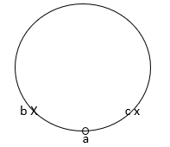

2! = (3 -1 )!

If the clockwise and the anti – clock wise arrangements are not different like in cases of flowers or beads of the same colour and size, the no of arrangement = !

Example: Mr. Ambani invites 9 businessmen for a business meeting, the invites are made to sit around a circular table. Find the no of arrangements such that Mr. Mahindra And Mr. Sahara are one either side of the host Mr. Ambani

Sol:

HOST = 1

GUESTS = 9

Total = 10 person

Mahi ,Saha x x Saha, Mahi

x Amba

Out of 10 persons, 3 are accounted for the remaining 7 persons can be arranged in 7! Ways

The total n of arrangements = 2 x 7! = 2 X 5040 = 10080

Permutation of like objects:

Suppose there are ‘n’ objects of which ‘p’ are alike in one way, ‘q’ are alike in another way and ‘r’ are alike in yet another way, then the no of arrangement of these ‘n’ objects

= where n = p + q + r

1. The no of different signals that can be made rom 5 identical Red flag, 4 identical Yellow flags and 3 identical Green flags

Total 5 + 4 + 3 = 12

2. The number of ways in which a father can distribute 9 toys among his four children such that the youngest gets 3 toys and the ret get 2 toys each

3. How many different 5 letter words can be made from the word B O B B Y

B E N Z E N E

E N G I N E E R I N G

4. Find the total number of arrangements of the letters of the word B H A R A T

a) In how many ways BH are together

b) In how many ways BH are NOT together

1. B H A R A T

2. BHARAT

3. BH are not together n = Total – BH together = 360 – 120 = 240

Exercise:

1. Find n if nP3 = 1320

nP3 = 1320 = 10 x 132 = 10 x 11 x 12

2. Find the number of 4 digit numbers that can be formed using the digits 1,2,4,5,7,8 when repetition is allowed?

Sol:

1, 2, 4, 5, 7, 8

n = 6 x 6 x 6 x 6 = 1296

3. Find the number of ways of arranging the letters of the word ORGANIC so that

a) all the vowels are together

b) No two vowels come together

sol:

ORGANIC

a) Total number of arrangements = 7! = 5040

b) Vowels together ORGANIC n = 5! X 3! = 120 x 6 = 720

c) Vowels not together = Total – Vowels together = 5040 – 720 = 4320

4. How many numbers of 4 digits can be formed from (0,1,2,3,5,6) if no digit is to occur more than once in each number ? How many of these are divisible by 2?

Sol:

0,1, 2, 3, 5, 6

n = 2 x 4 x 5 x 6 = 240

even numbers (DIVISIBLE BY 2)

n = 2 x 4 x 5 x 3 = 120

5. Find the number of ways of arranging 10 boys B1 B2 B3 B4 ………… Bn in a row such that B1 ,B2, B3,

a) Sit together

b) Sit together in a specified order

sol:

B1 B2 B3 B4 ………… B10

a) B1 B2 B3 sit together

B1 B2 B3 = 3 persons and B4 to B10  = 7 persons

n =8! X 3!

b) B1 B2 B3  sit together in a specified order

B1 B2 B3 = 1 B4 to B10  = 7

n= 8! X 3!

6. Find the number of different ways in which 4 boys and 6 girls may be arranged in a row so that two boys shall be together.

Sol:

B1 B2 B3 B4 G1  to G6

B1 B2

n= 91 x 2!

7. . Find the number of 5 digited numbers that can be formed using 0, 1, 2, 3, 4, 5 that are divisible by 5 when repetition is allowed?

Sol:

0, 1, 2, 3, 4, 5

n = 5 x 6 x 6 x 6 x 2 = 2160

8. Find the number of numbers less than 2000 that can be formed using the digits 1, 2, 3, 4 if repetition is allowed?

Sol:

1, 2, 3, 4

Number < 2000 in value

Single digit number = 4 = 4

Two digit number = 4 x 4 = 16

Three digit number = 4 x 4 x 4 = 64

Four digit number = 1 x 4 x 4 x 4 = 64

Total = 148 numbers

9. Find the number of ways of arranging 6 boys and 5 girls in a row so that

a) all the girls sit together

b) No two girls sit together

c) Boys and Girls sit alternately

d) No two boys sit together

sol:

6 boys , 5 girls

a) all girls sit together n = 7! X 5!

b) No two girls sit together

b1 b2 b3 b4 b5  b6

1 2 3 4 5 6 7

N = 6! X 7P5

c) Boys and Girls sit alternately

b1 g1 b2 g2 b3 g3 b4 g4 b5 g5 b6 g6

n = 6! X 5!

d) No two boys sit together

b1 g1 b2 g2 b3 g3 b4 g4 b5 g5 b6 g6

n = 6! X 5!

10. Find the sum of all numbers formed by taking all the digits from (2,3,4, 5)

Sol:

Sum of all the numbers formed by taking all the digits from 2,3,4,5

Sum = ( n – 1)! ( Sum of digits) (1111 …………. n times)

= ( 4 – 1) ! ( 2 + 3+ 4 + 5 ) ( 1111)

= 3! X 14 x 1111 = 84 x 1111 = 93324

11. How many different arrangements can be made out of the letters MISSISSIPI?

Sol:

MISSISSIPI

12. In how many ways can the letters of the expression P2 q3 r4 be arranged when written at full length

Sol:

Total = 2 + 3 + 4 = 9

13. How many numbers can be formed using all the digits 1, 2, 3, 4, 3, 2, 1 such that even digits occupy even places only

Sol:

1 **2** 3 **4** 5 **6** 7

1 2 3 4 3 2 1

14. In how many ways can 7 students sit around the table?

Sol;

7 students can be arranged around a circular table = 6!

13. In how many ways can 7 men and 4 women be arranged around a circular table if no two woman sit together?

n = 6! 7P4

16. In how many ways can 7 differently coloured beads be strung on necklace

Sol:

The number of ways 7 differently coloured beads be strung on a necklace n = 6!

17. Find n if (a) nC4 = 210 (b) 10 (nC2) = 3( n + 1C3)

c) nC21 = nC27

sol:

a)

5040 = 10 x 9 x 8 x 7

n = 10

b) 10 (nC2) = 3( n + 1C3)

n + 1 = 10

n = 9

c) nC21 = nC27

n = 21 + 27 = 48

( nCr = nCn – r)

18. A polygon has 44 diagonals. Find the number of its sides

Sol:

A polygon has 44 diagonals

Number of diagonals of a polygon

n( n -3) = 88

88 = 11 x 8

n = 11

19. How many triangles can be formed by joining the vertices of a hexagon

Sol;

Number of triangles formed by joining the vertices of an hexagon = nC3 = 6C3 = 20

20. In how many ways can a pack of 52 cards be divided equally among 4 players in order, to form into 4 groups of 13 cards each divided into 4 sets of three of them having 17 cards each and the fourth just one card?

Sol:

n = 52C17 x 35C17 x 18C17 x 1C1

S21. Find the number of factors of 2160?

Number of factors of 2160

Step 1: Break the number into product of its prime factors

Step 2 : Express them in index form

Step 3: Increase the indices by 1 and multiply

2160 = 10 x 216

= 10 x 6 x 6 x 6

= 2 x 5 x 2 x 3 x 2 x 3 x 2 x 3

= 24 x 33 x 51

nf(2160) = 5 x 4 x 2 = 40

22. Find the number of divisors of 4200 excluding 1 and 4200

Sol;

Number of factors of 4200 excluding 1 and the number it self

4200 = 42 x 100 = 6 x 7 x 4 x 25

= 2 x 3 x 2 x 2 x 5 x 5 x 7 = 23 x 52 x 31 x 71

Number of factor = 4 x 3 x 2 x 2 = 48

The required number of factors = 48 – 2 = 46

23. In a workshop there are 4 kinds of beds, 3 kinds of closets, 2 kinds of shelves and 7 kinds of chairs. In how many ways can a person decorate his room if he wants to buy in the workshop one shelf, one bed and one of the following: a chair or a closet?

A) 168

b) 16

c) 80

d) 48

e) 56

sol:

Beds Closets Shelves Chairs

4 3 2 7

n = (4C1 x 2C1) (3C1 + 7C1) = ( 4 x 2) ( 3 + 7) = 8 x 10 = 80

24. Three people are to be seated on a bench. How many different sitting arrangements are possible if Erik must sit next to Joe?

a) 2

b) 4

c) 6

d) 8

e) 10

sol:

J E __

E J __

__ E J

__ J E

There are 4 ways

25. How many 3 -digit numbers satisfy the following conditions: the first digit is different from zero and the other digits are different from each other ?

648

b) 504

c) 576

d) 810

e) 672

sol;

n = 9 x 9 x 8 = 648 numbers

26 . Barbara has 8 shirts and 9 pants. How many clothing combinations does Barbara have, if she doesn’t wear 2 specific shirts with 3 specific pants?

a) 41

b) 66

c) 36

d) 70

e) 56

sol;

Shirts Pants

8 – 2 = 6 9 – 3 = 6

Number of combinations = 6 x 6 = 36

27. A credit card number has 6 digits (between 1 to 9). The first two digits are 1 and 2 in that order, the third digit is bigger than 6, the forth is divisible by 3 and the fifth digit is 3 times the sixth. How many different credit card numbers exist?

a) 27

b) 36

c) 72

d) 112

e) 422

Sol:

n = 1 x 1 x 3 x 3 x 1 x 3 = 27 cards

28. In how many ways can you sit 8 people on a bench if 3 of them must sit together?

a) 720

b) 2,160

c) 2,400

d) 4,320

e) 40,320

sol:

P1 P2 P3 P4 to P8

n = 6! X 3! = 720 x 6 = 4320 ways

29. In how many ways can you sit 7 people on a bench if Suzan won’t sit on the middle seat or on either end?

a) 720

b) 1720

c) 2880

d) 5040

e) 10080

sol:

n = _!_ x __ x __ x _!_ x __ x __ x _!_

Susan won’t sit in the middle or on either end

She has 4 places to choose

n = 4C1 x 6! = 4 x 720 = 2880

30. In a jar there are 15 white balls, 25 red balls, 10 blue balls and 20 green balls. How many balls must be taken out in order to make sure we took out 8 of the same colour?

a) 8

b) 23

c) 29

d) 32

e) 53

sol:

White Red Blue Green Total

15 25 10 20

7 7 7 7 28

+ 1

29

∴ 29 balls must be taken out

31. In a jar there are 21 White balls, 24 Green balls and 32 Blue balls. How many balls must be taken out in order to make sure we have 23 balls of the same colour?

a) 23

b) 6

c) 57

d) 66

e) 67

sol:

White Green Blue Total

21 24 32

21 22 22 65

+ 1

66

66 balls must be taken out

32. How many 8 letter words can be created using computer language (0/1 only)?

a) 16

b) 64

c) 128

d) 256

e) 512

sol:

0 and 1

n = 2 x 2 x 2 x 2 x 2 x 2 x 2 x 2 = 28 = 256

33. Ruth wants to choose 4 books to take with her on a camping trip. If Ruth has a total of 11 books to choose from, how many different book quarters are possible?

a) 28

b) 44

c) 110

d) 210

e) 330

sol:

n = 11C4 = number

**Combinations**

1.Suppose there are ‘n’ objects, then the selection of any ‘r’ of these objects (r is called the combination of these ‘n’ objects taken ‘r’ at a time and it is denoted by nCr  and is defined as

=

2. The number of combinations of 3 letters a, b, c taken 2 at a time = ways : ab, bc, ca

∴

8 + 7 = 15

58 + 2 = 60

∴ If then n = 23 + 25 = 48

If n is odd if n is even

Let n = 5 let n = 6

5C0 = 1 6C0 = 1

5C1= 5 6C1 = 6

5C2 = 10 6C2 = 15

5C2 = 5C3= 10 6C3 = 20

5C1 = 5C4 = 5 6C4 = 6C2 = 15

5C0 = 5C5 = 1 6C6 = 6C0 = 1

If n is even, then nCr is maximum for

3. There are 3posts and these are 6 applicants. In how many ways can the posts be filled?

Sol:

There are 6 persons and 3 posts then the 1st post can be filled by any one of the 6 persons and the 2nd post by any one of the 5 persons and the 3rd post by anyone of the 4 persons.

∴ it is 6P3

n= 6P3 = 6 X 5 X 4 = 120 ways

4. There are 20 teachers in a school in how many ways can a Principal and a Vice Principal be selected?

Sol:

n = 20C1 X 19 C 1 = 20 X 19 = 380

from 20 teachers we can select principal in 20 ways after that there will be only 19 teachers to select a vice principal. This is done in 19 ways

∴ Total = 20 X 19 = 380 ways

**COUNTING PRINCIPLES**

1. Addition Principle:

Suppose an event E can occur in ‘m’ ways and another event F can occur in ‘n’ ways and

suppose events E and F cannot occur simultaneously, then the number of ways in which either event E or F can occur = m + n ways.

Example :

The number of ways in which a student can choose a professor from 7 male professors

And 5 female professors = 7 + 5 = 12 ways.

2. Product principle:

Suppose an event E can occur in ‘m’ ways and independent of this event another event F

Can occur in ‘n’ ways then the number of ways in which events E and F can occur = mn ways.

Example:

The number of ways in which a man can choose a shirt and a tie , if has 15 shirts and 20 ties

= 15 x 20 = 300 ways.

* How many 3 digit odd numbers can be formed from the digits 1,2,3,4,5 and6
* If (a) repetition of digits is allowed
* (b) repetition of digits is not allowed

There are 3 odd numbers in the given set of numbers

(a) when repetition is allowed

n = 6x6x3 = 108 numbers

(b ) when repetition is not allowed

N = 4x5x3 = 60 numbers

* How many different 5digit numbers divisible by 10 can be formed from the digits

1,2,5,7,0, and 9.

We need 5digit numbers divisible by 10 when repetition of digits is not allowed

n = 2x3x4x5x1 = 120 numbers.

1. How many three digit Palindrome number are there?

a) 50

b) 70

c) 90

d) 100

e) none

sol:

Palindrome words

M UM

DAD

MADAM

RACE CARE

MALAYALAM

Three digit Palindrome numbers are

101 202 ……………………………………………………… 909

111 212 ……………………………………………………… 919

10 121 222 ……………………………………………………… 929

. . .

. . .

. . .

. . .

191 292 999

10 10 10

Total three digit Palindrome numbers are = 9X 10 = 90

**Probability**

Probability is the study of ‘Uncertainties’

A random experiment is an experiment conducted any number of times, under essential and identical the result or the out come of which is ‘Uncertain’.

Ex:- Tossing of a coin

The occurrence of Head or Tail is called an event

**Types of events**

**1. Equally likely events**

When all the events having equal chances of occurring

There is no reason why a particular event occurs more number of times

2. **Mutually exclusive events**

when the occurrence of one event, prevents the occurrence of another event

ex:- Head prevents Tail

3. **Independent events**

when the occurrence of one event, does not prevent the occur of another event

ex:- Pulling of Queen of Hearts from a deck of cards

Q – a letter card

Heart - a design

Colour – Red

All the three events occur together and one does not prevent the other

**Addition Theorem of Probability**

If A and B are two events then P( A U B) = P(A) + P(B) - P(A n B)

If events A and B are mutually exclusive then P( A n B) = 0

∴ P (A U B) = P ( A) + P ( B)

If A and B are independent then P (A n B) = P ( A) x P ( B)

1. If P(A) = 0.5 , P (B) = 0.4 find P(A U B)

If 1. Event A and B are mutually exclusive

2. Event A and B are independent

Sol:

1. P ( A n B) = 0

P( A U B) = P (A) + P(B) = 0.5 + 0.4 = 0.9

2. P(A n B) = P(A) X P(B) = 0.5 x 0.4 = 0.2

P(AUB) = P(A) + P(B) – P(A n B) = o.5 + 0.4 – 0.2 = 0.7

**Definition of Probability**

if the ‘probability’ of the event ‘E’ occurring is denoted by P(E) then the ‘Probability’ of the event ‘E’ not occurring is denoted by then P(E) +

P(E) = 1 -

Probability of an event ‘E’ occurring =

Total no of events = sample space

∴

If P(E) = 1 then the event is certain and for an impossible event P(E) = 0

**Odds in favour ratio:**

P(E) : P

**Odds against ratio**

then odds in favour ratio = 5 : 7

and odds against ratio = 7: 5

1. A coin is tossed 3 times Find the odds against ratio for getting a Head at least once

Sol:

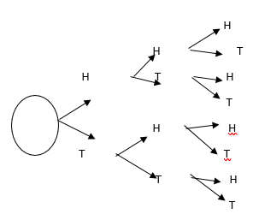

H H H T H H

H H T T H T

H T H T T H

H T T T T T

P : P (E) = 1 : 7

**Conditional Probability**

The probability for the event B to occur given that event A has already occurred is called the conditional P for B given A and it is denoted by P(B/A) and is defined as

Two dice are thrown simultaneously once and the sum of numbers appearing on top is observed. Find the P for one of the dice to be a 2 given their sum is 6.

The no of events = 6 2 =  6 X 6 = 36

(1,1) (1,2) (1,3) (1,4) (1,5) (1,6)

(2,1) (2,2) (2,3) (2,4) (2,5) (2,6)

(3,1) (3,2) (3,3) (3,4) (3,5) (3,6)

(4,1) (4,2) (4,3) (4,4) (4,5) (4,6)

(5,1) (5,2) (5,3) (5,4) (5,5) (5,6)

(6,1) (6,2) (6,3) (6,4) (6,5) (6,6)

Let A = {Sum is 6}

= {(5,1) (4,2) (3,3) (2,4)(1,5)}

B = { one of the dice is a 2}

= {(1,2) (2,2)(2,3) (2,4) (2,5)(2,6) (1,2) (3,2) (4,2) (5,2) (6,2)}

PLAYING CARDS

Spades, Hearts, Diamonds, Clubs

Black), (Red), ( Red) , ( Black)

A x x x x

Q x x x x

K x x x x

J x x x x

10 x x x x

9 x x x x

8 x x x x

7 x x x x

6 x x x x

5 x x x x

4 x x x x

3 x x x x

2 x x x x

AKQJ are called Court Cards. KQJ are called face cards. 10 to 2 are called Number Cards.

Let A = {face card}

B = { Hearts}

Find P(A), P(B), P(AnB) and P(AUB)

P(A) =

P(B) =

P(AUB) =

P(AUB) = P(A) + P(B) – P(AnB) =

1. In a single throw with two dice find the probability of throwing a sum (i) 10 (ii) which is a perfect square.

Sol: In (i) Sum 10 { (5,5) (4,6) and (6,4)}

P(E) =

(ii) Perfect square

4, 9 Sum = 4 {(2,2) (3,1) (1,3)} Sum = 9 {(6,3) (3,6) (4,5) and (5,4)}

P(E) = 7/36

2. A box contains 19 screws, 3 of which are defective. Two screws are drawn from the box at random with replacement. Find the probability that neither of the 2 screws is defective.

Sol:

Total 19 Screws

Defective = 3

Non – defective = 19 – 3 = 16

With replacement

P(E)=

3. What is the probability that a card drawn at random from the pack of playing cards may be either a queen or a king?

Sol:

Cards P(K U Q) = P(K) + P(Q)

=

4. A bag contains 4 green, 6 black and 7 white balls. A ball is drawn at random. What is the probability that it is either a green or a black ball?

Sol:

G B W Total

4 6 7 17

P(G U B) =

5. From a city 3 newspapers A,B,C are being published. A is read by 20% , B is read by 16%, C is read by 14%, both A and B are read by 8%, both A and C are read by 5%, both B and C are read by 4% and all the three A,B,C are read by 2%. What is the percentage of the population that read at least one newspaper.

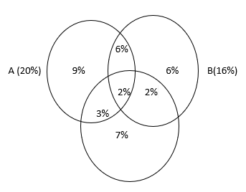

C (14%)

n(A n B) = 8%

n(B n C) = 4%

n(C n A) = 5%

% of population reading at least one paper = 20 + 6 +2 +7 = 35%

6. Three bags A,B,C contain balls as given below. Bag A:2 white, 2 red, 1 Black, Bag B:3 White , 4 red, 2 Black, Bag C: 4 white, 2 red, 3 black. A die is thrown. If either 1 or 2 turns up bag A is chosen; if either 3 or 4 turns up bag B is chosen and if either 5 or 6 turns up bag C is chosen. Of the bags, a bag is selected and from it a ball is chosen at random. If the ball is red, find the probability that it is from bag B?

Sol: W R B Total

Bag A : 2 2 1 5

Bag B : 3 4 2 9

Bag C: 4 2 3 9

P(E) =

7. A bag A1 contains 2 white and 3 red balls and a bag B1 contains 4 white and 5 red balls. One ball is drawn at random, from one of the bags and it is found to be red. Find the probability that the red ball drawn is from bag B1?

Sol: W R Total

Bag A1 : 2 3 5

Bag B1: 4 5 9

P(E)=

8. In jar A there are 3 white balls and 2 green ones, in jar B there is one white ball and three green ones. A jar is randomly picked, what is the probability of picking up a white ball out of jar A?

a)

b)

c)

d)

e)

Sol: W G Total

A : 3 2 5

B : 1 3 4

P(E) =

9. Out of a box that contains 4 black and 6 white mice, three are randomly chosen. What is the probability that all three will be black?

a)

b)

c)

d)

e)

sol:

4 Black mice

6 white Mice

Total 10 mice

3 mice are chosen random

P(E) =

10. Danny, Doris and Dolly flipped a coin 5 times and each time the coin landed on “heads”. Dolly bet that on the sixth time the coin will land on “tails”, what is the probability that she’s right?

Sol:

Getting a head or tail is a chance

∴ probability of Dolly winning =

11. In a deck of cards there are 52 cards numbered from 1 to 13. There are 4 cards of each number in the deck. If you insert 12 more cards with the number 10 on them and you shuffle the deck really good, what is the probability to pull out a card with a number 10 on it?

a)

b)

c)

d)

e)

Sol:

Total of cards 52

1 2 3 4 ……………. 10 11 12 13

1 2 10 13

1 2 10 13

1 2 10 13

12 more 10 number card are inserted

Total 4 X 13 = 52

Total no of cards = 52 + 12 = 64

Total of 10 numbered cards = 4 + 12 = 16

P(E) =

12. There are 18 balls in a jar. You take out 3 blue balls without putting them back inside, and now the probability of pulling out a blue ball is . How many blue balls were there in the beginning?

a) 9

b) 8

c) 7

d) 12

e) 6

Sol:

Total 18 balls

3 blue balls are taken remaining balls = 18 – 3 = 15

P(Blue) = = 3

Total no of Blue balls are 3 + 3 = 6

13. In a box there are A green balls, 3A + 6 red balls and 2 yellow ones. If there are no other colours, what is the probability of taking out a green or yellow ball?

a)

b)

c)

d)

e)

Sol:

G R Y Total

A (3A +6) 2 4A + 8

P(G U Y) =

14. The probability of Sam passing the exam is . The probability of Sam passing the exam and Michael passing the driving test is . What is the probability of Michael passing his driving test?

a)

b)

c)

d)

e)

sol:

P(S) = , P( S n M) =

P(M) = ?

P(S n M) = P(S) x P(M)

Since the events are independent

P(M) =

15. Two dice are rolled. What is the probability the sum will be greater than 10?

a)

b)

c)

d)

e)

sol:

Two dice are rolled P( > 10) =

16. The probability of having a girl is identical to the probability of having a boy. In a family with three children, what is the probability that all the children are of the same gender?

Sol:

Probability of getting a boy or girl =

Probability are of them are of the same gender =

17. On one side of a coin there is the number 0 and on the other side the number 1. What is the probability that the sum of three coin tosses will be?

a)

b)

c)

d)

e)

Sol:

One side of coin has 0 and the other side has 1

I II III Total

0 1 1 2

1 0 1 2

1 1 0 2

P(Sum is 2) =

18. In a jar there are balls in different colours: blue, red, green and yellow. The probability of drawing a blue ball is . The probability of drawing a red ball is The probability of drawing a green ball is . If a jar cannot contain more than 50 balls, how many yellow balls are in the jar?

a) 23

b) 20

c) 24

d) 17

e) 25

B R G Y Total

P(B) = P(R) = , P(G) = ?

Total no of balls 50

The LCM of 8, 5, and 10 = 40

∴ Total no of balls are ‘40’

The number of : Blue Balls =

: Red Balls=

: Green Balls =

Total : 17

The no of Yellow Balls = 40 – 17 = 23

19. In a jar there are 3 red balls and 2 blue balls. What is the probability of drawing at least one red ball when drawing two consecutive balls randomly?

a)

b)

c)

d)

e)

Sol:

R B Total

3 2 5

P(At least 1 Red Ball) = 1- P( Blue Ball) = 1-

20. What is the probability of getting a sum of 12 when rolling 3 dice simultaneously?

a)

b)

c)

d)

e)

sol:

Sum = 12

D1 D2 D3

6 ways 1 5 6

3 ways 2 5 5

6 ways 2 4 6

6 ways 3 4 5

1 ways 4 4 4

3 ways 3 3 6

P(E) =

21. What is the probability of getting a sum of 8 or 14 when rolling 3 dice simultaneously?

a)

b)

c)

d)

e)

sol:

Sum = 8

D1 D2 D3

6 ways 1 2 5

6 ways 1 3 4

3 ways 2 2 4

3 ways 2 3 3

3 ways 1 1 6

21

Sum = 14

D1 D2 D3

3 2 6 6

6 3 5 6

3 4 4 6

3 4 5 5

15

P(E) =

22. A six sided dice with faces numbered 1 thru 6 is rolled twice. What is the probability that the face with number 2 on it would not be facing upward on either roll?

a)

b) 2/3

c)

d)

e)

Sol:

6 sided dice is thrown

P(2) =

P(E)=

**Statistics**

The actual study of statistics involves

Four steps : 1. Collection of data

2. Classification of data

3. Analysis of data

4. Interpretation of data

But GRE is concerned about the measures of central tendencies only.

There are three measures

1. Mean 2. Median 3. Mode

**1. Mean:**

Mean is the arithmetic mean or Average which is sum of observations by number of observation.

If is the mean of x1, x2, x3 ------ xn then

Mean of a frequency distribution

Find

|  |  |  |  |  |  |
| --- | --- | --- | --- | --- | --- |
| x | 2 | 4 | 6 | 8 | 10 |
| F | 11 | 9 | 7 | 5 | 3 |
| fx | 22 | 36 | 42 | 40 | 30 |

2. Find the missing frequencies f1 and f2 if

|  |  |  |  |  |  |  |  |  |
| --- | --- | --- | --- | --- | --- | --- | --- | --- |
| X | 19 | 21 | 23 | 25 | 27 | 29 | 31 | Total |
| f | 13 | 15 | F1 | F2 | 16 | 15 | 13 | 108 |
|  |  |  | 16 |  |  |  |  |  |

We can observe that the variables are normally distributed and the frequencies are also repeating.

Sum frequencies = 28 + f1 + f2 + 16 + 28 = 108

F1 + f2  + 72 = 108

F1 + f2 = 36 also the frequencies are repeating

∴ f1 = 16 🡺 f2 = 20

**Mean of a grouped frequency distribution:**

Mean =

A = Assumed mean

d1 = d/i

d = ( x – a)

x = Class marks = (Upper limit + Lower limit)

= Class size

Find let A = 25

|  |  |  |  |  |  |
| --- | --- | --- | --- | --- | --- |
| CI | f | x | d= x - A |  | Fd1 |
| 0 – 10 | 9 | 5 | -20 | -2 | -18 |
| 10 – 20 | 11 | 15 | -10 | -1 | -11 |
| 20 – 30 | 13 | 25 | 0 | 0 | 0 |
| 30 – 40 | 17 | 35 | +10 | +1 | +17 |
| 40 - 50 | 20 | 45 | +20 | +2 | +40 |

x 10

Also we can find the mean by using

**Median:**

Median is the middle most observation after arranging the values in an ascending or descending order

1. Find median of 8, -3, 0, 5, 2, 1, 6

🡪 -3,0,1,2,5,6,8

Median = 2

Given number of observations are 7 and median = 4th value

th value = th value

∴ if n is odd then median = value

2. Find the median of 5, 1, -7, 2, 8, 10

🡪 -7 , 1, 2, 5, 8, 10

Median =

Given number of observations are 6 ( even) and median = values

= values

∴ if n is even then median = values

3. Find median of

|  |  |  |  |  |  |
| --- | --- | --- | --- | --- | --- |
| X | 3 | 5 | 7 | 9 | 11 |
| f | 10 | 8 | 6 | 4 | 2 |

We have to find the total number of observations

∴ N = cf = Cumulative frequency  
we find the total n of observation by column addition

|  |  |  |  |  |  |
| --- | --- | --- | --- | --- | --- |
| x | 3 | 5 | 7 | 9 | 11 |
| f | 10 | 8 | 6 | 4 | 2 |
| cf | 10 | 18 | 24 | 28 | 30 |

N = cf = 30 (even)

Median = value = = 5

**Median of a grouped frequency distribution**

Median =

L = Lower limit of median class

N = cf

M = cf of the class just above median class

F = frequency of median class

I = class size

4. find median of

|  |  |  |
| --- | --- | --- |
| CI | f | Cf |
| 0 - 10 | 3 | 3 |
| 10 - 20 | 6 | 9 |
| 20 – 30 | 5 | 14 -🡪 m |
| 30 - 40 | 8 🡪 f | 22 (median Class) |
| 40 - 50 | 7 | 29 |

N = 29 odd

Median = value

Median =

Median = 30.625

**Mode :**

Mode is the most of ten occurring observation

Mode of 1,3,2,3,4,3 is 3

* If two observations occur the same number of times, then it is BI – MODAL
* If each observation occurs the same number of times, then ‘there is NO MODE ‘

**mode of a grouped frequency distribution**

mode=

l = lower limit of the modal class

= f – f1 and = f – f2

F = frequency of the modal class

F1 = frequency of the class just above the modal class

F2 = frequency of the class just below modal class

I = class size

1. Find mode of

|  |  |
| --- | --- |
| cf | F |
| 0 - 10 | 3 |
| 10 - 20 | 5 |
| 20 - 30 | 10 – f1 |
| 30 - 40 | 20 – f (modal class) |
| 40 - 50 | 15 – f2 |

Modal class is 30 to 40 f = 20 l = 30

**Standard Deviation ‘’ :**

Find of 1, 2, 3, 4, 5

Step 1 : find : 3

Step 2 : find (x - : 1 – 3, 2 -3, 3 -3, 4 -3, 5 -3, = -2, -1, 0 , +1, +2

Step 3: find : 4, 1, 0, 1, 4

Step 4: find = 10

Step 5: find

Step 6 : find

* If of 1,2, 3, 4, 5 is then
* of 51, 52, 53, 54,55 is also

**Note:**  if the observations are in A.P then

where ‘n’ is the number of observations

d = Common difference

51, 52,53,5 4,55 are in A. P

d= 1 n = 5

NOTE : By adding or subtracting a constant to (from) each term the ’ remains unchanged

* If of 1,2,3,4,5 is then
* of 5, 10, 15, 20, 25 is

1,2,3,4,5 n = 5, d = 1 ,

5, 10, 15, 20, 25 n = 5, d = 5 ,

NOTE : By multiplying or diving each term by a constant the ‘ ‘ is also multiplied or divided by the same.

**Quartiles**

The median divides a data into two halves, the upper half and the lower half. Q1, the first Quartile or lower quartile is the median of the lower half

Q1

0 25 50 75 100

Q3

Q3, the third Quartile or the upper quartile is the median of the upper half

Inter Quartile Range = Q3 – Q1

Semi Quartile Range =

Range = Maximum value – Minimum value

1. Find mean, Median, Mode Q1, Q3 Inter Quartile Range and Range of :

15,16, 17, 18, 15, 15, 19, 12, 13, 20

Sol:

--🡪 12, 13, 15, 15, 15, 15 16, 17, 18, 19, 20

Median =

Mode = 15

Q1 = 15 , Q3  = 18

Inter Quartile Range = 18 – 15 = 3

Range = 20 -12 = 8

**Normal Distribution:**

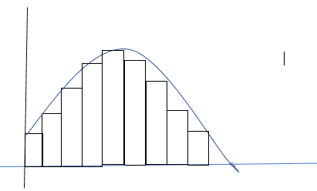

If we connect the vertices of these bar chart which is evenly distributed, we get a curve called a   
Bell curve.

**68% - 95% - 99.7% Rule**

* 68% of the observations fall within
* 95% of the observations fall within
* 99.7% of the observations fall within

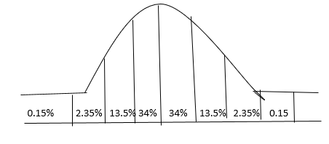

Example :

The scores of an IQ test are normally distributed with and

Find what % of the observations will have IQ scores 1. > 145 2. < 85

1. Scores up to 145:

100 + 45 = 100 + 3( 15) =

* 99.7% of the observations have IQ scores up to 145

Therefore of observations will have IQ scores > 45

2. IQ scores up to 85

85 = 100 – 15 =

68% of the observations will have IQ scores up to 85

∴ % of observations having IQ scores < 85

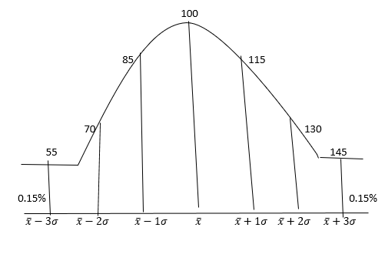

**EXERCISE**

1. Husain and Dino have an average of $20 each. Dino wins a cash prize, which raises their average to $80. Assuming no other changes occurred, how many dollars did Dino Win

Sol:

Original sum of money between Husain and Dino = 2 x 20 = 40

Total money, after winning a cash prize = 2 x 80 = 160

∴ The prize money = 160 – 40 = 120

2. In Clarice’s class, each test weights her overall grade average three times as much as each quiz does. If Clarice Scored 88 and 94 on two quizzes, respectively, and she scored 90 on the only test, what is her current overall grade average?

Sol: Test : Quiz

Weightage = 3 : 1

Clarice takes 2 quizzes and 1 test

Average grade =

3. The average of four numbers is 12. If the set of numbers includes 9, 11, and 12, what is the fourth number?

a) 12

b) 14

c) 16

d) 20

e) 24

sol:

The average of 4 numbers = 12

∴ Their sum = 4 x 12 = 48

Sum of three numbers = 9 +11+ 12 = 32

∴ 4th number = 48 – 32 = 16

4. If X is negative, what is the median of the list 20, x, 7, 11, 3?

a) 3

b) 7

c) 9

d) 11

e) 15.5

sol:

x is negative then median of 20, x, 7, 11, 3 is ( after arranging order)

-🡪 x, 3, 7, 11, 20

median = 7

5. If the average of n and 11 is equal to 2n, then what is the average of n and 13/3?

Sol:

Average of n and 11 is 2n

n + 11 = 4n

3n = 11

Average of n, 13/3

∴ Average =

6. Balpreet’s quiz scores in English are 80, 82, 79 and 84. Her quiz scores in History are 90 and 71. What is the sum of the scores she would need to get on her next English quiz and her next History quiz to raise each class’ quiz score average to 85?

Sol:

Total

Scores in four English quiz = 80 + 82+ 79+ 84 = 325

Total scores in two History quiz = 90 + 71 = 161

Total scores required in all 8 quiz = 8 x 85 = 680

∴ The total score required in the remaining English and History quiz = 680 – (325 +161) = 194

7. The average (arithmetic mean) of 8 numbers is 42. One of the numbers is removed from the set, and the resulting average (arithmetic mean) of the remaining numbers is 40. What number was removed from the set?

a) 26

b) 28

c) 50

d) 54

e) 56

sol:

Average of 8 numbers = 42

One number is removed, then average of 7 numbers = 40

The number removed = (8 x42) – (7 x 40) = 336 – 280 = 56

Or

the number removed is 8x2 = 16 more than the current average.

Which is = 40 + 16 = 56

8. The average population in Town X was recorded as 22,455 during the years 2000- 2010, inclusive. However, an error was later uncovered: the figure for 2009 was erroneously recorded as 22,478, but should have been correctly recorded as 22,500. What is the average population in Town X during the years 2000 – 2010, inclusive, once the error is corrected?

Sol:

The average population of Town X for 11 years from 2000 to 2010 = 22,455

But in 2009 the population taken was = 22,478

The correct population = 22500

The increase = 22

The average increase per year =

The correct average = 22455 + 2 = 22457

9. Set A: 1,3,5, 7, 9

Set B: 6,8, 10, 12, 14

For the sets of numbers above, which of the following statements are true?

Indicate all such statements.

a) The mean of Set B is greater than the mean of Set A

b) The median of Set B is greater than the median of Set A

c) The standard deviation of Set B is greater than the standard deviation of Set A

d) The range of Set B is greater than the range of Set A

sol:

a) The mean of Set B is greater than the mean of Set A

mean of set B = 10

mean of Set A = 5

Statement A is true

b) The median of Set B is greater than the median of Set A

median of set B = 10

median of set A = 5

statement B is true

c)

d = 2 n = 5

: d = 2 n = 5 equal

d) Range of Set B > Range of Set A

Range of Set B = 14 – 6 = 8

Range of Set A = 9 -1 = 8

They are equal

Statement : D is not true

10. Set S {5, 10, 15}

If the number 15 were removed from Set S and replaced with number 1,000. Which of the following would change? Indicate all such statements

a) The mean

b) The median

c) The standard deviation

sol

Set S = { 5, 10, 15}

Number 15 is removed and replaced with 1000

S1 = {5,10, 1000}

Which of the following will changes

a) The mean will change is True

b) The median = 10 will not change

c) The standard deviation of S less than of S1

will change

11 Set W : -9, -3, 3, 9 Set X: 2, 4, 6, 8 Set Y : 100,101,102,103 Set Z: 7, 7, 7, 7

Which of the following choices lists the four sets above in order from smallest standard deviation to greatest standard deviation?

a) W, X, Y, Z

b) W, Y, X, Z

c) W, X, Z, Y

d) Z, Y, X, W

e) Z, X, Y, W

sol:

Set W : -9, -3, 3, 9 n = 4, d = 6

Set x: 2, 4, 6, 8 n = 4, d = 2

Set Y: 100, 101, 102, 103 n = 4, d = 1

Set Z : 7, 7, 7, 7 n = 4, d = 0

The arrangement of is Z < Y<X< W

12. Set S = {2,5,7,11, 16, 24, 28, 50, 52, 101, 120, 130}

What is the average of the first quartile (“Q1”) and the third quartile (“Q3”) of set S?

Sol:

Median =

Q1 =

Q3 =

13. Which of the following sets of data applies to this graph?

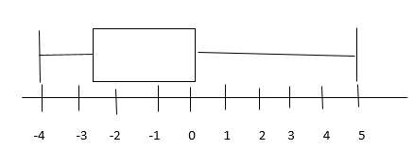a) -4, -4, -2, 0, 0, 5

b) -4, 1, 1, 3, 4, 4

c) -4, -3, -1, 0, 5

d) -4, -4, -2, -2, 0, 0, 0, 5

sol:

The least value is -4

Q1 = -3 Q3 = 0

Median = Q2 = -1

The greatest value = 5

The set od data : -3,-1, 0,

14. If a set of data consists of only the first ten positive multiples of 5, What is the interquartile range of the set?

Sol:

S = {5,10, 15, 20, 25 30, 35, 40, 45, 50}

Q1  median Q3

Inter Quartile Range = Q3 – Q1 = 40 – 15 = 25

15. What is the range of the set of number comprised entirely of {1,6, x, 17, 20, y} if all terms in the set are positive integers and xy = 18?

a) 16

b) 17

c) 18

d) 19

e) Cannot be determined from the information given

sol:

Range of set { 1, 6, x, 17, 20, y} of positive integers and xy = 18

Xy = 18 18x1, 9x 2, 6x 3 , whatever be the values of x and y

The range of the set is not affected range = 20 – 1 = 19

16. Column A Column B

The average of the three smallest distinct The average of the three distinct positive odd

positive integers integer

sol:

Column A Column B

Average of three smallest even integers Average of three smallest odd integers

= =

3x = 4y

Ans: Column A

17. Column A Column B

The ratio of x to y ¾

Sol:

Column A Column B

3x = 4y

Ans : Column A

18. The score for half of the students in a class on a certain test was 90. The score for another fourth of the students was 80. If the average (arithmetic mean) score for all of the students was 78, what was the average score for the remaining students?

a) 52

b) 58

c) 64

d) 70

e) 78

sol:

score of half the student = 90

score of th students = 80

let the score of remaining th students = x

score of all students = 78

let the total of students = 20

then ( 10 x 90) + ( 5 x 80) + (5x) = ( 20 x 78)

900 + 400 + 5x = 1560

5x = 260

X = 52

19. The average (arithmetic mean) of 6,21, x, and y is 13, where x and y are integers with a product of 100 which of the following could be the value of x?

a) 50

b) 20

c) 10

d) 4

e) 1

sol:

average of 6, 21, x and y = 13

xy = 100

X + y = 52 – 27 = 25

Xy = 100 🡺 20 x 5 =

∴ x = 20

20. The mean score on a certain test is 80. If the test scores have a normal distribution and standard deviation is 7, what percent of examinees score between 66 and 94?

a) 50%

b) 68%

c) 82%

d) 95%

e) 98%

sol:

66 = 80 – 14 = 80 – 2(7) =

94 = 80 + 14 = 80 + 2(7) =

95% of the observations within σ

∴ The % of examinees having scores between 66 and 94 = 95%

21. R = {15, 11, 4, 7, 15, 20, 13, 6, 17}

Column A Column B

Range of Set R Mode of Set R

Sol:

Column A Column B

Range of Set R Mode of Set R

Max – min

= 20 -4 = 16 Mode = 15

Ans : A

**Basic Geometry**

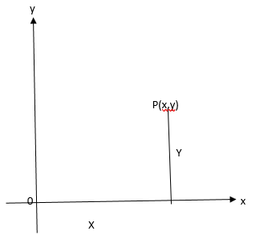

* A point can be located in the co-ordinate axes system but a point does not have any dimension
* If has – no length

-- no width

-- no thickness

Line : A line is a set of infinite points

* A line has no end points
* It cannot be ‘measured’
* It is represented by

A B

Line Segment:

* A line segment has 2 end point
* It can be ‘measured’
* It is denoted by AB

A 27.3 cm B

Ray:

* A ray has only one end point
* It also cannot be measured
* It is denoted by

O P

Angle:

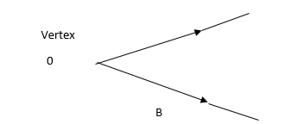

Union of two rays forms an angle .

The point of union is called the ‘vertex’

Types of Angles:

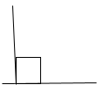1. Acute angle 0 < x< 90 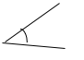

2. Right Angle x = 90

3. Obtuse Angle 90 < x < 180 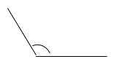

4. Straight Angle x = 180 x

5. Reflex Angle 180 < x < 360 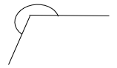

6. Complete Angle x = 360o 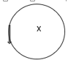

<a = <b vertically opposite angle 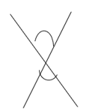

<a, <b are adjacent angles

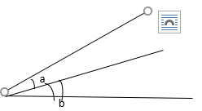

* If <a + <b = 90 then <a <b are called Complementary angles
* If <a + <b = 180 then <a . <b are called Supplementary angles

Angle Complement Supplement

0 90 180

30 60 150

45 45 135

60 30 120

90 0 90

X (90-x) (180 -x)

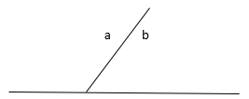

<a , <b are adjacent angle and <a + <b = 180, then <a, <b are called a linear pair of angles

1. Find the angle, which is

1. of its complement

X = 🡺9x = 90 🡪 x = 10

2. of its Supplement

🡺 10x = 180 🡪 x = 20

3. of its Complement

🡺 5x = 2 x90 🡪 x = 36

4. of its Supplement

🡺 9x = 4 x 180 🡪 x = 80

5. of its Complement

🡺 20x = 7 x 90 🡪 x = 31.5

Given two lines , either they intersect at one point or they do not intersect at any point.

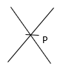

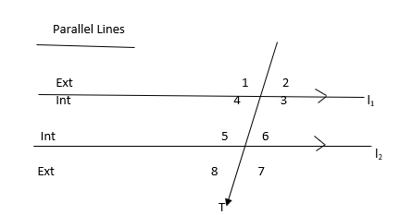

Interior Angles : 3, 4, 5, 6

Exterior Angles : 1, 2, 7, 8

Corresponding Angles :

One interior angles, one exterior angle but on the same side of the transversal

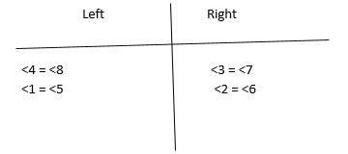

Alternate Angles:

Both interior angles, but on either side of the transversal

Look for

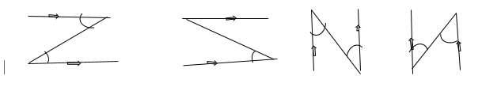

<6 = <4 <5 = <3

* <5 + <6 = 180 (straight line )

But <6 = <4 (alternate angles)

∴ <5 + <4 = 180

The interior opposite angles are Supplementary

Example:

Find x

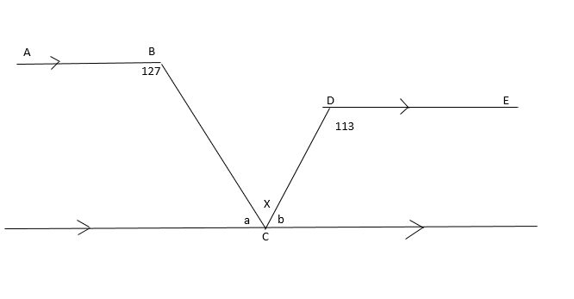

Sol:

Draw a line through C parallel to AB and DE then

a + 127 = 180

a = 53, a+x = 113

53 + x = 113 🡪 x = 60

OR

b + 113 = 180 b = 67

67 + x = 127 🡪 x = 60

Now,

a = 53 and b = 67

A + b + x = 180

53 + 67 + x = 180

X = 60

OR

Or 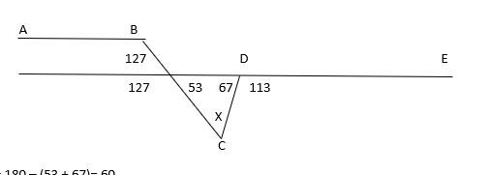

X = 180 – (53 + 67)= 60

X = 127 + 113 – 180 = 60

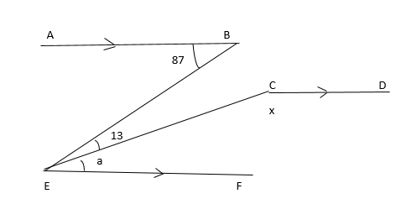

Let <CEF = a

Then a + 13 = 87

a = 74

And a + x = 180

74 + x = 180

X = 106

**TRIANGLES**

A

B C

Definition: An ‘area’ enclosed by three line segments is a triangle

Properties:

1. Sum of three angles of a triangle is 180

2. The sum of any two sides of a triangle must be greater than the third side

3. The difference between any two sides of a triangle must be lesser than the third side

A B C

If AB + BC = AC then THE points A, B, and C are collinear points.

For a triangle to happen, the point B should get up or down.

B

A C

Then AB + BC > AC (always )

7 10

x

X is an integer. Find the range of value of x

10 – 7 < x < 10 + 7

3 < x < 17

X = {4,5,6 ……….. 15, 16}

4. The sides opposite to equal angles are equal in a triangle

A

B C

If <B = <C then AB = AC

5. The angles opposite to equal sides are equal in a triangle

If AB = AC then <B = <C

6. In a triangle , the side opposite to the greater angle is greater in measure

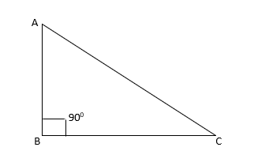

7.

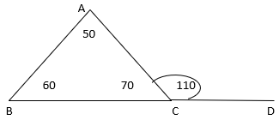

<ACD is the exterior angle of

<ACD = <BAC + <ABC

110 = 50 + 60

In a triangle, the exterior angle is equal to the sum of interior opposite angles

8.

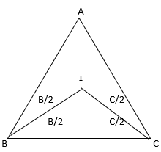

BI, CI are the interior angle bisection of <B, and <C

Express <BIC in terms of <A

Sol:

<A + <B + <C = 180

From

<BIC = 180 –

= 180 -

9.

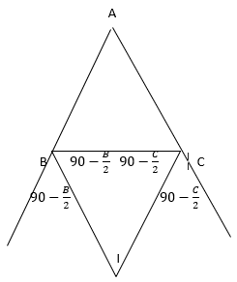

BI, CI are the exterior angle bisector of <B and <C.

Express <BIC in terms of <A

Sol:

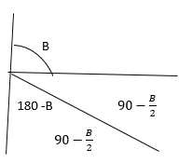

From <BIC = 180 –

<BIC =

* Two lines intersect at a point.

Three or more lines concur at a point .

**ALTITUDES**

1.

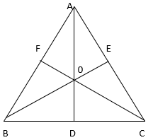

AD, BE, CF are the altitudes of ‘0’ their point of concurrency is the ‘Ortho Centre’

2. **MEDIANS**

A median is the line joining a vertex to the mid point of the opposite side of a triangle.

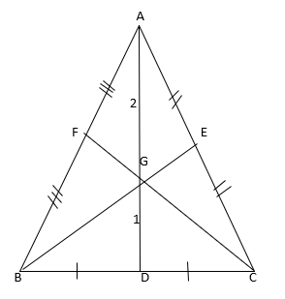

G, their point of concurrency is the ‘Centroid’

G divides a median in the ratio of 2 : 1

**Property of a median:**

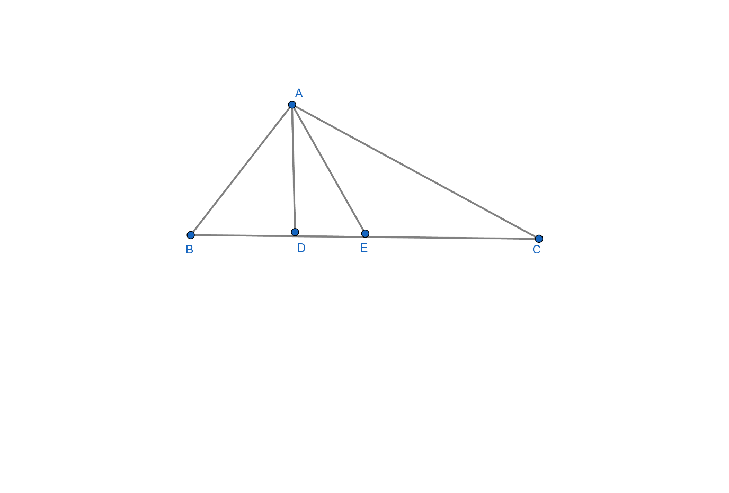

D is the mid point of BC

∴ BD = DC =

=

* A median divides a triangle into two triangles of equal area.

Example

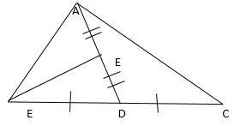

If = 15 cm2 find the area of

(BE is a median)

= (AD is a median)

∴ cm2

3**. PERPENDICULAR BISECTORS OF THE SIDES**

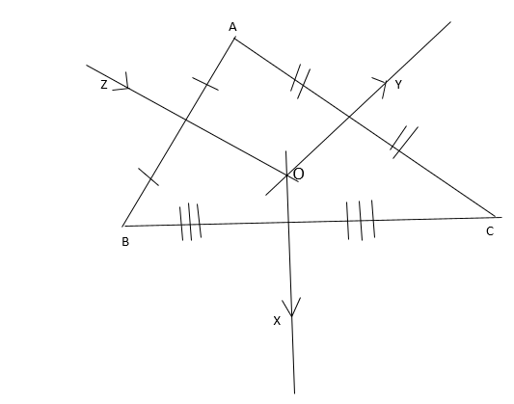

OX, Oy, OZ are the perpendicular bisectors of the sides BC, CA, and AB of

O, their point of concurrency is the ‘Circumcentre’

* The Circumcentre is equidistant from the vertices of a triangle
* The Circumcentre of an acute angled triangle lies inside the triangle
* The Circumcentre of an obtuse angled triangle lies outside the triangle
* The Circumcentre of a right angled triangle is the mid point of the hypotenuse.

4. **ANGLE BISECTOR**

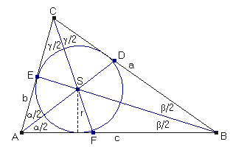

AD, BE, CF are the angle bisectors of

I, their point of concurrency is the incentre

The incentre is equidistant from the sides of a triangles.

**Theorems:**

1. Basic Proportionality theorem:

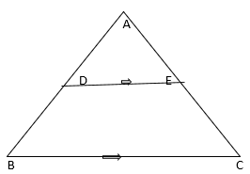

The line drawn through the mid point of one side of a triangle parallel to another side, bisects the third side.

D is the mid point of AB

DE// BC AE = EC

3**. Mid point theorem:**

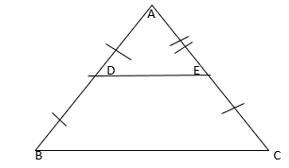

The line joining the mid points of any two sides of a triangle will be parallel to the third side and half of it.

D, E are the mid points of AB and AC then DE// BC and DE =

**Quadrilaterals**

Any four sided closed figure

1. Square :

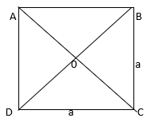

1. All sides are equal

2. All angles are equal

3. Diagonals are equal

4. A Diagonal divides a square into 2 congruent triangles

5. Both the diagonals divides the square into 4 congruent triangles

2. **Rectangle:**

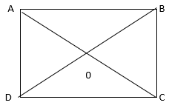

1. Opposite sides are equal

2. All angles are equal

3. Diagonals are equal

4. A Diagonal divides the rectangle into 2 congruent triangles

5. Both the diagonals divide the rectangle into 2 pairs of congruent triangles

3. **Rhombus:**

1. All sides are equal

2. One pair of opposite angles are acute and equal and the other pair obtuse and equal

3. Diagonals are not equal

4. Diagonals bisect each other Perpendicularly

5. A diagonal divides the rhombus in to 2 congruent triangles

6. Both the diagonals divide the rhombus into 4 right angled congruent triangles.

7. If one angle of a rhombus is 600 then the

longer diagonal = ( the shorter diagonal)

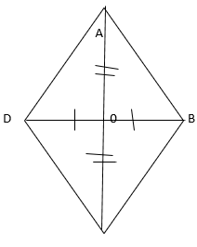

In angle ratio = 30 : 60 : 90

Side ratio = sin 30 : sin 60 : sin 90

=

= 1 : : 2

AC = , BD = 2

or AC =

**Trapezium:**

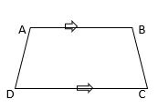

1. Only one pair of opposite sides are parallel
2. If the non – parallel sides are equal then it is an isosceles trapezium
3. In an isosceles Trapezium the diagonals are equal

**Parallelogram:**

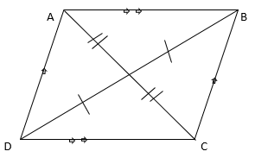

1. Opposite sides are equal
2. Opposite angles are equal
3. Adjacent angles are supplementary
4. Diagonals are not equal
5. Diagonals bisects each other
6. A diagonal divides the parallelogram into 2 congruent triangles
7. Both the diagonals divide the parallelogram in to 2 pairs of congruent triangles

**Polygons:**

A many sided closed figure

1. Convex Polygon: A polygon in which each angle is <180

x

1. Concave Polygon : A polygon in which at least one angle is reflex

x

180 < x < 360

1. Regular Polygon: A Polygon in which each side and each angle is equal

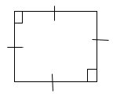

X + y = 180

|  |  |  |  |  |  |
| --- | --- | --- | --- | --- | --- |
| Number  Of sides | Name of the polygon | Sum of interior angles =  (2n – 4) 90 | Each interior angle  x | Each exterior angle  y | Number of diagonals |
| 3  4    5  6  7  8  9  10 | Equilateral Triangle  Square  Pentagon  Hexagon  Heptagon  Octagon  Nonagon  Decagon | 180  360  540  720  900  1080  1260  1440 | 60  90  108  120  128  135  140  144 | 120  90  72  60  51  45  40  36 | 0  2  5  9  14  20  27  35 |

To find the sum of interior angles of a regular Polygon of ‘n’ side

Ex: Hexagon (n = 6)

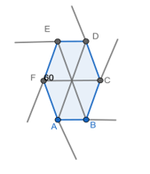

To find: A + B + C + D + E + F

LHS = Sum of the angles in 6 triangles – sum of the angles in the centre

= 6 x 180 – 360

= 2 x 6 x 90 – 4 x 90

= ( 2 x 6 -4) 90 = (2n -4) 90

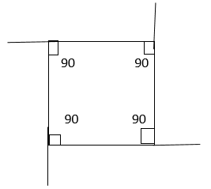

Let each interior angle = x

And each exterior angle = y

X + Y = 120 + 60 = 180 ( In a hexagon )

Sum of exterior angles = 6 x 60 = 360

X + y = 90 + 90 = 180 ( in a square)

Sum of Exterior angle = 4 x 90 = 360

**Points to remember:**

1. The sum of interior angles = (2n -4)900
2. The sum of exterior angles = 3600 (always)
3. The interior and exterior angles are supplementary 🡺 x + y = 1800
4. The number of sides =
5. Also number of sides = 2[α +1], α =
6. Number of diagonals = nC2 – n =

1. If the sum of interior angles is equal to 4 times the sum of exterior angles find the n of sides of the polygon

(2n =4)90 = 4 x 360

2n -4 = 16

2n = 20

N = 10

2. If each interior angle is equal 11 times each exterior angle find the number of sides of the polygon

X = 11y

n = 2[α +1] = [11 + 1] = 24 sides

3. If the difference between each interior angle of two polygons of sides n and (n + 1) is 12. Find ‘n’

X1 + y1 = 180

X2 + y2 = 180

X1 – x2 = 12

Y1 – y2 = 12

n = 5

**CIRCLES**

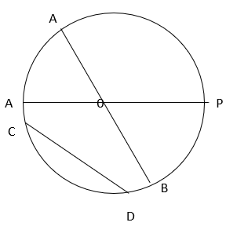

**Locus**: The path traced by a moving point

**Definition**: The locus of the point such that it is at a constant distance from a fixed point is a circle

The fixed point is the **centre** of the circle

The constant distance OP = r is a **radius**

AB = 2r a **diameter**

CD is a **chord**

The part of a circle is called **an ‘arc’**

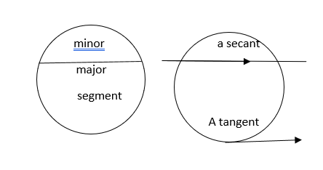

**Sector:**

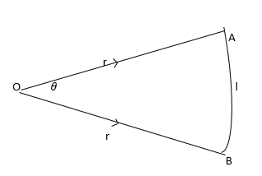

l = length of arc of a sector

l =

A = Area of a sector

A=

Also A = ½ lr

**Properties of circle**

1. **Chord Properties:**

Equal chords are equidistant from the centre

If AB = CD then OP = OQ

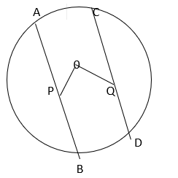

1. Chords which are equidistant from the centre will be equal lengths

If OP = OQ then AB = CD

1. The line drawn from the centre perpendicular to a chord bisects the chord

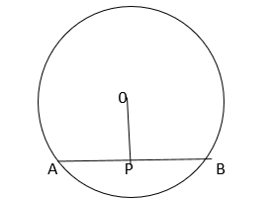

If OP perpendicular AB then AP = BP

1. The line joining the centre and the midpoint of a chord will be perpendicular to the chord.
2. If AP = BP then OP perpendicular AB
3. Longer chords are nearer the centre
4. Equal chords subtend equals/arcs/ Segments / angles
5. AB and CD are two chords intersecting internally at E, then AE x BE = CE x DE

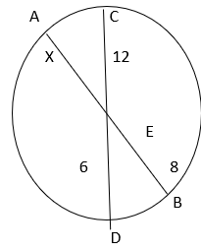

X 8 = 12 x 6

X = 9

1. AB and CD are two chords extended to meet at E, outside the circle. Then AE x BE = CE x DE

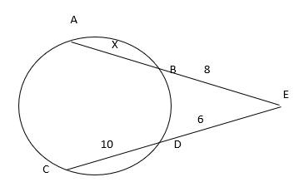

16 x 6 = (x + 8) 8

X + 8 = 12

X = 4

1. AB is a chord and PT is a tangent then, AT x BT = PT2

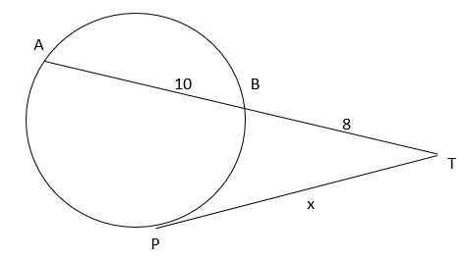

18 x 8 = x2

X = 12

II . **Angle Properties:**

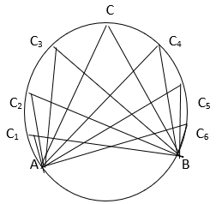

1. The angle in the centre is **twice** the angle in the remaining part of the circle

<AOB = 2<ACB

1. Angles in the **same** segment are equal

<AC 1B =<AC2B = <AC3B = = x

1. Angles in the ***equal*** segments are **equal**
2. AB is a diameter <AOB = 180

<ACB = 90

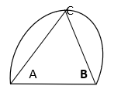

The angle in the semi circle is a right angle

III. **Tangent Properties:**



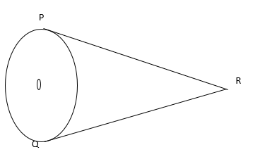

1. Two tangents of equal lengths can be drawn from an external point to a circle

PR = QR

1. The tangent is perpendicular to a radius at the point of contact

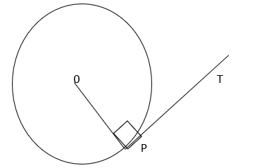

<OPT = 90

**Cyclic Quadrilateral**

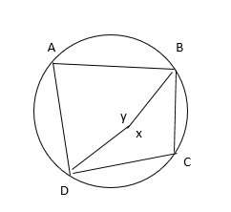

1. X + y = 360

<A + <C =

The opposite angles of a cyclic quadrilateral are supplementary

1. <BCE = z is the exterior angle

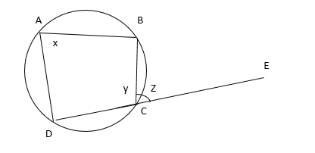

X +y = 180 (from 1)

Y + z = 180 (straight line)

<z = <x

The exterior angle of acyclic quadrilateral is equal to the remote interior angle

Quadrilaterals

Name of figure fig Area Perimeter Diagonal

Square 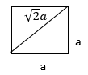 a2 4a

Also A = diagonal2/2

Rectangle 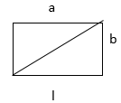 lb 2(l + b)

Parallelogram 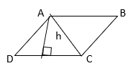 A= bh

also in a parallelogram

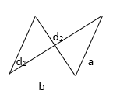

Rhombus

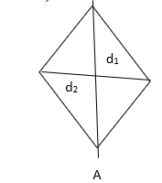

Trapezium:

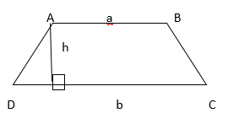

Any Quadrilateral

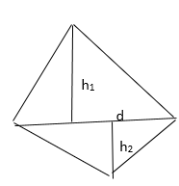

Area of path running inside:

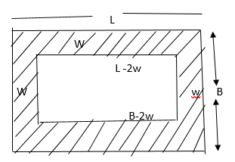

Area of path =

Area of path running Across:

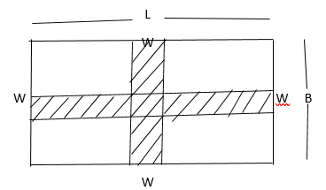

Area of path = W [ L + B – W]

1. The Perimeter of one square field is 60m and that of another square field is 80m. Find the diagonal of the third square field whose area equals the sum of the areas of the former two

Sol:

4a1 = 60 4a2 = 80

a1= 15 a2 = 20

a2 = a12 + a22 = 152 + 202 = 252

a = 25

diagonal =

2. The adjacent sides of a parallelogram are 11 cm and 13cm. If one of the diagonals is 16cm. Find the other diagonal

Sol:

d12 +d22 = 2(a2 + b2)

162 + d22 = 2( 112 + 132)

256 + d22 = 2( 121 + 169)

=

d22 = 580 – 256 = 324

d2 =

2.Find area of ABCD

from the Pythagorean triplets 7,24,25 and 10,24,26

we get the height of trapezium as 24

∴ Area of ABCD =

3. Find Area PQRS

Sol:

From the Pythagorean triplet

10,24, 26

The height of trapezium = 24

Area =

4. Find the width of the path if path area = 570 m2

Sol:

Area of path = 2W( L + B – 2W)

2W( 37 + 30 – 2w) = 570

2W(67 – 2w) = 570

W = 5m =

= 10(67 – 10) = 570m2

Mensuration 2D : Area Triangles

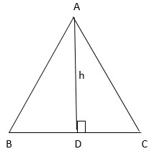

A =

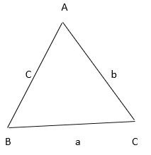

Find the area :

1. a = 5 , b = 6 , c= 7

square units

2. a = 7, b = 24 , c f= 25

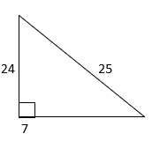

Pythagorean Triplets :

a2 + b2 = c2

1) 3 , 4, 5

2) 5, 12, 13

3) 7, 24, 25

4) 8, 15, 17

5) 9, 40, 41

6) 11, 60, 61

7) 12, 35, 37

8) 13, 84, 85

9) 16, 63, 65

10) 20, 21, 29

Isosceles Triangle:

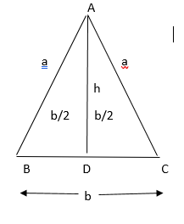

h = AD =

a = equal side

b = base

Equilateral Triangle:

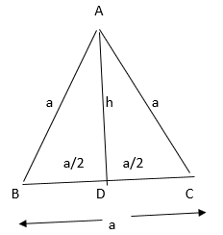

h = AD =

Also

1. The area of an isosceles triangle of base 126m is 1008m2 . Find the equal side of the triangle.

Recall the Pythagorean Triplet : 16, 63, 65

The equal side = 65m

2. There is an equilateral triangle of side 2m. Circles of radius 1m are drawn with the vertices as centre. Find

1. The area common to both triangle and circles

2. The area unoccupied in between them

Sol:

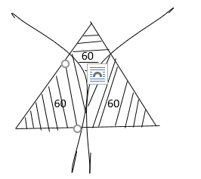

1. Common area = area of 3 sectors =

2. Area unoccupied in between them = area of triangle – Common area

GEOMETRY

**Exercise:**

1. In the figure below, if c = 2e =b ?

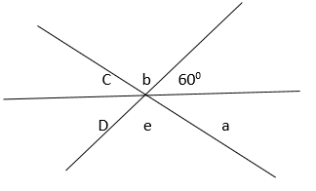

C = 2e b = ?

C = 2e b = e ( V. O . A)

2e + e + 60 = 180

3e = 120

E = 40

Therefore b = e = 40

1. Given that line XY is parallel to line WZ and <A is 105 degrees, what is the sum of angles C and H?

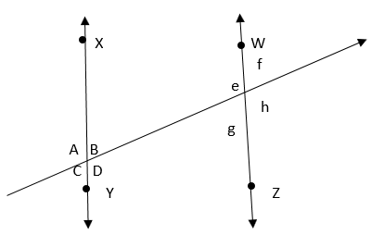

<A = 105 <C + <H = ?

<A = 105 🡺 <C = 180 – 105 = 75 ( STRAIGHT LINE)

<C = <G = 75 🡺 <H = 105 (CORRESPONDING ANGLES)

∴ <C + <H = 75+ 105 = 180

3.

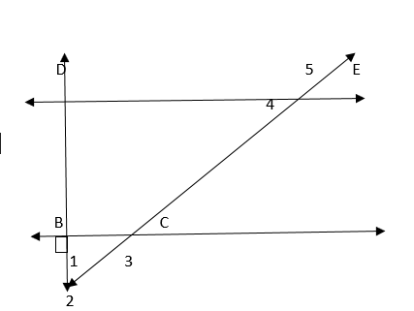

<2 = <3 = 45

<3 = <4 = 45

Therefore <5 = 180 – 45 = 135

4.

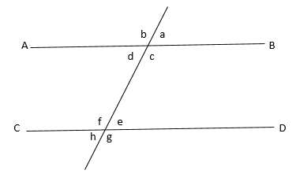

<d + <c = 180 (straight line)

But <d need not be equal to <c Ans: D

5.

800 b

Quantity A Quantity B

6b Sum of the interior angles of the pentagon

Sol:

Ans : B

6.

Quantity A Quantity B

No of the diagonals in a decagon 36

Sol:

n = 10

No of diagonals = 36

Ans: B

7 Quantity A Quantity B

The greatest angle in a pair of supplementary The angle which is equal to 4

Angles that differ by 360 times its complement

Sol:

X + y = 180 y = 4 (90 – y)

X – y = 36 y = 360 – 4y

2x = 216 5 y = 360

X = 108 y = 72

Ans: A

8.

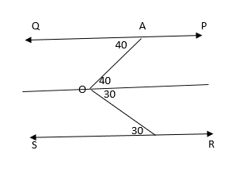

PQ // RS, <OAQ = 400 and <OBS = 300

Sol:

Draw a line through O parallel to QP and RS then

<AOB = 40 + 30 = 70

Column A Column B

<AOB = 70 50

Ans : A

9

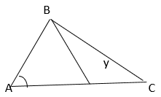

Given AB = AC

* <x + a = y

Column A Column B

X y

Ans: B

10.

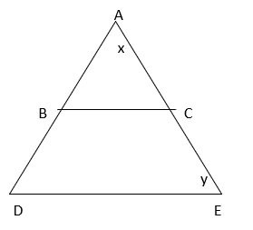

AC = BC

X = 65

BC // DE 🡺 <ACB = y (corresponding)

Y = 180 – (65 + 65) = 50

Column A Column B

X = 65 x = 50

Ans: A

11. In the figure above, the value of ‘y’ is

3x

2x y + 30

a) 6

b) 12

c) 24

d) 36

e) 42

Sol:

5x= 180 x = 36

2(36) = y + 30

Y + 30 = 72= 42

13. In the figure below, what is the value of ‘x

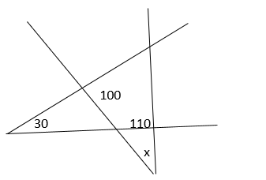

a) 20

b) 30

c) 40

d) 50

e) 70

sol:

From

<A = 180 –(30 + 11) = 40

From ADE

X = 180 –(100 + A)

= 180 –(100 + 40) = 40

X = 40 Ans: C

14 .If the measure of each interior angle of a regular polygon is numerically equal to 20 times its side, find the number of sides. **Select all that apply.**

a) 8

b) 3

c) 4

d) 6

e) 9

sol:

x = 20n

a) 8 octagon x = 135

135

b) 3 equilateral triangle x = 60

60 = 20

c) 4 Square x = 90

90 20 4

d) 6 Hexagon x = 120

120 = 20 6

e) 9 Nonagon x = 140

140

Ans: B and D

15. In the figure below, what value of ‘x’ will AOB a straight line?

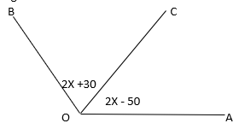

Sol:

<AOB = 180

2x + 30 + 2x – 50 = 180

4x – 20 = 180

4x = 200

X = 50

16. Column A Column B

X y

X

No of sides interior angle

3 60

4 90

5 108

6 120

7 128

As the number of sides increases in a polygon the interior angle also increases

Ans: B

17. what is the value of a + b + c + d ?

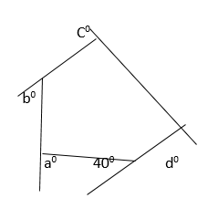

a) 240

b) 320

c) 360

d) 500

e) 540

sol:

Sum of exterior angles = 360 (always)

a + b + c + d+ 40 = 360

a + b + c + d = 320

Triangles

1. What is the value of x ?

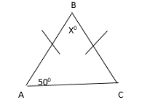

Sol:

AB = BC 🡺 <A = <C = 50

Therefore x = 180 – (50 + 50) = 80

1. DFG is a straight line. What is the value of x?

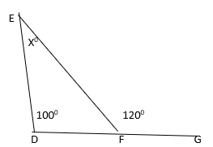

Sol:

100 + x = 120 (exterior angle property)

Therefore x = 20

1. What is the perimeter of triangle ABC?

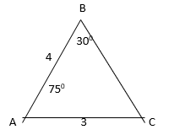

Sol:

Sum of the angles = 30 + 75 = 105

3rd angle = 75

Therefore AB = BC = 4

The perimeter = 3 + 4 + 4 = 11

1. The area of right triangle ABC is 15. What is the length of hypotenuse BC?

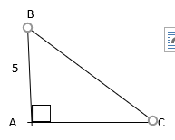

Sol:

AC = 6

Therefore BC =

5.

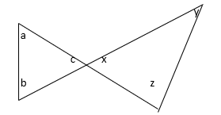

Quantity A Quantity

a + b + x c + y + z

sol:

<C = <x (V. O . A)

Therefore a + b + c = x + y + z = 180 Ans: C

6 What is the length of side HI?

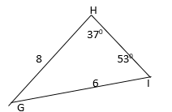

Sol:

Sum of the two angles = 37 + 53 = 90

is right angled at G

Therefore HI =

HI = 10

7. If the hypotenuse of an isosceles right triangle is , what is the area of the triangle ?

a) 14

b) 18

c) 24.5

d) 28

e) 49

sol:

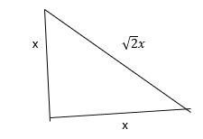

==. X = 7

Area of triangle =

8. WZ has a length of 3 and ZX has a length of 6. What is the area of triangle XYZ?

Y

S

X 6 Z 3 W

Sol:

WYZ is a right angled triangle

Therefore WY =

The height of

Therefore Area of XYZ =

9. Isosceles triangle ABC has two sides with lengths 8 and 5

Quantity A Quantity B

The length of the third side 8

Sol;

8 8 5 5

5 8

Quantity A Quantity B

The third side can be 8 or 5 8

And: D

10. Isosceles triangle ABC has two sides with lengths 2 and 11

Quantity A Quantity B

The length of the third sides 11

Sol:

11 11

2

Quantity A Quantity B

Third side 11

The third side cannot be 2 it has to be 11.

11.

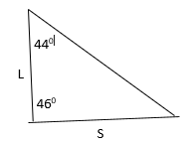

Quantity A Quantity B

L/S 1

Sol:

Side L is opposite to 440

Side S is opposite to 460

The side opposite to the greater angle is greater in measure

Therefore S > L 🡺

Quantity A Quantity B

1

Ans:B

12.What is the number of possible values of ‘x’?

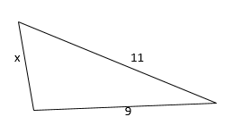

X is an integers

The third side must be lesser than the sum of other two sides and it must be greater than the difference of other two sides

Therefore 11 – 9 < x < 11 + 9

2 < x < 20

Possible value of x = { 3, 4, 5 , ---------- 17 , 18, 19 }

13. If p is the perimeter of a triangle with one sides of 6 and another side of 9, what is the range of possible values for P?

a) 3 < p < 15

b) 15 < p < 24

c) 18 < p < 30

d) 18 < p < 42

e) 21 < p < 42

sol:

P is the perimeter of a triangle of two sides 6 and 9

Let the third side be x then

9 – 6 < x < 9 + 6

3 < x < 15

Therefore 3 + 6 + 9 < p < 15 + 6 + 9

18 < p < 30

Ans : D

14.

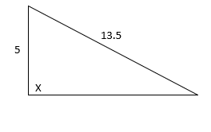

Quantity A Quantity B

X 900

Sol:

52 + 122 < 13.52

X is an obtuse angle

Quantity A Quantity B

X > 90 90

Ans: a

15. What is the value of ‘x’?

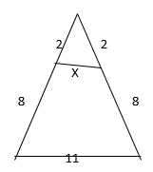

Sol:

AE // BC

Therefore

16.

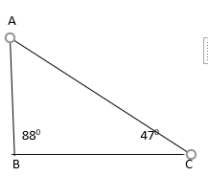

Quantity A Quantity B

The length of side AB The length of side BC

Sol:

Quantity A Quantity B

Length AB opposite to 470 > Length BC opposite to 45

Ans A

17.

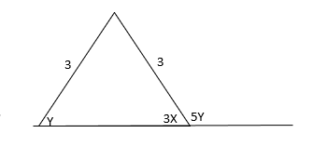

What is the value of x in figure above?

1. 5
2. 10
3. 18
4. 30
5. 54

Sol:

Since AB = AC

<y = <3x

And 3x + 5y = 180

Y + 5y = 180

6y = 180

Y = 3x = 30

X = 10

18. In the figure shown, What is the value of x?

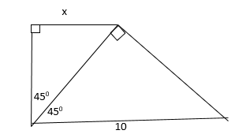

Sol:

AD = AB = x

Therefore BD =

BD = DC =

Therefore BC = = 2x

2x = 10 -🡪 x = 5

19. What is the perimeter of right triangle ABC?

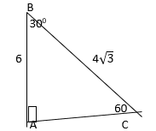

Sol:

Angle ratio = 30 : 60 : 90

Side ratio = 1 :

1 =

Therefore AC =

BC =

Perimeter of

=

CIRCLE

1. A circle has a circumference of 20. What is its area?

a) 10

b) 20

c) 40

d) 100

e) 400

sol:

2r = 20

R = 10

Area =

Ans: D

2. A circle’s area equals its circumference. What is its radius?

Sol:

Area of circle = circumference

= 2

r = 2

3.

Quantity A Quantity B

The radius of a circle with area 36 The radius of a circle with circumference 12

Sol:

Quantity A Quantity B

= 36

r= 6 r = 6

Ans : C

4.

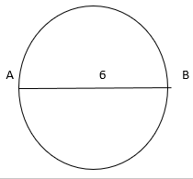

AB is not a diameter of the circle

Quantity A Quantity B

The area of the circle 9

Sol:

Diameter = 2r > 6

∴ r > 3

Area =

Quantity A Quantity B

The area of circle

> 9

Ans: A

5. A circle has an area of 4. If the radius were doubled, the new area of the circle would be how many times the original area?

a) 2

b) 3

c) 4

d) 5

e) 5

sol:

area of circle =

r = 2

if radius is doubled

new area =

The new area is 4 times the old area

6. In the figure below, point O is the centre of the circle. If the radius of the circle is 8, what is the area of the sector?

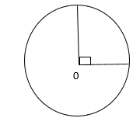

Sol:

Area of Quadrant =

7. A sector of a circle has an arc length of If the diameter of the circle is 14, what is the measure of the central angle of the sector, in degree?

a) 45

b) 60

c) 90

d) 120

e) 180

sol:

d = 2r = 14

r = 7

8. A sector of a circle has a central angle of 2700. If the circle has a radius of 4, what is the area of the sector?

Sol:

, r = 4

Area of sector =

9. The area of the shaded sector is of the area of the full circle

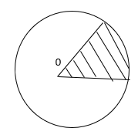

Quantity A Quantity B

2x 750

Sol:

Area of sector = area of circle

Quantity A Quantity B

2x 75

=

10. If O is the centre of the circle with radius 5, what is the perimeter of the sector with central angle 720?

Sol:

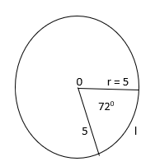

Perimeter of sector = l + 2r

Perimeter of sector = l + 2r = 2 + 10

11. If point O is the centre of the circle in the figure below, what is the radius of the circle?

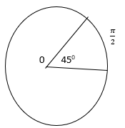

Sol:

Length of arc of a sector =

r = 4/2 = 2

12.If the diameter of the circle is 36, what is the length of arc ABC?

a) 8

b) 8

c) 28

d)

e)

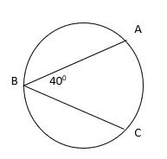

Sol:

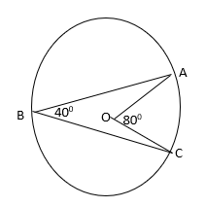

The angle in the centre is twice the angle in the remaining part of the circle

d = 36

r = 18

∴ <AOC =

∴ ABC =

13.

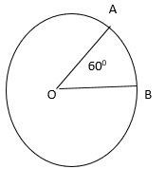

Point O is the centre of the circle above.

Quantity A Quantity B

The ratio of the length of minor arc

AB to major arc AB

Sol:

Quantity A Quantity B

=

Ans: A

2D AREA

1. The two parallelograms pictured below have the same perimeter. What is the length of side EH?

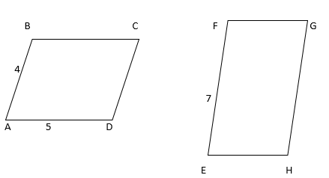

Sol:

The two parallelograms have the same perimeter

Therefore 2(4 + 5) = 2 ( 7 + x)

9 = 7 + x

X = 2

2. Triangle ABC and Rectangle JKLM have equal areas. What is the perimeter of Rectangle JKLM?

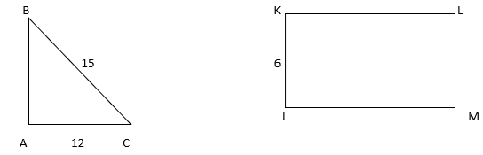

AB =

The area triangle ABC = Area of rectangle JKLM

L = 9

Therefore Perimeter of JKLM = 2( 6 + 9 ) = 30

1. Quantity A Quantity B

The longest side of a rectangle with area 36 6

Sol:

Ans : A

4 Quantity A Quantity B

The area of a rectangle with perimeter 40 110

Sol:

Area = 100 10

2( l + h) = 40

L + b = 20

The greatest area is when l = b = 10

Area = 100

Quantity A Quantity B

100 110

Ans: B

5 Quantity A Quantity B

The area of a parallelogram with a base The area of a trapezoid with two parallel

of length 4 and height of 3.5 sides of lengths 5 and 9 and a height of 2

sol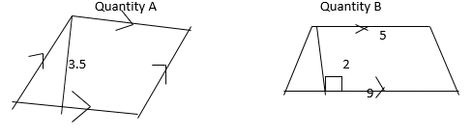

Area = bh = A =

Ans : C

6. A 10 by 15 inch rectangular picture is displayed in a 16 by 24 inch rectangular frame. What is the area, in inches, of the part of the frame not covered by the picture?

a) 150

b) 234

c) 244

d) 264

e) 384

sol:

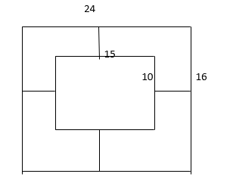

Area of the part of the frame not covered by the picture = 24

= 234

7. Garden A is a 225 meter by 180 meter rectangular vegetable garden, and Garden B is a rectangle with exactly half the length and width of Garden A. What is the ratio of the area of Garden A to the area of Garden B?

a) 1 : 4

b) 1 : 2

c) 2 : 1

d) 4 : 1

e) 8 : 1

Sol:

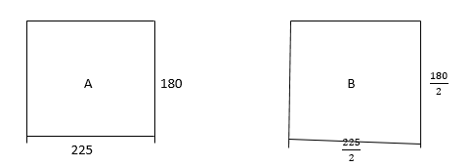

Ratio of area =

Ans : D

8. In the trapezoid below, AE = ED = 3 and BC is parallel to AD. What is the area of the trapezoid?

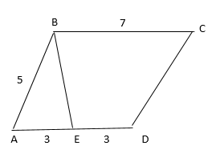

Sol:

is a right angled triangle

Therefore BE =

Area of trapezium =

9.

Quantity A Quantity B

X + y + z 2700

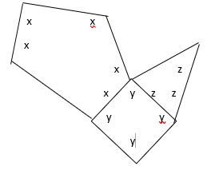

5x = 540 ; x = 108

4y = 360 ; y = 90

3z = 180 ; z = 60

X + y + z = 258

Quantity A Quantity B

X + y + z = 258 2700

Ans : b

10. What is the area of a regular hexagon with side length 2?

a)

b) 2

c)

d)

e)

sol:

Area of a regular hexagon with side = 2

An Hexagon is a figure formed by 6 equilateral triangles.

A =

11. The figure is composed of 5 squares of equal area, as indicated by the dotted lines. The total area of the figure is 45.

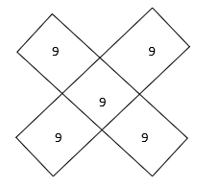

Quantity A Quantity B

The perimeter of the figure 48

Sol:



Area of 5 squares = 45

Area of 1 square = = 9

Side of each square = 3

Quantity Quantity B

Perimeter of the figure = 9 48

Ans: B

12. If the area of the circle is 36π and the area of the rectangle is 72, what is the length of DC?

O is centre of the circle

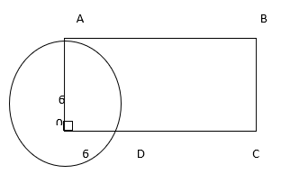

Sol:

Area of circle =

r = 6

area of rectangle = 72

OA = OD = r = 6

Therefore , Width of rectangle = 6

Length of rectangle =

AB = CD = 12

DC = 12 – 6 = 6

13. A square’s perimeter in inches is equal to its area in square inches. A circle’s circumference in inches is equal to its area in square inches.

Quantity A Quantity B

The side length of the square The diameter of the circle

Sol:

a2 = 4a 🡺 a = 4

🡺 r = 2

Quantity A Quantity B

Side of square = 4 diameter of the circle = 2r = 4

Ans : C

14. In the 7 –inch square above, another square is inscribed. What fraction of the larger square is shaded?

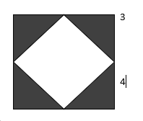

Sol:

15. What is the value of ‘x’?

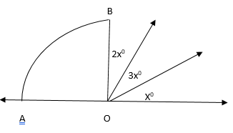

Sol:

Sector OAB is a Quarter circle

Therefore x + 2x + 3x = 90

6x = 90 -🡪 X = 15

16. In the figure, line segments AC and BD are parallel.

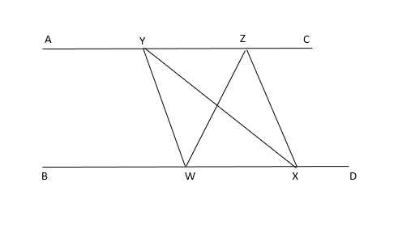

Quantity A Quantity B

The area of triangle WYX The area of triangle WZX

Sol:

Area of

The area of triangles on the same base and in between same parallels are equal

17. Lines L1 and L2 are parallel, and <a > 90

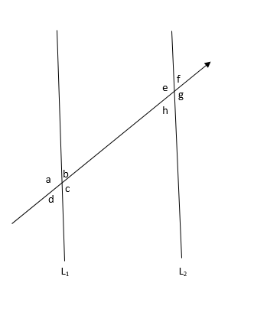

L1// L2

<a > 90

Quantity A Quantity B

a + g + f c + b + h

<g = <e (vertically Opposite angles)

<f = <h (vertically opposite angles)

a >90 and b <9 0

Because a + b = 180

Ans: A

18. What is the area of the region ABCDEF?

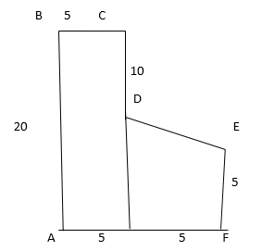

Sol:

Area of the figure ABCDEF = Area of rectangle ABCG + Area of Trapezium DEFG

= ( 20

**Solids – I**

Name of figure figure curved total volume

Surface area surface area (v)

(CSA) (TSA)

Cylinder

r h h

R

Cone

h r l

l = slant height =

Sphere

1. Find TSA and volume of cylinder of r = 7m and h = 15m

Sol:

TSA =

2. The CSA of a cylinder is of its TSA if TSA = 231cm2 find its volume

Sol:

CSA =

3h = 2r + 2h

h = 2r

CSA =

r = 7/2

h = 2r = 7 cm

volume =

3. The sum of radius and height of a cylinder is 37 cm. if TSA = 1628cm2 find its volume

Sol:

( r + h) = 37

r = 7

h = 30

v =

4. Marbles of diameter 1.4cm each are dropped into a cylindrical beaker of diameter 7cm, containing some water. If the water level rises by 5.6cm find the number of marbles dropped

Sol:

-------------------------------

------------------------------ 5.6

---------------------------

-------------------- r = 0.7 = 7/10

**Archimedes’ Principle**

The volume of objects completely immersed = The volume of water displaced

n = 150

solids II

Name of figure figure lateral total volume length of

Surface area surface area (v) longest diagonal

(LSA) (TSA) (XY)

Cube 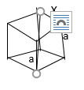 4a2 6a2 a3

Cuboid 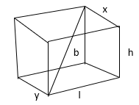 2h( l + b) 2( lb + bh + lh) lbh

1. Two cubes of edge 5 cm each are joined end to end to form a cuboid find TSA of the cuboid

Sol:

L = 10 b = 5 h = 5

TSA = 29 lb + bh + lh0 = 29 50 + 25 + 50) = 2 x 125 = 250

= 10 x 25 = 10 x 52 = 10a2

1. If three cubes of joined then TSA ?

Sol:

l = 15 b = 5 h = 5

TSA = 29 lh + bh + lh) = 2( 75 + 25 + 75)

= 2 x 175 = 350 = 14 x 25

= 14 x 52 = 14a2

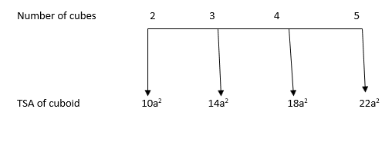

1. If the SA of the adjacent sides of a cuboid are 180 cm2, 240 cm2 and 300 cm2. Find the volume of cuboid

Sol:

V = lbh

lh = 300 c m2

bh = 180 cm2

lh = 240 c m2

v =

4 How many ice – cubes of edges 2 cm each can be kept in the freezer compartment of dimensions

10cm x 5cm x 4cm

sol:

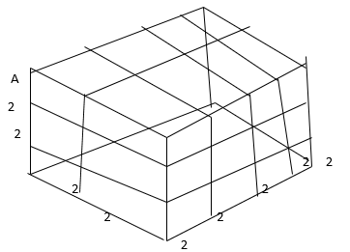

The number of ice cube kept =

3D solids

1. A rectangle box has edges of length 2, 3 and 4

Quantity A Quantity B

Twice the volume of the box Surface area of the box

Sol:

l = 4 b = 3 h = 2

Quantity A Column B

V = 2(lbh) TSA = 2( lb + bh + lh)

= 2( 4 = 2( 12 + 6 + 8)= 52

Ans : B

1. A perfect cube has surface area 96. What is its volume?

Sol:

TSA of a cube = 6a2 = 96

a2 = 16

a = 4

V = a3 = 43 = 64

1. How many 2 –inch by 2 –inch by 2 –inch solid cubes can be cut from six solid cubes that are 1 foot on each side? ( 12 inches = 1 foot)?

Sol:

1 foot = 12 inches

1. What is the height of a right circular cylinder with radius 2 and volume 16?

Sol:

r = 2 volume of cylinder = 16

1. If a half full 4 inch by 2 inch by 8 inch box of soymilk is poured into a right circular cylindrical glass with radius 2 inches, how many inches high will the soymilk reach?

Sol:

1. If a right circular cylinder’s radius is halved and its height doubled, by what percent will the volume increase or decrease?

Sol:

Volume of cylinder =

If radius is halved and its height is doubled

The new volume =

=

The volume of cylinder is decreased by 50%

1. A rectangle solid has edges of lengths 7 inches, 10 inches and 2 inches. Find the surface area, volume and the length of diagonal of the figure?

Sol:

l = 10 b = 7 h = 2

TSA = 2( lb + bh + lh)= 2( 70 + 14 + 20 ) = 2 104 = 208 sq inches

Volume = lbh =

Length of the longest diagonal =

1. A cube and a rectangular solid are equal in volume. If the length of the edges of the rectangular solid are 4, 8 and 16, what is the surface area of the cube?

Sol:

Volume of cube = volume of cuboid

Total Surface Area of cube = 6a2 =

9. Quantity A Quantity B

The volume of a cylinder if the radius is The volume of a cylinder if the radius doubled height is doubled

Sol:

Quantity A Quantity B

Volume of cylinder if the radius is Volume of cylinder if height is doubled doubled

=

Ans: A

10. Quantity A Quantity B

The total surface area of a cylinder The total surface area of a cube

With radius 7cm and height is 3 cm with edges 3 inches ( 1 inch = 2.5cm)

Sol:

Quantity A Quantity B

TSA of cylinder TSA of cube edge = 3 inches

=

= TSA = 6a2 =

= 6

Ans : A

11. Quantity A Quantity B

The greatest possible straight line distance, The distance from any vertex to centre

in centimetres , between two vertices of a of a cube, if the volume of the cube is

rectangular box of dimensions 6cm, 15cm 9261

and 10cm.

sol:

Quantity A Quantity B

The longest diagonal of a cuboid Volume of cube a3 = 9261

a =

a = 21cm

= 19cm The distance from vertex to centre of cube

= =

=

Ans : A

12. The volume of a box with a square base is 54 cubic centimetres. If the height of the box is twice the width of the base, what is the height, in cm?

a) 2

b) 3

c) 4

d) 6

e) 9

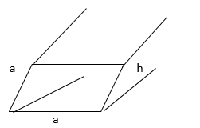

sol

volume of box = a2h = 54 cm3 h = 2a

a2(2a) = 54

a3 = 27 => a = 3cm

h = 2a

13. Approximately 90percent of the volume of a certain cube that is floating in a tank of water is beneath the surface. If 6.4 cubic centimetres of the cube is above the surface of the water, what is the length, in centimetres, of an edge of the cube?

a) 10

b) 8

c) 6

d) 4

e) 2

sol:

90% of volume of cube is under water

10% of volume of cube is above water

10% of cube = 6.4 cubic centimetre

Therefore volume of cubic centimetre =

a3 = 64 cm3

a = 4 cm

14. The radius of a right circular cylinder in 8cm and its height is 20cm. If a new cylinder is formed by increasing either the radius or the height by 25%, then find the new volume of the cylinder**. Select all that apply**.

a) 1000

b) 1200

c) 1600

d) 2000

e) 2500

sol:

cylinder : r = 8 cm G = 20cm

if radius is increased by 25%

new r =

V1 =

If height is increased by 25%

New h =

V2 =

Ans : C and D

15. A solid metal cuboid of dimensions is melted to form a cylindrical rod of base diameter 5ft or 10ft or 20ft. Find the length of the rod. Select all that apply

a)7.5 ft

b)30 ft

c) 50 ft

d) 80 ft

e) 120ft

sol:

Volume of solid cuboid = Volume of cylinder

d= 5ft 🡺 r =

1.

h = length of rod = 120 ft

2. d = 10 ft , r = 5ft

h= length of rod = 30ft

3. d = 20ft , r = 10ft

h = length of rod = 7.5ft

Ans : A,B,E

**Co-ordinate Geometry**

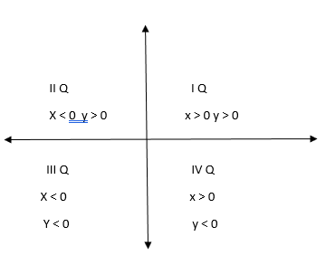

y < 0

(2, -3) is in IV Q

(-5,4) is in II Q

(-3, -5) is in III Q

(4, 5) is in I Q

Draw the graph of

|  |  |  |  |  |  |  |
| --- | --- | --- | --- | --- | --- | --- |
| X | 0 | 5 | 1 | 2 | 3 | 4 |
| Y | 5 | 0 | 4 | 3 | 2 | 1 |

A B C D E F

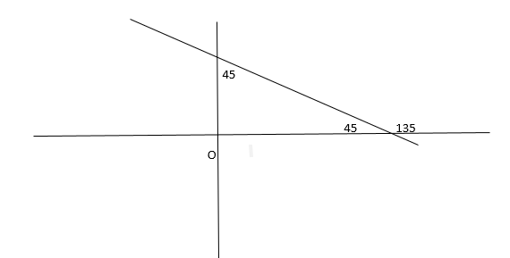

m = tan

Tan135 = tan(90 + 45)= -cot 45 = -1

X + y = 5 is a linear equation and a linear equation always represents a straight line

Consider the ratio of

This constant (-1) is called the slope of the line x + y = 5

Slope =

**Definition of slope:**

Slope is the tangent of the angle which the line makes with the positive direction of the x – axis and it is denoted by in m = tan

**Slope of x – axis:**

Any two points on the x – axis are of the form (,0) (

Slope =

Slope of x – axis is zero

**Slope of y –axis:**

Any two points on the y-axis are of the form (0,(0,

Slope = is indeterminant

Slope of y – axis does not exist

Slope of parallel line:

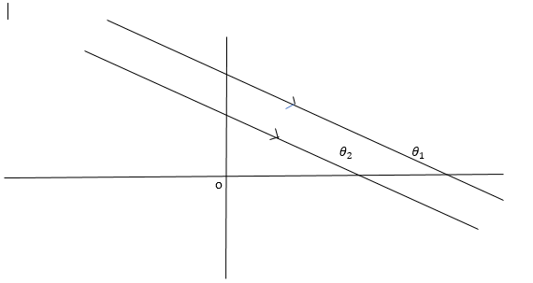

L1// L2

* (corresponding angles)

Therefore tan or m1 = m2

Parallel lines have equal slopes

Slopes of Perpendicular lines:

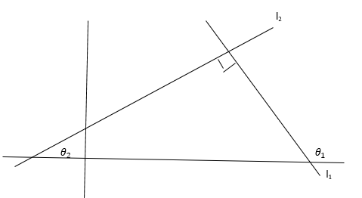

is the exterior angle

Therefore = 90 +

tan

tan

or m1 m2 = -1

slope of the line ax + by + c = 0

by = -ax – c

Miscellaneous:

1. The distance between any two points (x1, y1) and (x2, y2) is

D =

1. The co-ordinate of the mid point joining (x1, y1) and (x2, y2) is

=

1. The co-ordinates of the point p(x ,y) dividing the line joining (x1, y1) and (x2, y2) internally in the ratio of m : n

=

1. The co-ordinates of the centroid of triangle ABC A(x1, y1) B (x2, y2) C(

G(x, y) =

Equations of lines

1. Equation of t he line through the origin is y = mx

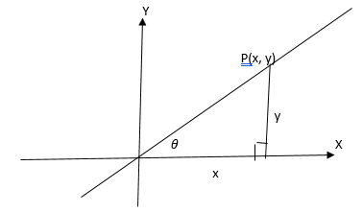

2. Equation of the line whose slope is ‘m’ and y – intercept ‘c’ is fy = mx + c

3. Equation of the line whose slope is ‘m’ and through any point (x1 , y1) is

4. Equation of the line through any two points ( x1, y1) and (x2, y2) is

( x – x1)

5. Equation of the line is intercepts form is

6. The area of triangle ABC A(x1, y1) B (x2, y2) C( is

A =

**Exercise**

1.

Quantity A Quantity B

The slope of line l1 The slope of line l2

Sol:

Line l1 has more inclination with x – axis is than line l2

2. Which of the following is most likely to be the equation of line l ?

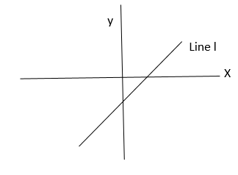

a) y = 4x + 4

b) y = 4x -4

c) y = x – 6

d) y = x +

e) y = -x -3

sol:

The line has a positive x – intercept and a negative y – intercept and the intercepts are almost equal

∴ we can select c y = x – 6

If x = 0 y -intercept= -6

If y = 0 x – intercept = 6

3. Which of the following could be the equation of line m?

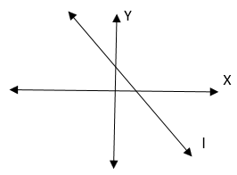

a) 6y + 6x = 7

b) 3y = -4x -3

c) 5y + 10 = -4x

d) y =2

e) x = -2

sol:

The line has both x and y intercepts positive

We can select

a) 6y + 6x = 7

when y = 0, x – intercept =

when x = 0, y – intercept =

4. what is the equation of the line that passes through (-1, -3) and has a slope of -2?

a) y = -2x -1

b) y = -2x -2

c) -2x -5

d) y = -4x -2

e) y = -5x + 2

sol:

Equation of the line through (-1, -3) with m = -2

Equation is y – y1 = m (x – x1)

Y + 3 = -2(x + 1)

Y + 3 = -2x – 2

Y = -2x -5

5. What is the slope of a line that passes through the points (-4,5) and (1,2)?

Sol:

Scope of the line joining (x1 , y1) (x2 , y2) is

M =

(-4,5) (1,2)

m =

6. Which of the following could be the slope of a line that passes through the point (-2, -3) and crosses the y – axis above the origin? Indicate all such values

A)

b)

c)

d)

e)

f) 4

sol:

which must be the slope of the line through (-2, -3) and crosses the y – axis above the origin

which means the y – intercept is positive let that point be (o, b)

then m =

a) will make b < 0

b) also will make b < 0

c) b = 0

d) 🡺 b +3 =🡺 b =

e) 🡺 b + 3 = 🡺 b =

f) 4🡺 🡺 b + 3 = 0 b = 5

ans: d, e, f

7. If a line has slope -2 and passes through the points (4,9) and (6,y) what is the value of y?

Sol:

m = -2

9 – y = -2 x -2 = 4

Y = 9 – 4 = 5

8. If the longest distance between any two of the points (-1, -2) (6, 2) and ( 7, 10) is p what is the value of p?

Sol:

Longest distance between (-1, -2) (6, -2) (7, 10) = p

The longest distance is between (-1, -2) and (7, 10)

d =

P = 4

9. Which of the following points does NOT lie on the curve y = x2- 3?

a) (3,6)

b) (-3, 6)

c) (0, -3)

d) (-3, 0)

e) (0.5, -2.75)

sol:

which point does not lie m : y = x2- 3

a) (3,6) 6 = 32 – 3 point A lies on the line

b) (-3, 6) 6 = (-3)2 – 3 Point B also lies on the line

c) (0,-3) -3 = 02 – 3 Point C also lies on the line

d) (-3,0) 0 (-3)2 – 3 Point D does not lie on the line

e) (0.5, 2.75) -2.75 = (0.5)2 – 3 E also lies on the line

ans: d

10. Which of the following could be the equation of the figure below?

Y

X

a) y = x – 2

b) y = x2 – 4

c) y = x2 – 2

d) y2 = x2

e) y = x3 – 2

sol:

The parabola is symmetric about the y – axis

We select b) y = x2 – 4

When y = 0

X2 = 4

X =

11. Which of the following could be the equation of the parabola

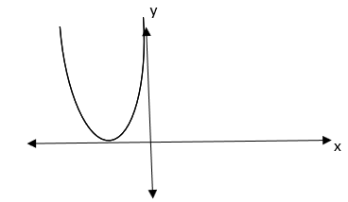

from the choices we can select E because the vertex is at (-3, 3) also the y value is decreasing at the beginning and then increasing symmetrically

12. Which Quadrant, if any, contain no point(x, y) that satisfies the inequality

a) I

b) II

c) III

d) IV

e) All quadrants contain at least one point that satisfies the given inequality

a) I Quadrant

b) II Quadrant

c) III Quadrant

ans : c

13.In the XY co ordinate plane, line L1 and L2 intersect at (2,4). If the equation of L1 is y = px + 16 and the equation of L2 is y = mx + p, where m and p are constants, what is the value of m?

Sol:

L1 and L2 intersect at (2, 4)

L1 : y = px + 116

(2, 4) lies on L1

∴ 4 = 2p + 16

2p = -12

P = -6

L2 : y = mx + p

(2,4) lies on this line L2

4 = 2m – 6

2m = 10

m = 5

14. If (3,5) and (4,9) are points on line L, which of the following is also a point on that line?

a) (2,1)

b0 (5,12)

c) 6,17)

sol;

(3,5) (4,9) lies on line l scope of line ‘L’ =

a) (2,1) (3,5) m =

b) (5, 12) (3, 5) m =

c) (6, 17) (3, 5) m =

points A and C are on the line ‘L’

15. What is the area of a triangle with vertices (-2,4) (2,4) and (-6,6)?

Sol:

Area of A9-2,4) b(2,4) c(-6,6)

A =

=

16. In the coordinate plane, points (a, b) and(c, d) are equidistant from the origin.

Quantity A Quantity B

Sol:

Points ( a, b0 and (c, d) are equidistant from the origin

If

Column A Column B

Let the points be (5,0) and (3,4)

🡺

Column A Column B

<

17. In the xy plane, which of the statements below individually provide enough information to determine whether line z passes through the origin?

Indicate all such statements

a) The equation of line z is y = mx + b and b = 0

b) the sum of the slope and the y – intercept of line z is 0

c) For any point (a,b) on line z,

sol;

a) The equation of Z is y = mx + c and b = 0 y = mx is the equation of the line through the origin

b) Slope + y intercept = 0

c) For any point (a, b)

(1,1) (2,2) (3,3) ………….. line through the origin

(1, -1) (2,-2) (3,-3) ………...line through the origin

(-1,1) (-2, 2) (-3,3) …………… also line the origin

Ans: A and C

18.

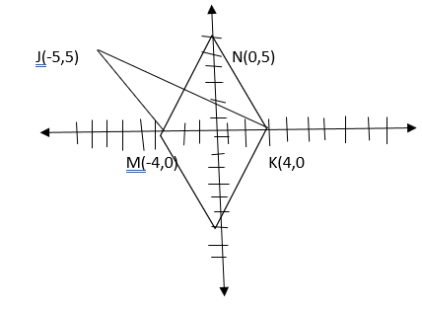

Quantity A Quantity B

The area of parallelogram KLMN The area of quadrilateral JKLM

Column A Column B

Area KLMN Area JKLM

=

Triangle on the same base and between same parallel are equal in area

**Pie Charts**

The following pie – chart shows the percentage distribution of the expenditure incurred in publishing a book. Study the pie – chart and the answer the questions based on it.

1. If for a certain quantity of books, the publisher has to pay ₹. 30,600 as printing cost, then what will be the amount of royalty to be paid for these books?

a) ₹ 19, 450

b) ₹ 21, 200

c) ₹ 22, 950

d) ₹ 26, 150

sol:

Printing cost = 20% = ₹ 30, 600

∴ The amount of royalty = 15% = ?

2. What is the central angle of the sector corresponding to the expenditure incurred on Royalty?

a) 15

b) 24

c) 54

d) 48

sol:

The Central angle of the sector representing to the expenditure on Royalty = 15

=

3. The price of the book is marked 20% above the C.P. If the marked price of the book is ₹ 180, then what is the cost of the paper used in a single copy of the book?

a) ₹ 36

b) ₹ 37.50

c) ₹ 42

d)₹ 44.25

sol:

The marked price = 120% of C.P = 180

∴ Cost price

Cost of paper used in a single copy of the book =

4. If 5500 copies are published and the transportation cost on them amounts to ₹. 82,500, then what should be the selling price of the book so that the publisher can earn a profit of 25%?

a) ₹ 187.50

b) ₹ 191.50

c) ₹ 175

d) ₹ 180

sol:

Transportation cost = ₹ 82500 = 10%

∴ Total cost of 5500 copies =

Cost price of a single copy =

= ₹ 150

The required selling price to earn a profit of 25% =

5. Royalty on the book is less than the printing cost by:

a) 5%

b) 33

c) 20%

d) 25%

sol:

Printing Cost = 20%

Royalty Cost = 15%

Royalty Cost is loss by = 5%

% of Royalty cost less than printing by =

The following pie charts exhibits the distribution of the overseas tourist from India. The two charts show the tourist distribution by country and the age profiles of the tourist respectively.

Distribution of Overseas Tourist Traffic from India

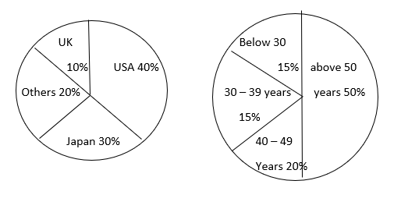

6. What percentage of Indian tourists went to either USA or UK?

a) 40%

b) 50%

c) 60%

d) 70%

sol:

Percentage of Indian tourists who went to UK or USA = 10 + 40 = 50%

Ans: b

7. The ratio of the number of Indian tourists that went to USA to the number of Indian tourists who were below 30 years of age is?

a) 2 : 1

b) 8 : 3

c) 3 : 8

d) Cannot be determined

sol:

Ratio of Indian tourists went to USA : Indian tourists who went < 30 years

= 40 : 15 = 8 : 3

Ans: B

Study the following graph carefully and answer the questions below:

Distribution of candidates who were enrolled for MBA entrance exam and the candidates (out of those enrolled) who passed the exam in different institutes:

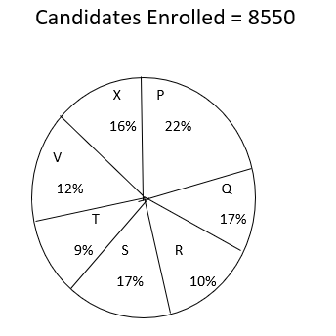

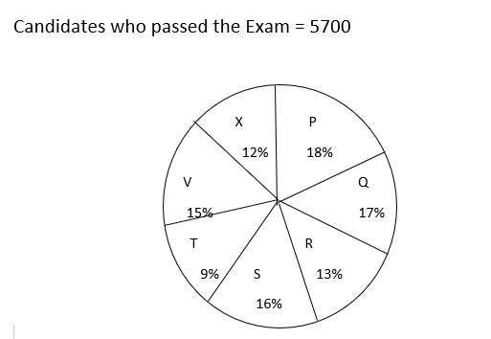

8. What percentage of candidates passed the Exam from institute T out of the total number of candidates enrolled from the same institute?

a) 50%

b) 62.5%

c) 75%

d) 80%

sol:

Institute T

9. Which institute has the highest percentage of candidates passed to the candidates enrolled?

a) Q

b) R

c) V

d) T

sol:

The institute having highest pass % cancelling equal values

a) { since( 57/85.5)/100 } is common for all we can compare only the ratio of passed to enrolled for each institute in the option

b)

c)

d)

from the above, it is clear that institute R had the highest pass %

10. The number of candidates passed from institutes S and P together exceeds the number of candidates enrolled from Institutes T and R together by:

a) 228

b) 279

c) 399

d) 407

sol:

Candidates passed from ( S + P ) – Candidates enrolled from ( T + R)

=

=

11. What is the percentage of candidates passed to the candidates enrolled for institutes Q and R together?

a) 68%

b) 80%

c) 74%

d) 65%

sol;

Q + R

12. What is the ratio of candidates passed to the candidates enrolled from institute P?

a) 9 : 11

b) 14 : 17

c) 6 : 11

d) 9 : 17

sol:

Institute P:

Candidates passed : Candidates enrolled =

=

Two different finance companies declare fixed annual rate of interest on the amounts invested with them by investors. The rate of interest offered by these companies may differ from year to year depending on the variation in the economy of the country and the banks rate of interests. The annual rates of interest offered by the two Companies P and Q over the years are shown by the line graph provided below.

13. What percentage of proteins of the human body is equivalent to the weight of its skin?

a) 41.66%

b) 43.33%

c) 44.44%

d) Cannot be determined

sol:

Total percentage of proteins equivalent to the weight of skin =

14. How much of the human body is neither made of bones or skin?

a) 40%

b) 50%

c) 60%

d) 70%

sol:

The percentage body is neither made of bones or skin = 100 – ( 10 + 20) = 100 – 30 = 70%

Ans: D

15. What is the ratio of the distribution of proteins in the muscles to that of the distribution of proteins in the bones?

a) 2 : 1

b) 2 : 3

c) 3 : 2

d) Cannot be determined

sol:

If cannot be determined since the respective distributions are not known

Ans:D

The following pie chart shows the sources of funds to be collected by the National Highways Authority of India ( NHAI) for its phase II projects. Study the pie – chart and answers the question that follows.

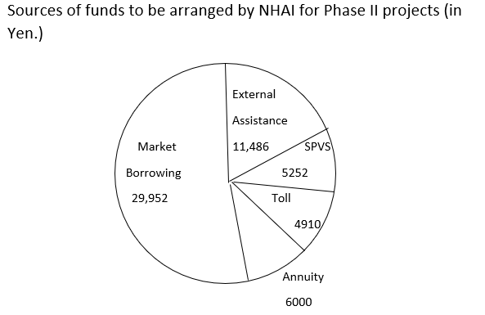

16. Near about 20% of the funds are to be arranged through:

a) SPVS

b) External Assistance

c) Annuity

d) Market Borrowing

sol:

Total Funds = 29952

11486

6000

5252

4910

57600 yens

NearB

17. If NHAI could receive a total of 9695 Yen as External Assistance, by what percent (approximately) should it increase the Market Borrowing to arrange for the shortage of funds?

a) 4.5%

b) 7.5%

c) 6%

d) 8%

sol:

External Assistance received = 9695 Yen

External Assistance required = 11486

The deficit = 11486 – 9695 = 1791 Yen

The percentage by which the market borrowing is to be increased for the shortage

Ans: c

18. If the toll is to be collected through an outsourced agency by allowing a maximum 10% commission, how much amount should be permitted to be collected by the outsourced agency, so that the project is supported with 4910 Yen?

a) 6213 Yen

b) 5827 Yen

c) 5401 Yen

d) 5316 Yen

sol:

The amount to be permitted to be collected by the outsourced agency for Toll

Original Toll = 4910

At 10% commission =+ 491

5401 Yen

19. The central angle corresponding to Market Borrowing is

a) 52

b) 137. 8

c) 187.2

d) 192.4

sol:

The central angle of Market Borrowing =

20. The approximate ratio of the funds to be arranged through Toll and that through Market Borrowing is

a) 2 : 9

b) 1 : 6

c) 3 : 11

d) 2 : 5

sol;

Ratio of Toll : Market Borrowing = 4910 : 29,952 = 5000 : 30,000 = 1 : 6

The following pie charts shows the distribution of students of graduate and Post graduate levels in seven different institutions in a town.  
Distribution of Students at Graduate and Post Graduate levels in Seven Institutes :

Total Number of Students of Graduate Level = 2730

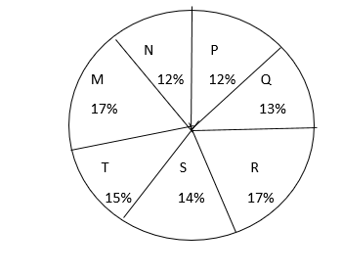

Total Number of Students of Post Graduate Level = 24700

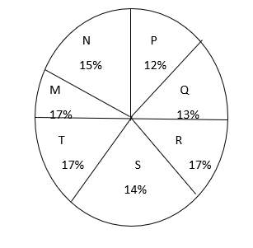

21. What is the total number of graduate and Post graduate level students in institute R?

\a) 8320

b) 7916

c) 9116

d) 8099

sol:

Institute R

Total number of graduates + Post graduate =

22. What is the ratio between the number of students studying at post graduate and graduate levels respectively from institute S?

a) 14 : 19

b) 19 : 21

c) 17 : 21

d) 19 : 14

sol:

Institute S:

Number of post graduate : Number of graduates

=

23. How many students of institutions of M and S are studying at graduate level?

a) 7516

b) 8463

c) 9127

d) 9404

sol:

Number of graduates form institutes M and S = ( 17 + 14) 273 =

=

24. What is the ratio between the number of students studying at post graduate level from institutes S and the number of students studying at graduate level from institute Q?

a) 13 : 19

b) 21 : 13

c) 13 : 8

d) 19 : 13

sol:

Number of post graduates from S : Number of graduates from Q

=

25. Total number of students studying at post graduate level from institutes N and P is

a) 5601

b) 5944

c) 6669

d) 8372

sol:

Number of post graduates from N + P = ( 15 + 12) x 247

The following pie chart shows the amount of subscriptions generated for India Bonds from different categories of investors.

Subscriptions Generated for India Bonds

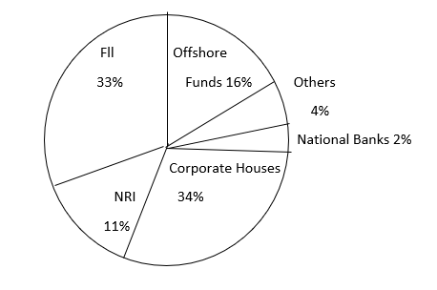

26. In the corporate sector, approximately how many degrees should be there in the central angle?

a) 120

b) 121

c) 122

d) 123

sol;

The central angle of the sector representing corporate sector =

27. If the investment by NRI’s are ₹ 4,000 then the investments by corporate houses and FII’s together is :

a) ₹ 24,000

b) 24, 363

c) 25,423

d) 25,643

sol:

investment by NRI = 4000

investment by corporate House + FII = ?

NRI = 11%

Corporate House + FII = 34 33 = 67% =

28. What percentage of the total investment is coming from FII’s and NRI’s?

a) 33%

b) 11%

c) 44%

d) 22%

sol;

FII + NRI = 33 + 11 = 44%

29. If the total investment other than by FII and corporate houses is ₹ 333,000 then the investment by NRI’s and Offshore funds will be (approximately )?

a) 274,100

b) 285,600

c) 293,000

d) Cannot be determined

sol;

FII + Corporate House = 33 + 34 = 67%

The investment by other = 100 – 67 = 33%

∴ 33% _ 333,000

The investment by NRI + Offshore funds = 11 + 16 = 27%

=

30. If the total investment flows from FII’s were to be doubled in the next year and the investment flows from all other sources had remained constant at their existing levels for this year, then what would be proportion of FII investment in the total investment into India Bonds next year (in US $ millions)?

a) 405

b) 50%

c) 60%

d) 70%

sol:

investment from FII = 33%

in the next year the investment from FII = 2 x 33 = 66%

∴ The percentage of FII investment next year on the total investment

31. What is the approximate ratio of investment flows into India Bonds from NRI’s to corporate houses?

a) 1 : 4

b) 1 : 3

c) 3 : 1

d) Cannot be determined

sol:

Ratio of NRI investment : Corporate house investment = 11 : 34

= 1 : 3

Pie chart I and Pie chart II show the break up – according to different expenditure heads and savings of the incomes of Mr. and Mrs. Anand respectively. Pie chart III shows the break up – according to the type of savings – of the total savings of the couple (i.e., the savings of Mr. and Mrs. Anand put together).

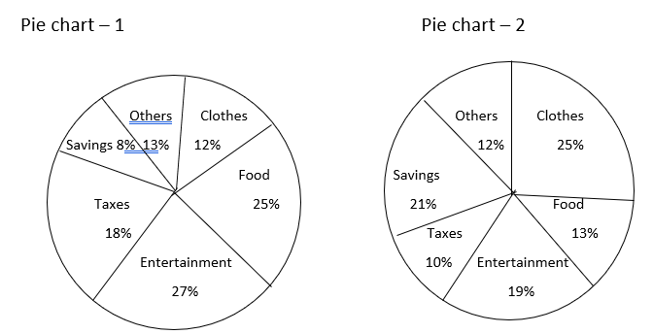

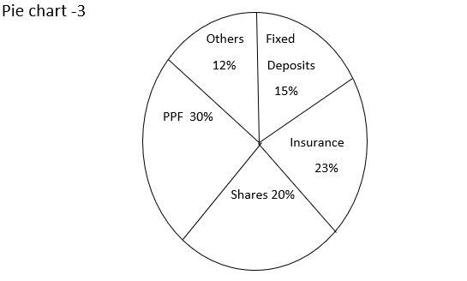

32. If Mr. Anand’s savings are twice the total savings of the couple invested in fixed deposits, What is the ratio of the income of Mr. Anand to that Mrs. Anand?

a) 7 :3

b) 3 : 7

c) 5 : 9

d) 9 :5

sol:

Mr. Anand’s saving = 2(FD) =

Ratio of saving = Mr. Anand : Mrs. Anand = 30: 70 = 3 : 7

5% of Mr. Anand’s income : 21% of Mrs. Anand’s income = 3 : 7

35% of Mr. Anand’s income = 63% of Mrs. Anand’s income

33. If the ratio of the income of Mr. Anand to that of Mrs. Anand is 3 : 1, the total savings of the couple invested in PPF as a percentage of Mr. Anand’s savings are:

a) 50%

b) 65%

c) 72%

d) 78%

sol:

Income ratio = Mr. Anand : Mrs. Anand = 3 : 1 = 1 :

From the question saving ratio =

Total = 12

If we take the total saving of the couple as ₹ 12 then saving on PPF at 30%

=

Then

34. If for an income of up to ₹ 1 lakh, no tax is charged and for any income above ₹ 1 lakh, the rate of tax for male and females is 30% and 20010 respectively of the income in excess of ₹ 1 lakh, then what is the ratio of the income of Mr. Anand to that of Mrs. Anand?

a) 3 : 4

b) 5 : 4

c) 4 : 5

d) None of these

sol:

Mr. Anand’s income

30% of Mr. Anand’s income – 1 lakh = 18% of Mr. Anand’s income

30% of Mr. Anand’s income – 30% of 1 lakh = 18% of Mr. Anand’s income

12% of Mr. Anand’s income = 30,000

∴ Mr. Anand’s income =

Mrs. Anand’s income

20% of Mrs. Anand’s income – 1 lakh = 10% of Mrs. Anand’s income

20% of Mrs. Anand income – 20% of 1 lakh = 10% of Mrs. Anand income

∴ 10% of Mrs. Anand’s income = 20,000

Mrs. Anand’s income =

Ratio of income = Mr. Anand : Mrs. Anand’s = 25 : 20 = 5 : 4

Ans: B

35. If the expenditure on clothes by Mr. Anand and that by Mrs. Anand are in the ratio 2 :5, then what is the ratio of the income of Mrs . Anand to that of Mr. Anand?

a) 5 : 6

b) 4 : 5

c) 5 : 4

d) None of these

sol:

Ratio of expenditure on clothes = Mr. Anand : Mrs. Anand = 2 : 5

12% of Mr. Anand’s income = 25% of Mrs. Anand’s income

60% of Mr. Anand income = 50% of Mrs. Anand income

Expenditure Incurred by Mr Gupta on various heads in

2001 and 2002

Year 2001 Year 2002

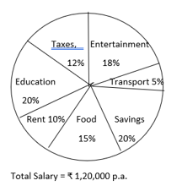 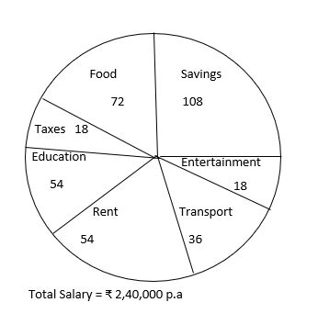

36. How much more money does Mr. Gupta spend on taxes than on transport in the year 2001?

a) ₹ 8,400

b) ₹ 12,000

c) ₹ 14,400

d) ₹ 15,600

e) Cannot be determined

sol:

Mr. Gupta’s expenses on taxes more than transport by in 2001 = (12 – 5)% of 1,20,000

37. How much more money was spent on education than on entertainment in the year 2002?

a) ₹ 6,000

b) ₹ 14,000

c) ₹ 18,000

d) ₹ 22,000

e) None of these

sol:

The money spent on education more than entertainment in 2002 =

=

38. The percentage increase in the savings from 2001 to 2002 is how many percentage points less than that of transport?

a) 66.66

b) 100.00

c) 133.33

d) 150.25

e) 200.75

sol:

savings

In 2001 =

In 2002 =

The increase in savings = 72,000

= - 24,000

RS 48,000

The Percentage in saving from 2001 to 2002 =

Transport

In 2001 :

In 2002 :

The increase in Transport expenses = 24000 – 6000 = 18000

The percentage in Transport expenses from 2001 to 2002 =

The difference = 100% points

39. What is the percentage increase in the angle subtended at the centre by food in 2002 over that in 2001?

a) 66.66%

b) 50.50%

c) 33.33%

d) 25.25%

e) 75.75%

sol:

The central angle of food in 2001 : 15% =

Food in 2002 = 72

The increase in central angle = 72 – 54 = 18

The Percentage increase in the central angle of food sector =

40. If in 2003, Mr. Gupta’s salary increases by 25% compared to the pervious year and his expenditure on food and rent increase by 25% each and all other expenditures remain the same as that in the previous year, then what is the percentage increase in his savings from 2002 to 2003?

a) 25.25%

b)31.33%

c) 43.72%

d) 54.16%

e) None of these

sol:

Let Mr. Gupta’s salary in 2002 = 360

Then his salary in 2003 =

The increase in food and rent expense =

The savings in 2003 = 450 – ( 157.5 + 18 + 54 + 36 + 18) = 450 – 283.5 = 166.5

The increase in savings = 166.5

= - 108

58.5

The percentage increase in saving =

**Line Graphs**

Study the following line graph and answer the questions.

Exports from Three Companies Over the Years ( in ₹. Crore)

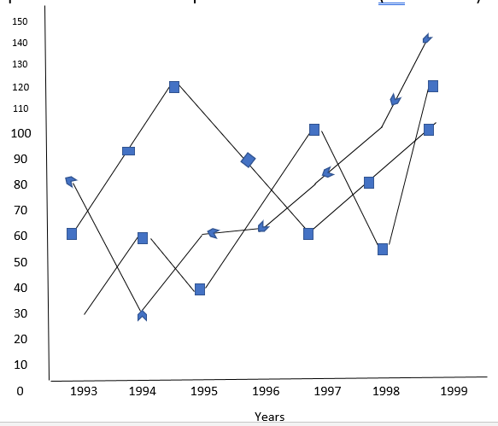

Company X Company Z Company Y

1. For which of the following pairs of years the total exports from the three Companies together are equal?
2. 1995 and 1998
3. 1996 and 1998
4. 1997 and 1998
5. 1995 and 1996

Sol:

Year X Y Z Total

Total exports for 1993 30 80 60 170

Three companies 1994 60 40 **90** 190

Were equal for the 1995 40 60 **120**  220

Year 1995 and 1996 1996 70 60 **90**  220

1997 100 80 60 240

1998 50 100 80 230

1999 120 140 **100**  360

470 560 600 1630

1. Average annual exports during the given period for Company Y is approximately what percent of the average annual exports for Company Z?
2. 87.1%
3. 89.64%
4. 91.21%
5. 93.33%

Sol:

Total exports

1. In which year was the difference between the exports from Companies X and Y the minimum?
2. 1994
3. 1995
4. 1996
5. 1997

Sol: Difference between the exports from X and Y was minimum in the year : 1996

1. What was the difference between the average exports of the three Companies in 1993 and the average exports in 1998?
2. Rs . 15.33 crores
3. Rs. 18.67 crores
4. Rs. 20 crores
5. Rs. 22.17 crores

Sol:

The difference between the average exports of the three Companies in 1998 and average exports in 1993

1. In how many of the given years, were the exports from Company Z more than the average annual exports over the given years?
2. 2
3. 3
4. 4
5. 5

Sol:

Average exports from company Z =

In 1994, 1995, 1996, and 1997 the exports of Z were more than the average exports from Z

Ans: c

The following line graph gives the ratio of the amount of imports by a company to the amount of exports from that company over the period from 1995 to 2001

Ratio of Value of Imports to Exports by a Company Over the Years

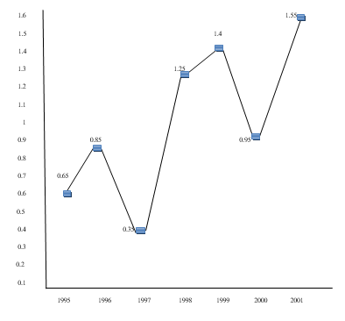

1. If the imports in 1998 was Rs. 250 crores and the total exports in the years 1998 and 1999 together was Rs. 500 crores, then the imports in 1999 was?
2. Rs. 250 crores
3. Rs. 300 crores
4. Rs 357 crores
5. Rs 420 crores

Sol:

Year

1995 0.65

1996 0.85

1997 0.35

1998 1.25

1999 1.40

2000 0.95

2001 1.55

The imports in 1998 = 250 crores

Total exports in 1997 and 1998 = 500 crores

Ratio in 1998 =

-🡪 exports in 1998 = Rs.200 crores

Exports in 1999 = 500 – 200 = 300 crores

Ratio of in 1999 =

Imports in 1999 = 420 crores

1. The imports were minimum proportional to the exports of the company in the year ?
2. 1995
3. 1996
4. 1997
5. 2000

Sol:

The imports were minimum proportionate to the exports in the year 1997 =

1. What was the percentage increase in imports from 1997 to 1998?
2. 72
3. 56
4. 28
5. Date inadequate

Sol;

Imports from 1997 to 1998 cannot be determined as we are given only the ratio of

1. If the imports of the company in 1996 was Rs 272 crores, the exports from the company in 1996 was?
2. Rs. 370 crores
3. Rs. 320 crores
4. Rs. 280 crores
5. Rs. 275 crores

Sol:

Imports of the company in 1996 = 272 cr

Ratio of in 1996 = 0.85 =

Exports of the company in 1996 =

1. In how many of the given years were the exports more than the imports?
2. 1
3. 2
4. 3
5. 4

Sol:

Number of years in which the exports were more than the imports = 4 years

The following line graph gives the percentage of the number of candidates who qualified an examination out of the total number of candidates who appeared for the examination over a period of seven years from 1994 to 2000.

Percentage of Candidates Qualified to Appeared in an Examination Over the Years

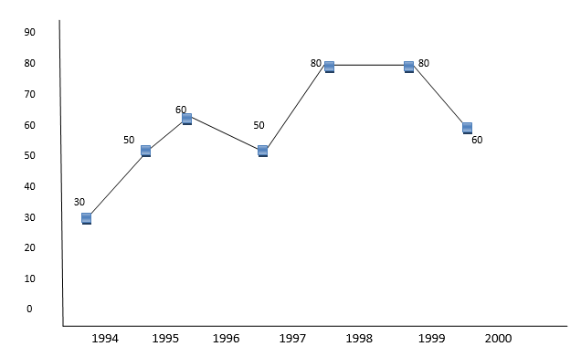

1. The difference between the percentage of candidates qualified to appeared was maximum in which of the following pairs of years?
2. 1994 and 1995
3. 1997 and 1998
4. 1998 and 1999
5. 1999 and 2000

Sol:

The difference between the percentage of candidates qualified to appeared was maximum in the year 1997 to 1998

Ans: B

1. In which pair of years was the number of candidates qualified, the same?
2. 1995 and 1997
3. 1995 and 2000
4. 1998 and 1999
5. Data inadequate

Sol:

The year in which the number of candidates qualified was the same cannot be determined .Since we are given only percentage and no value is given the data is inadequate to find the answer.

1. If the number of candidates qualified in 1998 was 21200, what was the number of candidates appeared in 1998?
2. 32000
3. 28500
4. 26500
5. 25000

Sol:

Number of candidates qualified in 1998 = 21200

The percentage qualified in 1998 = 80%

The number appeared in 1998 =

1. If the total number of candidates appeared in 1996 and 1997 together was 47400, then the total number of candidates qualified in these two years together was?
2. 34700
3. 32100
4. 31500
5. Data inadequate

Sol:

Total number of candidates appeared in 1996 and 1997 = 47400 then the number of candidates appeared in these two years cannot be found as the data is inadequate

1. The total number of candidates qualified in 1999 and 2000 together was 33500 and the number of candidates appeared in 1999 was 26500. What was the number of candidates in 2000?
2. 24500
3. 22000
4. 20500
5. 19000

Sol:

Total number qualified in 1999 and 2000 together = 33500

Number appeared in 1999 = 26500

Percentage qualified in 1999 =

Therefore, Number qualified in 2000 = 33500 – 21200 = 12300

Percentage qualified in 2000 = 60%

Therefore Number of students appeared in 2000 =

%Profit =

The following line graph gives the annual percent profit earned by a Company during the period 1995 – 2000.

Period Profit Earned by a Company Over the Years

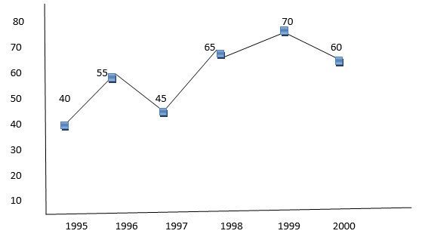

%Profit =

1. If the expenditures in 1996 and 1999 are equal, then the approximate ratio of the income in 1996 and 1999 respectively is?
2. 1 : 1
3. 2 : 3
4. 13 : 14
5. 9 : 10

Sol:

If the expenditure in 1996 and 1999 are equal then

Let expenditure in 1996 and 1999 = E

% Profit in 1996 = 55%

Let the income in 1996 = I1 and the income in 1999 = I2

Then

11E = 20I1 – 20E

20I1 = 31 E

I1=

% Profit in 1999 = 70%

7E = 10 I2 – 10E

10 I2 = 17E

I2 =

1. If the income in 1998 was Rs. 264 crores, what was the expenditure in 1998?
2. Rs. 104 crores
3. Rs. 145 crores
4. Rs. 160 crores
5. Rs. 185 crores

Sol:

Income in 1998 = 264

Expenditure = ?

% Profit in 1998 =

13E = 5280 – 20E

33E = 5280

Expenditure in 1998 =

1. In which year is the expenditure minimum?
2. 2000
3. 1997
4. 1996
5. Cannot be determined

Sol:

The expenditure was minimum in which year cannot be determined since the date in inadequate

1. If the profit in 1999 was Rs. 4 crores, what was the profit in 2000?
2. RS. 4.2 crores
3. Rs 6.6 crores
4. Rs. 6.8 crores
5. Cannot be determined

Sol:

If profit in 1999 = 4 crores then profit in 2000 cannot be determined as the data is inadequate

1. What is the average profit earned for the given years?
2. 50(2/3)
3. 55(5/6)
4. 60(1/6)
5. 335

Sol:

The average profit % for the given years =

Ratio of Exports to Imports (in terms of money in Rs. Crores) of Two Companies Over the Years

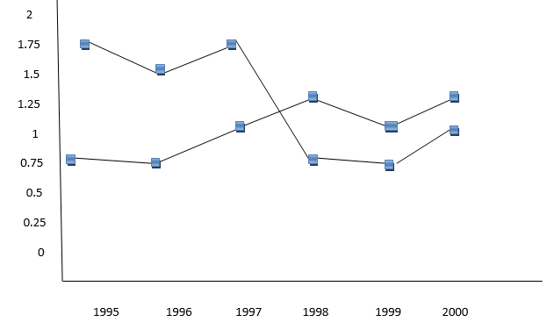

1. In how many of the given years were the exports more than the imports for Company A?
2. 2
3. 3
4. 4
5. 5

Sol:

|  |  |  |
| --- | --- | --- |
| Year | Company A | Company B |
| 1995  1996  1997  1998  1999  2000 | 1.75  1.50  1.75  0.75  0.75  1.00 | 0.75  0.75  1.00  1.25  1.00  1.25 |

The number of years in which the exports were more than the imports in terms of Company A = 3 years

1. If the imports of Company A in 1997 were increased by 40%, what would be the ratio of exports to the increased imports?
2. 1.20
3. 1.25
4. 1.30
5. Cannot be determined

Sol;

The imports of company A in 1997 was increased by 40% then the new ratio is

The ratio of of A in 1997 = 1.75 = 7/4

The new ratio =

1. If the exports of Company A in 1998 were Rs. 237 crores, what was the amount of imports in that year?
2. Rs. 189.6 crores
3. Rs. 243 crores
4. Rs. 281 crores
5. Rs. 316 crores

Sol:

Exports of A in 1998 = Rs. 237 crores

The ratio of in 1998 for A =

Therefore Imports of A in 1998 =

1. In 1995, the exports of Company A was double that of Company B. If the imports of Company A during the year was RS. 180 crores, what was the approximate amount of imports of Company B during that year?
2. Rs 190 crores
3. Rs 210 crores
4. Rs 225 crores
5. Cannot be determined

Sol:

In 1995 , exports Company A = 2( exports of B)

Exports of B in 1995 = ( Exports of A in 1995)

The ratio of in 1995 for A = 7/4

Therefore, Exports of A in 1995 =

Exports of B in 1995 =

The ratio of in 1995 for B = ¾

Therefore Imports of B in 1995 =

1. In which years was the difference between imports and exports of Company B the maximum?
2. 2000
3. 1996
4. 1998 and 2000
5. Cannot be determined

Sol:

The difference between the imports and exports of B was maximum in which year **cannot be determined** because we are given only the ratio of and no values

Two difference finance companies declare fixed annual rate of interest on the amounts invested with them by investors. The rate of interest offered by these companies may differ from year to year depending on the variation in the economy of the country and the banks rate of interest. The annual rate of interest offered by the two Comapanies P and Q over the years re shown by the line graph provided below.

Annual Rate of Interest Offered by Two Finance Companies Over the Years

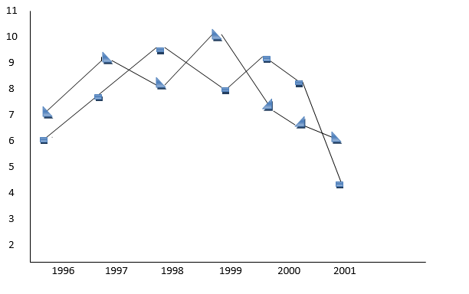

|  |  |  |
| --- | --- | --- |
| year | P | Q |
| 1996 | 7 | 6.5 |
| 1997 | 9 | 8 |
| 1998 | 8 | 9.5 |
| 1999 | 10 | 8 |
| 2000 | 7.5 | 9 |
| 2001 | 6.5 | 8 |
| 2002 | 6 | 4 |

26. A sum of ₹ 4.75 lakhs was invested in Company Q in 1999 for one year. How much more interest would have been earned if the sum was invested in Company P?

A) ₹ 19,000

B) ₹ 14,250

C) ₹ 11,750

D) ₹ 9500

Sol:

Investment = 4.75 lakhs

Years : 1999

Q = 8%

P = 10%

The interest earned more by investing in P instead of Q =

27. If two different amounts in the ratio 8 : 9 are invested in Companies P and Q respectively in 2002, then the amounts received after one year as interests from Companies P and Q are respectively in the ratio?

A) 2 : 3

B) 3 : 4

C) 6 : 7

D) 4 : 3

Sol:

Year : 2002 P = 6% Q = 4%

Ratio of investment = P : Q = 8x : 9x

Ratio of interest = P : Q =

28. In 2000, a part of ₹ 30 lakhs was invested in Company P and the rest was invested in Company Q for one year. The total interest received was ₹ 2.43 lakhs. What was the amount interest invested in Company P?

A) ₹ 9 lakhs

B) ₹ 11 lakhs

C) ₹ 12 lakhs

D) ₹ 18 lakhs

Sol:

Year : 2000 P = 75% Q = 9%

Let the investment in Company P = x lakhs then the investments in Company A = ( 30 – x) lakhs

Total interest earned = 2.43 lakhs

∴

7.5x + 270 – 9x = 243

1.5x = 270 – 243 = 27

X = 18

The investment in P = ₹ 18 lakhs

29. An investor invested a sum of ₹ 12 lakhs in Company P in 1998. The total amount received after one year was re-invested in the same Company for one more year. The total appreciation received by the investor on his investment was?

A) ₹ 2,96,200

B) ₹ 2,42,200

C) ₹ 2,25,600

D) ₹ 2,16,000

Sol:

Year : 1998 = 8%

Year : 1999 = 10%

Investment = ₹ 12 lakhs

A1 = 12.96 lakhs

Total interest earned = 0.960

= +1.296

2.256 lakhs = ₹ 2,25,600

30. An investors invested ₹ 5 lakhs in Company Q in 1996. After one year, the entire amount along with the interest was transferred as investment to Company P in 1997 for one year. What amount will be received from Company P, by the investor?

A) ₹ 5,94,550

B) ₹ 5,80,425

C) ₹ 5,77,800

D) ₹ 5,77,500

Sol:

Year : 1996 Q = 6.5%

Year : 1997 P – 9%

Investment = ₹ 5 lakhs

A1 = 5.325 lakhs

Total amount received = 5.32500

0.47925

5.8042 = ₹ 5,80,425

Study the following line graph which gives the number of students who joined and left the school in the beginning of year for six years, from 1996 to 2001.

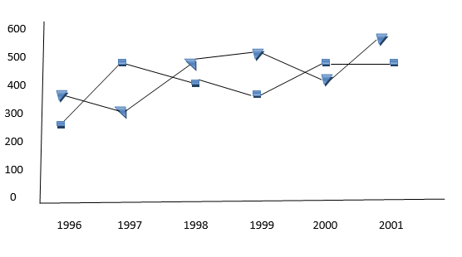

31. The number of students studying in the school during 1999 was?

A) 2950

B) 3000

C) 3100

D) 3150

Sol:

Initial strength in 1995 = 3000 students

|  |  |  |  |  |
| --- | --- | --- | --- | --- |
| Year | Left | Joined | Net | Strength |
| 1996 | 250 | 350 | +100 | 3100 |
| 1997 | 450 | 300 | -150 | 2950 |
| 1998 | 400 | 450 | +50 | 3000 |
| 1999 | 350 | 500 | +150 | 3150 |
| 2000 | 450 | 400 | -50 | 3100 |
| 2001 | 450 | 550 | +100 | 3200 |

The strength in t he school in 1999 = 3150

32. For which year, the percentage rise/ fall in the number of students who left the school compared to the previous year is maximum?

A) 1997

B) 1998

C) 1999

D) 2000

Sol:

The year in which the % rise or fall with the number of students left compared to the previous year was maximum

in the year 1997 Left was 450

in the year 1996 left was 250

The increase = 200 and the % increase = 80%, the maximum.

33. The strength of school increased/decreased from 1997 to 1998 by approximately what percent?

A) 1.2%

B) 1.7%

C) 2.1%

D) 2.4%

Sol:

The strength of the school is increased from 1997 to 1998 by

Strength in 1997 = 29950

Strength in 1998 = 3000

The increase = 50

% increase =

34. The number of students studying in the school in 1998 was what percent of the number of students studying in the school in 2001?

A) 92.13%

B) 93.75%

C) 96.88%

D) 97.25%

Sol:

35. The ratio of the least number of students who joined the school to the maximum number of students who left the school in any of the years during the given period is?

A0 7 : 9

B) 4 : 5

C) 3 : 4

D) 2 : 3

Sol:

Least no of students who joined : Max no of students who left = 300 : 450 = 2 : 3

Table Charts

Study the following table and answer the questions.

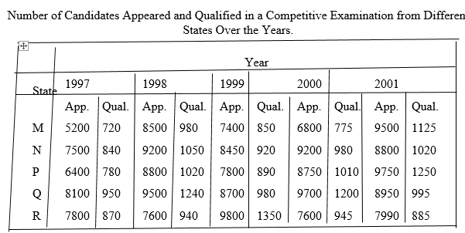

1. Total number of candidates qualified from all the states together in 1997 is approximately what percentage of the total number of candidates qualified from all the states together in 1998?

A) 72%

B) 77%

C) 80%

D) 83%

Sol:

Required percentage =

|  |  |
| --- | --- |
| 2. | What is the average candidates who appeared from State Q during the given years? |

A) 8700

B) 8760

C) 8990

D) 8920

Sol:

Required percentage =

3. In which of the given years the numbers of candidates appeared from State P has maximum percentage of qualified candidates?

A) 1997

B) 1998

C) 1999

D) 2001

Sol:

The percentage of candidates qualified to candidates appeared from state P during different years are:

For 1997

For 1998

For 1999

For 2000

For 2001

Therefore Maximum percentage is for the year 2001.

4. What is the percentage of candidates qualified from State N for all the years together, over the candidates appeared from State N during all the years together?

A) 12.36%

B) 12.16%

C) 11.47%  
D) 11.15%

Sol:

Required percentage =

5. The percentage of total number of qualified candidates to the total number of appeared candidates among all the five states in 1999 is?

A) 11.49%

B) 11.84%  
C) 12.21%

D) 12.57%

Sol:

Required percentage =

The following table gives the percentage of marks obtained by seven students in six different subjects in an examination.

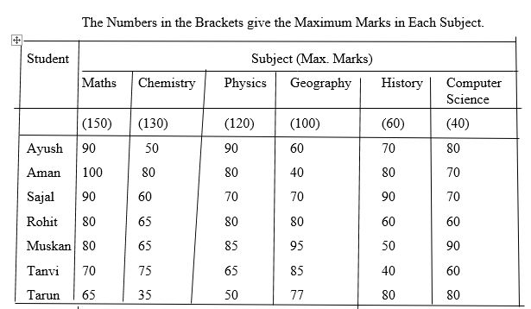

5. What are the average marks obtained by all the seven students in Physics? (rounded off to two digit after decimal)

A) 77.26

B) 89.14

C) 91.37

D) 96.11

Sol:

Average marks obtained in Physics by all the seven students

=

7. The number of students who obtained 60% and above marks in all subjects is?

A) 1

B) 2

C) 3

D) None

Sol:

From the table it is clear that Sajal and Rohit have 60% or more marks in each of the six subjects

8. What was the aggregate of marks obtained by Sajal in all the six subjects?

A) 409

B) 419

C) 429

D) 449

Sol;

Aggregate marks obtained by Sajal

= [(90% of 150) + (60% of 130) + (70% of 120) + (70% of 100) + (90% of 60) + (70% of 40)]

= (135 + 78 + 84 + 70 + 54 + 28) = 449

9. In which subject is the overall percentage the best?

A) Maths

B) Chemistry

C) Physics

D) History

Sol:

We shall find the overall percentage (for all the seven students) with respect to each subject.

The overall percentage for any subject is equal to the average of percentages obtained by all the seven students since the maximum marks for any subject is the same for all the students.

Therefore, overall percentage for:

1. Maths =

=

1. Chemistry =
2. Physics =
3. Geography =
4. History =
5. Computer Science =

Clearly, this percentage is highest for Maths.

10. What is the overall percentage of Tarun?

A) 52.5%

B) 55%

C) 60%

D) 63%

Sol:

Aggregate marks obtained by Tarun = [(65% of 150) + (35% of 130) + (50% of 120) + (77% of 100) + (80% of 60) + (80% of 40)]

= [97.5 + 45.5 + 60 + 77 + 48 + 32] = 360

The maximum marks (of all the six subjects) = 9150 + 130 + 120 + 100 + 60 + 40) = 600

Therefore Overall percentage of Tarun =

Study the following table and answer the questions based on it.

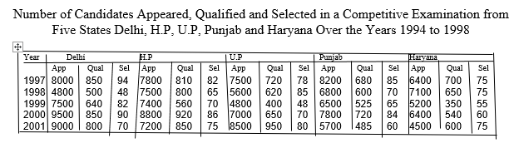

1. For which state the average number of candidates selected over the years is the maximum?

A) Delhi

B) H.P

C) U. P

D) Punjab

Sol:

The average number of candidates selected over the given period for various states are:

For Delhi =

For H.P = = 75.6

For U. P =

For Punjab =

For Haryana =

Clearly, this average is maximum for Delhi

2. The percentage of candidates qualified from Punjab over those appeared from Punjab is highest in the year?

A) 1997

B) 1998

C) 1999

D) 2000

Sol;

The percentage of candidates qualified from Punjab over those appeared from Punjab during different years are :

For 1997 =

For 1998 =

For 1999 =

For 2000 =

For 2001 = %

Clearly this percentage is highest for the year 2000.

13. In the year 1997, which state had the lowest percentage of candidates selected over the candidates appeared?

A) Delhi

B) H.P

C) U.P

D) Punjab

Sol:

For Delhi =

For H.P =

For U.P =

For Punjab=

For Haryana= %

Clearly, this percentage is lowest for Punjab

14. The number of candidates selected from Haryana during the period under review is approximately what percent of the number selected from Delhi during this period?

A) 79.5%

B) 81%

C) 84.5%

D) 88.5%

Sol:

Required percentage =

= 88.54

15. The percentage of candidates selected from U.P over those qualified from U.p is highest in the year?

A) 1997

B) 1998

C) 1999

D) 2001

Sol;

For 1997 =

For 1998 =

For 1999 =

For 2000 =

For 2001 = %

Clearly, this percentage is highest for the year 1998

A school has four sections a, B, C, D of Class IX students

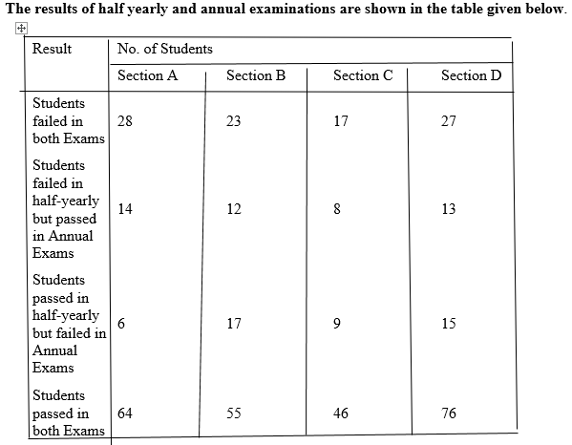

16. If the number of students passing an examination be considered a criteria for comparison of difficulty level of two examinations, which of the following statements is true in this context?

A) Half yearly examinations were more difficult

B) Annual examinations were more difficult

C) Both the examinations has almost the same difficulty level

D) The two examinations cannot be compared for difficulty level

Sol;

Number of students who passed half-yearly exams in the school = (Number of students passed in half-yearly but failed in annual exams) + (Number of students passed in both exams)

  (6 + 17 + 9 + 15) + (64 + 55 + 46 + 76) = 288.

Also, Number of students who passed annual exams in the school

  = (Number of students failed in half-yearly but passed in annual exams) + (Number of students passed in both exams)

  (14 + 12 + 8 + 13) + (64 + 55 + 46 + 76)= 288.

Since, the number of students passed in half-yearly = the number of students passed in annual exams. Therefore, it can be inferred that both the examinations had almost the same difficulty level.

Thus Statements (a), (b) and (d) are false and Statement (c) is true.

17. How many students are there in Class IX in the school?

A) 336

B) 189

C) 335

D) 430

Sol:

Since the classification of the students on the basis of their results and sections form independent groups, so the total number of students in the class:

= (28 + 23 + 17 + 27 + 14 + 12 + 8 + 13 + 6 + 17 + 9 + 15 + 64 + 55 + 46 + 76)

= 430.

18. Which section has the maximum pass percentage in at least one of the two examinations?

A) A section

B) B section

C) C section

D) D section

Sol:

Pass percentage in at least one of the two examinations for different sections are:

For Section A

For Section B

For Section C

For Section D

Clearly, the pass percentage is maximum for Section D

19. Which section has the maximum success rate in annual examinations?

A) A Section

B) B Section

C) C Section

D) D Section

Sol:

Total number of students passed in annual exams in a section

= [ (No. of students failed in half-yearly but passed in annual exams)  + (No. of students passed in both exams) ] in that section

* Success rate in annual exams in Section A

=

=

Similarly, success rate in annual exams in:

Section B

|  |  |
| --- | --- |
|  |  |
|  |

Section C

Section D

Clearly, the success rate in annual examinations is maximum for Section A

20. Which section has the minimum failure rate in half yearly examination?

A) A Section

B) B Section

C) C Section

D) D Section

Sol:

Total number of failures in half-yearly exams in a section

= [ (Number of students failed in both exams) + (Number of students failed in half-yearly but passed in Annual exam)  ] in that section

* Failure rate in half-yearly exams in Section A

Similarly, failure rate in half – yearly exams in:

Section B

|  |  |
| --- | --- |
|  |  |
|  |

Section C

Section D

Clearly, the failure rate is minimum for Section D

The following table shows the number of new employees added to different categories of employees in a company and also the number of employees from these categories who left the company every year since the foundation of the Company in 1995.

|  |
| --- |
| Year |
| Managers | | Technicians | | Operators | | Accountants | | Peons | |
| New | Left | New | Left | New | Left | New | Left | New | Left |
| 1995 | 760 | - | 1200 | - | 880 | - | 1160 | - | 820 | - |
| 1996 | 280 | 120 | 272 | 120 | 256 | 104 | 200 | 100 | 184 | 96 |
| 1997 | 179 | 92 | 240 | 128 | 240 | 120 | 224 | 104 | 152 | 88 |
| 1998 | 148 | 88 | 236 | 96 | 208 | 100 | 248 | 96 | 196 | 80 |
| 1999 | 160 | 72 | 256 | 100 | 192 | 112 | 272 | 88 | 224 | 120 |
| 2000 | 193 | 96 | 288 | 112 | 248 | 144 | 260 | 92 | 200 | 104 |

21. What is the difference between the total number of Technicians added to the Company and the total number of Accountants added to the Company during the years 1996 to 2000?

A) 128

B) 112

C) 96

D) 88

Sol:

Required difference

    = (272 + 240 + 236 + 256 + 288) - (200 + 224 + 248 + 272 + 260)

    = 88.

22. What was the total number of Peons working in the Company in the year 1999?

A) 1312

B) 1192

C) 1088

D) 968

Sol:

Total number of Peons working in the Company in 1999

    = (820 + 184 + 152 + 196 + 224) - (96 + 88 + 80 + 120)

    = 1192.

23. For which of the following categories the percentage increase in the number of employees working in the Company from 1995 to 2000 was the maximum?

A) Managers

B) Technicians

C) Operators

D) Accountants

Sol:

**Number of Managers working in the Company:**

|  |  |
| --- | --- |
| In 1995 | = 760. |
| In 2000 | = (760 + 280 + 179 + 148 + 160 + 193) - (120 + 92 + 88 + 72 + 96) |
|  | = 1252. |

Therefore Percentage increase in the number of Managers =

Number of Technicians working in the Company:

In 1995 = 1200

In 2000 = ( 1200 + 272 + 240 + 236 + 256 + 288) – (120 + 128 + 96 + 100 + 112) = 1936

Therefore Percentage increase in the number of Technicians =

Number of Operators working in the Company:

In 1995 = 880

In 2000 = ( 880 + 256 + 240 + 208 + 192 +248 ) – ( 104 + 120 +100+ 112 + 144) = 1444

Therefore Percentage increase in the number of Operators =

Number of Accountants working in the Company:

In 1995 = 1160

In 2000 = ( 1160 + 200+ 224+ 248 + 272 + 260) – ( 100 + 104+96+88+92) = 1884

Therefore Percentage increase in the number of Accountants =

Number of Peons working in the Company:

In 1995 = 820

In 2000 = 9 820 + 184 + 152 + 196 + 224+ 200) – ( 96 + 88 +80 +120 +104) = 1288

Therefore Percentage increase in the number of Peons =

Clearly, the percentage increase is maximum in case of Managers.

24. What is the period average of the total number of employees of all categories in the year 1997?

A) 1325

B) 1195

C) 1265

D) 1235

Sol:

Total number of employees of various categories working in the Company in 1997 are:

|  |  |
| --- | --- |
| Managers | = (760 + 280 + 179) - (120 + 92) = 1007. |
| Technicians | = (1200 + 272 + 240) - (120 + 128) = 1464. |
| Operators | = (880 + 256 + 240) - (104 + 120) = 1152. |
| Accountants | = (1160 + 200 + 224) - (100 + 104) = 1380. |
| Peons | = (820 + 184 + 152) - (96 + 88) = 972. |

ThereforePooled average of all the five categories of employees working in the Company in 1997

25. During the period between 1995 and 2000, the total number of Operators who left the Company is what percent of total number of Operators who joined the Company?

A) 19%

B) 21%

C) 27%

D) 29%

Sol;

Total number of Operators who left the Company during 1995 - 2000

    = (104 + 120 + 100 + 112 + 144)  = 580.

Total number of Operators who joined the Company during 1995 - 2000

    = (880 + 256 + 240 + 208 + 192 + 248) = 2024.

Therefore Required Percentage =

The following table gives the percentage distribution of population of five states, P, Q, R, S and T on the basis of poverty line and also on the basis of sex.

|  |  |  |  |
| --- | --- | --- | --- |
| State | Percentage of Population below the Poverty Line | Proportion of Males and Females | |
| Below Poverty Line | Above Poverty Line |
| M : F | M : F |
| P | 35 | 5 : 6 | 6 : 7 |
| Q | 25 | 3 : 5 | 4 : 5 |
| R | 24 | 1 : 2 | 2 : 3 |
| S | 19 | 3 : 2 | 4 : 3 |
| T | 15 | 5 : 3 | 3 : 2 |

26. If the male population above poverty line for State R is 1.9 million, then the total population of State R is?

A) 4.5 million

B) 4.85 million

C) 5.35 million

D) 6.25 million

Sol:

Let the total population of Station R be x million

Then, population of State R above poverty line = [9100 – 24)% of x] million =

And so, male population of State R above poverty line =

But it is given that male population of State R above poverty line = 1.9 million

Therefore

Therefore Total population of State R = 6.25 million

27. What will be the number of females above the poverty line in the State S if it is known that the population of State S is 7 million?

A) 3 million

B) 2.43 million

C) 1.33 million

D) 5.7 million

Sol:

Total population of State S = 7 million.

ThereforePopulation above poverty line

    = [(100 - 19)% of 7] million

    = (81% of 7) million

    = 5.67 million.

And so, the number of females above poverty line in State S

28. What will be the male population above poverty line for State P if the female population below poverty line for State P is 2.1 million?

A) 2.1 million

B) 2.3 million

C) 2.7 million

D) 3.3 million

Sol:

Female population below poverty line for State P = 2.1 million

Let the male population below poverty line for State P be *x* million.

Then 5 : 6 = x : 21

Population below poverty line for State P = (2.1 + 1.75) million = 3.85 million.

Let the population above poverty line for State P by *y* million.

Since, 35% of the total population of State P is below poverty line, therefore, 65% of the total population of State P is above poverty line i.e., the ratio of population below poverty line to that above poverty line for State P is 35 : 65.

35 : 65 = 3.85 : y

Population above poverty line for State P = 7.15 million and so, male population above poverty line for State P =

29. If the population of males below poverty line for State Q is 2.4 million and that for State T is 6 million, then the total populations of States Q and T are in the ratio?

A) 1 :3

B) 2:5

C) 3:7

D) 4 : 9

Sol:

Male population below poverty line = 2.4 million.

Let the female population below poverty line be *x* million.

Then , 3 : 5 = 2.4 : x

Total population below poverty line = 2.4 + 4 = 6.4 million

If Nq be the total population of State Q, then, 25% of Nq = 6.4 million

For State T:

Male population below poverty line = 6 million

Let the female population below poverty line be y million

Then, 5 :3 = 6 : y

Total population below poverty line = ( 6 + 3.6) = 9.6 million

If Nt be the total population of State T, then

15% of Nt = 9.6 million

Thus, Required ration =

|  |  |  |
| --- | --- | --- |
|  |  | . |
|  |